
October 2026




All members are invited to attend the CACCN Annual Meeting of the Members (AGM)

AGM Information and Registration: HERE



Meeting details
- October 22, 2026
- 1600 hrs ET
- Zoom

Registration is required.

Why you should attend
- Exercise your Voting Rights: Cast your vote on crucial matters like approving financial statements, or appointing auditors.
- Financial Transparency: Review the annually audited financial reports to see how funds or investments were managed.
- Strategic Insights: Hear firsthand about upcoming goals and initiatives.

Proxy Votes
- Unable to attend? Proxy Form: PDF / PDF Fillable
- Proxy votes are due by October 19, 2026 @ 1600 hrs ET.
- Proxy votes do not count towards the required quorum for voting at the meeting.

Agenda
- Download Agenda and Information regarding voting
- Access to the meeting information is available by logging into About Us: Association Reports in the Members Only area of the website: HERE.
- Hold an open forum.
- Stay for the webinar: Resuscitation to Evacuation: Critical Care Nursing Officers in the Canadian Armed Forces

New & Returning Members!

Thank you for your
membership and support!
We look forward to your participation in your specialty nursing association!

Canadian Critical Care
Nursing Conference 2026

Thank you to all attendees,
sponsors and exhibitors!

Continuing Learning Hours

- The credit system remains available until November 15.
- Your username (email address) and password will be required to log in and complete the evaluation(s).
- Evaluations may be completed on a laptop, tablet, or mobile device.
- Once finished, delegates may print, email, or save their Continuing Learning Hours certificate.
- CL Hours certificates will be issued through the online system after delegates complete the full conference evaluation, including the overall evaluation and individual session evaluations.
- Link: https://www.xcdsystem.com/caccn/credits/index.cfm?ID=PxCwphV



Canadian Critical Care
Nursing Conference 2026
We look forward to welcoming everyone to the conference September 29 and 30.

Preconference Sessions – September 28

There may still be time to register for the Preconference Sessions:

Innovating together: Let’s collaborate!
Sponsored by Cardinal Health
Registration: Cardinal Health – Fill out form
Help shape the future of intermittent pneumatic compression (IPC) technology by participating in an interactive feedback session featuring prototypes of eco-friendly sleeves and wireless IPC devices. Your insights will play a key role in refining next-generation solutions designed to improve patient mobility, comfort, and sustainability while delivering clinically proven venous thromboembolism prophylaxis. Complimentary lunch will be provided. Limited spaces available!
PrisMax PowerCourse – Understanding Extracorporeal Therapies (1300 – 1700 hrs AST)
- View the flyer: HERE.
- Sponsored by Vantive
- Registration: PrisMaxPowerCourse
- Plan to attend this dynamic 4-hour educational experience featuring gamified stations, hands-on learning, and concise evidence-based discussions to support clinician engagement and practical application in critical care. Requirement that attendees must be CRRT trained to participate. Limited spaces available!

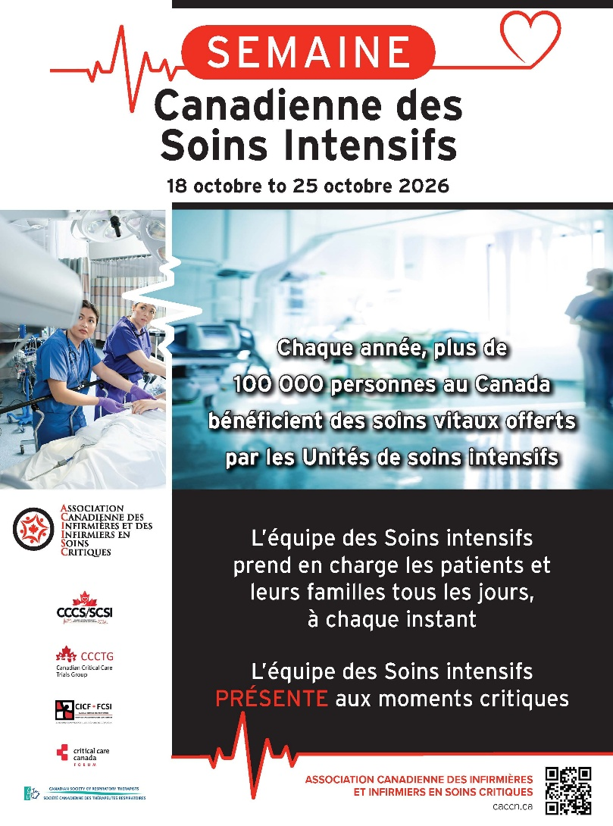
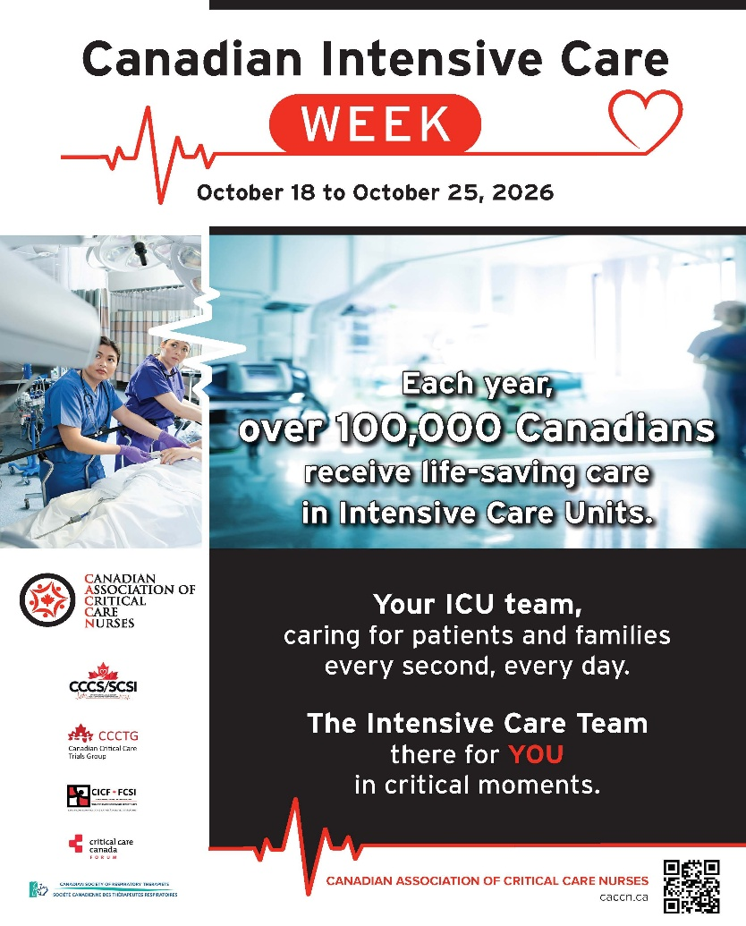
Toot your own horn!
Start a conversation with a patient and/or their family about critical care nursing! Tell them why you do what you do! Ask if they have any questions and thank them for listening.
Offer tours of the Intensive Care Unit.
Set up an information table or display showcasing the ICU Team! Have volunteers available to share information about what we do.
Write a brief article for your hospital/facility internal newsletter!
How to participate :
Print & post ICU Week posters on information boards in your unit/hospital.
Encourage your CACCN chapter leadership to visit your ICU to share information about CACCN!
Tell a coworker...or two...what a great job they do on a daily basis!

The CACCN annually proclaims the last week of October as Canadian Intensive Care Week. This is a week to reflect on the dedication, commitment and passion of the ICU team, take time to reflect on our practice, promote the work we do, promote our workplace, acknowledge our co-workers and celebrate the work we do!

Le CACCN proclame chaque année la dernière semaine d'octobre Semaine canadienne des soins intensifs. C'est une semaine pour réfléchir au dévouement, à l'engagement et à la passion de l'équipe des soins intensifs, prendre le temps de réfléchir à notre pratique, promouvoir le travail que nous faisons, promouvoir notre lieu de travail, reconnaître nos collègues et célébrer le travail que nous faisons!

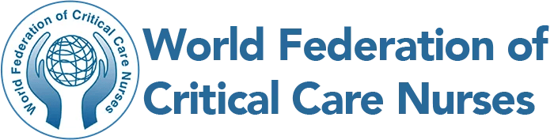

Clinical Knowledge and Practice Gap Survey

This survey aims to better understand existing gaps in clinical knowledge and practice and identify educational and system-level interventions that are practical, culturally relevant, and adaptable to resource-limited settings. Your participation is valuable in helping identify priority areas for improvement and supporting the development of meaningful, context-appropriate educational initiatives for critical care nurses worldwide.

Please complete the survey by October 21, 2026.

Survey links by language:

- English: https://form.jotform.com/261255590323050
- French: https://form.jotform.com/262594996002162
- Spanish: https://form.jotform.com/262595324361156
- Portuguese: https://form.jotform.com/262595921647166

Certification

Good luck to our critical care nursing colleagues writing the critical care certification examination in November!

Certification Bursaries

CACCN offers bursaries to support members on their certification journey.

Initial Certification
Two bursaries are available.
Each bursary is valued at $500.

Renewal Certification
Four bursaries are available.
Each bursary is valued at $250.

Criteria
https://caccn.ca/awardsandrecognition/
To qualify for the bursaries, you must meet the
Overall Award Criteria, and your exam / renewal
must be in 2026.



Call for Nominations
for the
World Federation of Pediatric Intensive
& Critical Care Societies (WFPICCS)
Board of Directors
1 January 2027 to 31 December 2028 term.

WFPICCS Member Societies are invited to nominate eligible colleagues to serve on the incoming WFPICCS Board. In accordance with the approved WFPICCS Bylaws, Member Societies are encouraged to consider both regional and professional balance when putting forward nominees, with the aim of supporting a broadly representative and multidisciplinary Board.

Current WFPICCS Committees and areas of activity include:
- Education
- Allied Health Professionals
- Nursing
- World PICU Awareness Week (WPAW)
- Website
- Global Health and Advocacy

If you are interested in sitting on the WFPICCS Board of Directors, please provide the following to CACCN at vicepresident@caccn.ca for consideration and submission by no later than November 2, 2026:

- A statement of intent, outlining why the nominee would like to serve on the WFPICCS Board and how they hope to contribute to WFPICCS.

- A current Curriculum Vitae (CV).

- Identification of at least one WFPICCS Committee in which the nominee would be willing to actively participate during their Board term.

WFPICCS Website: https://wfpiccs.org/

EDUCATIONAL OPPORTUNITIES

Initial Burn Care and Stabilization – Priorities in the First 24 Hours
November 25 @ 1300 hrs ET
Caring for patients with severe burn injuries presents unique challenges that extend far beyond wound management. From recognizing inhalation injury and securing a threatened airway to managing complex fluid resuscitation and identifying time-sensitive surgical emergencies, all critical care nurses can play a vital role in improving outcomes during the early phases of burn care.
__________________________________________

Additional Educational Opportunities

The Treatment of Viral Pneumonia in Critically Ill Patients
October 21, 2026 @ 12:00 hrs ET
Learning Objectives:
- Discuss the clinical presentation and epidemiology of critical illness due to influenza.
- Explain the latest evidence for antiviral use in critically ill patients with influenza.
- Compare the role and impact of steroids in influenza pneumonia versus other viral pneumonias.
REGISTER NOW

Mucolytic Agents Within the Ventilated Patient Population
November 27, 2026 @ 1200 hrs ET
Learning Objectives:
- Understand the mechanisms by which mechanical ventilation impairs mucociliary clearance and predisposes to mucus plugging.
- Distinguish the main mucoactive agent classes and their mechanisms.
- Summarize current evidence for mucoactive therapy in ventilated patients.
- Describe a potential approach to mucolytic prescribing: indications, safety, alternatives.
REGISTER NOW
Care of the Critically Ill Obstetric/Peri-Partum Patient
October 14, 2026
Saskatchewan Chapter
In-Person, Virtual and Recording Options Available

Montreal Chapter Quarterly Conference
October 22, 2026
The most exciting Conference yet!
Join us for a morning of learning at the Montreal Neurological Hospital, de Grandpré Conference room, followed by an afternoon of hands-on experiences at the Strathcona Anatomy lab. We will have access to hands on learning opportunities like you have not experienced before. A morning snack and lunch will be provided.

Beyond the Alarms
October 23, 2026
Alberta Chapter and UAH GSICU Team
Featured topics include Hyperammonia Syndrome, Navigating Difficult Conversations, and Esophageal Balloons. Your ticket includes two coffee breaks, lunch, prizes, and more!

The Human Side of Health Systems: Part 1: Understanding the Individual Experience of Burnout in Critical Care Nursing
October 27 @ 1200 hrs ET
Nova Scotia Chapter
Madison Hickey is a Registered Nurse with a background in critical care, health research, implementation science, and clinical innovation, bringing a unique perspective on the relationship between nurse experience, wellness, and health-system performance. Her work is grounded in a central question relevant to critical care nursing: how can we move beyond understanding the challenges nurses face to designing systems that enable nurses, and the patients and families they care for, to thrive?

Chronic Hand Eczema w/ Cdn Association of Neonatal Nurses
November 3 @ 1200 hrs ET
This session will explore the underrecognized burden of chronic hand eczema (CHE) among Canadian nurses and its implications for workforce sustainability.

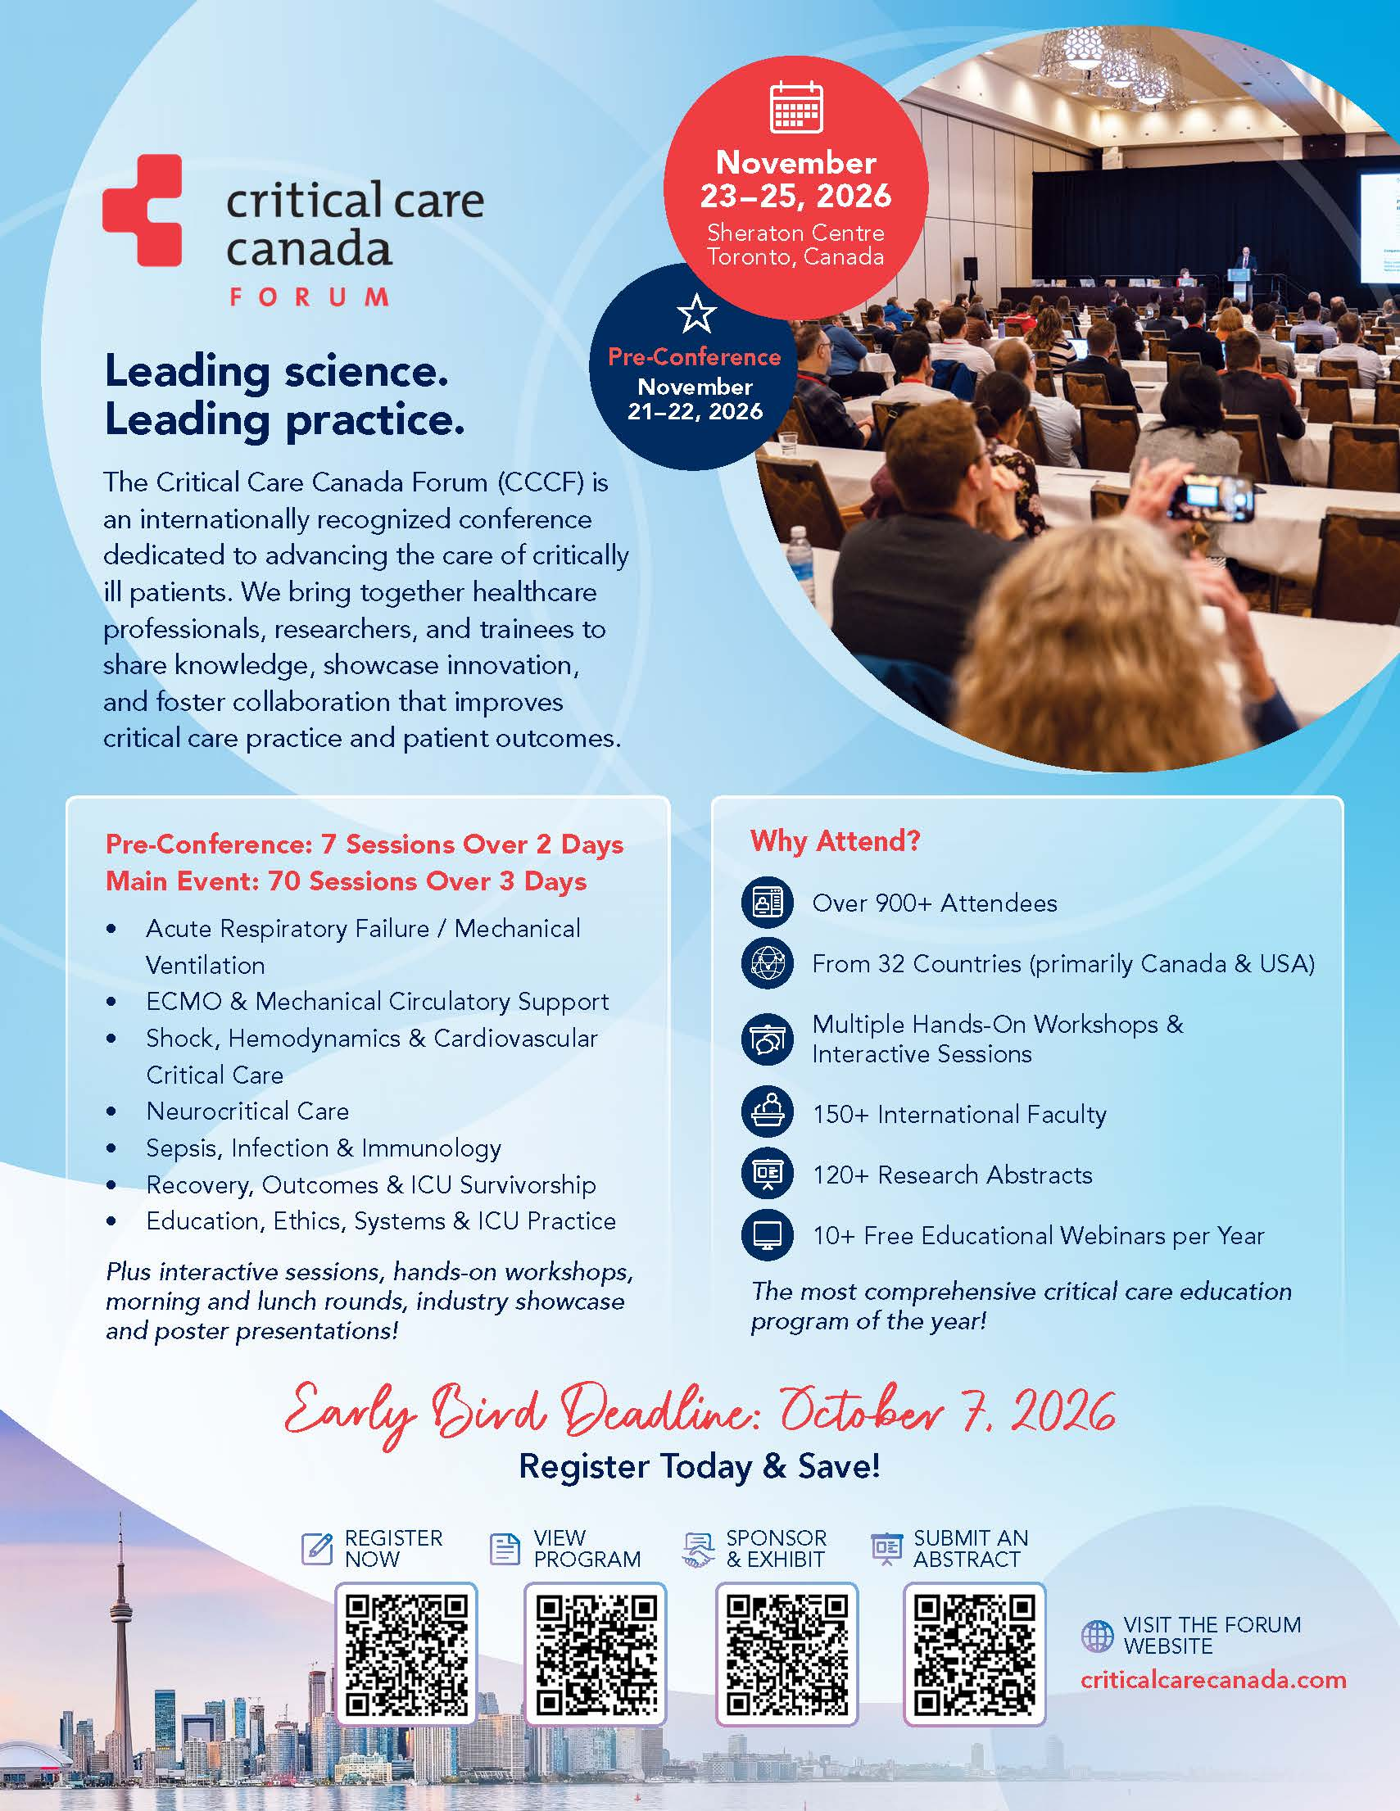
PUBLICATIONS

Experiences of intensive care nurses on dying with dignity: A qualitative study
Nursing Ethics
https://doi.org/10.1177/09697330251403146

Palliative Care in Intensive Care Units: Nurses' Perspectives on Challenges
and Strategies
BACCN
https://doi.org/10.1111/nicc.70240

Dual role caregivers in critical care nursing: Matrescence and workforce sustainability
Intensive and Critical Care Nursing
https://doi.org/10.1016/j.iccn.2026.104334

Not So F.A.S.T.: Uncovering the DecisionMaking Processes Behind Seeking Emergency Medical Care for Stroke Among Survivors and Their Caregivers — An Exploratory Qualitative Descriptive Study in Northern British Columbia
Canadian Journal of Cardiovascular Nurses
https://cccn.ca/_uploads/6aba6620d6a3c.pdf

Basilic vein transposition arteriovenous fistula: Outcomes in a tertiary hospital
Canadian Journal of Vascular Access
https://cvaa.info/Portals/0/2026%20Files/Publications/20-2%20Tanmit%20et%20al.pdf

Intravenous fluid resuscitation: Learning from a case study with complex presentation
British Journal of Nursing
https://cvaa.info/Portals/0/2026%20Files/Publications/20-2%20Henson%20and%20Perkins.pdf

2025-26 HEC Impact Report:
Forward, Together
Healthcare Excellence Canada
https://a-ca.storyblok.com/f/850807391887861/x/9d4c7235d8/healthcare-excellence-canada-impact-report-2025-26-en-compressed.pdf?utm_source=email&utm_medium=mailout&utm_campaign=impact-report-2026

The heartbeat of nursing: finding purpose through advocacy –
A message to every nursing student
and nurse: your voice matters
Canadian Nurse
https://www.canadian-nurse.com/blogs/cn-content/2026/10/05/heartbeat-of-nursing?_zs=71I9O1&_zl=OVim3

A review of free radicals and antioxidants for critical care nurses
Intensive and Critical Care Nursing
https://doi.org/10.1016/j.iccn.2004.07.007

Reducing workplace injuries: impact of an air-powered turning system on staff safety and satisfaction
Canadian Nurse
https://www.canadian-nurse.com/blogs/cn-content/2026/08/24/workplace-injuries-air-powered-turning-system?_zs=71I9O1&_zl=dVim3

Implementing Evidence-Based Practice in Critical Care Nursing: An Ethnographic Case Study of Knowledge Use
Journal of Advanced Nursing
https://doi.org/10.1111/jan.70054

Translating compassion into innovation: why nurses belong at the decision-making table
Canadian Nurse
https://www.canadian-nurse.com/blogs/cn-content/2026/09/28/translating-compassion-into-innovation?_zs=71I9O1&_zl=RVim3

