
September 2026



CACCN is seeking an interested Association member to serve as a volunteer Board Member on the National Board of Directors for a two-year term from May 1, 2027, to April 30, 2029.

Region: Central

Region Eligibility: Members from Manitoba and Ontario

Position(s): One (1)

Eligibility Criteria: Active member of CACCN, holding a registered nursing license, and currently working in critical care.

Why Serve on the Board?
Serving on the Board is an opportunity to use your skills, experience, and voice to make a meaningful impact in your specialty nursing association.

As a Board Member, you will help provide governance and operational leadership, support strategic direction, and contribute to the Association’s long-term strength and sustainability.

Nominations will be accepted until 1600 hrs ET
on October 1, 2026.

More information
https://caccn.ca/about-caccn/annual-general-meeting/



On September 30, observe National Day for Truth & Reconciliation (Orange Shirt Day), a day to honour and remember the children taken from their families, those who never returned home, and the individuals, families, and communities who continue to live with the lasting trauma and impacts of Canada’s residential school system.

Remembering this tragic and painful history, and its ongoing consequences, is an essential part of reconciliation.



New & Returning Members!

Thank you for your
membership and support!
We look forward to your participation in your specialty nursing association!

Join your CACCN member colleagues for the upcoming Annual General Meeting of the Members on Thursday, October 22, 2026 at 1600 hrs ET.

Why your participation matters: Your participation in your professional nursing association important!
Who can attend: Active members of the Association (RNs working in critical care in Canada) hold voting rights at the annual meeting of the members. Affiliate members and student registrants may attend the Annual meeting of the members but do not hold voting rights.

AGM Registration: HERE

Canadian Critical Care
Nursing Conference 2026
We look forward to welcoming everyone to the conference September 29 and 30.

Preconference Sessions – September 28

There may still be time to register for the Preconference Sessions:

Innovating together: Let’s collaborate!
Sponsored by Cardinal Health
Registration: Cardinal Health – Fill out form
Help shape the future of intermittent pneumatic compression (IPC) technology by participating in an interactive feedback session featuring prototypes of eco-friendly sleeves and wireless IPC devices. Your insights will play a key role in refining next-generation solutions designed to improve patient mobility, comfort, and sustainability while delivering clinically proven venous thromboembolism prophylaxis. Complimentary lunch will be provided. Limited spaces available!
PrisMax PowerCourse – Understanding Extracorporeal Therapies (1300 – 1700 hrs AST)
- View the flyer: HERE.
- Sponsored by Vantive
- Registration: PrisMaxPowerCourse
- Plan to attend this dynamic 4-hour educational experience featuring gamified stations, hands-on learning, and concise evidence-based discussions to support clinician engagement and practical application in critical care. Requirement that attendees must be CRRT trained to participate. Limited spaces available!


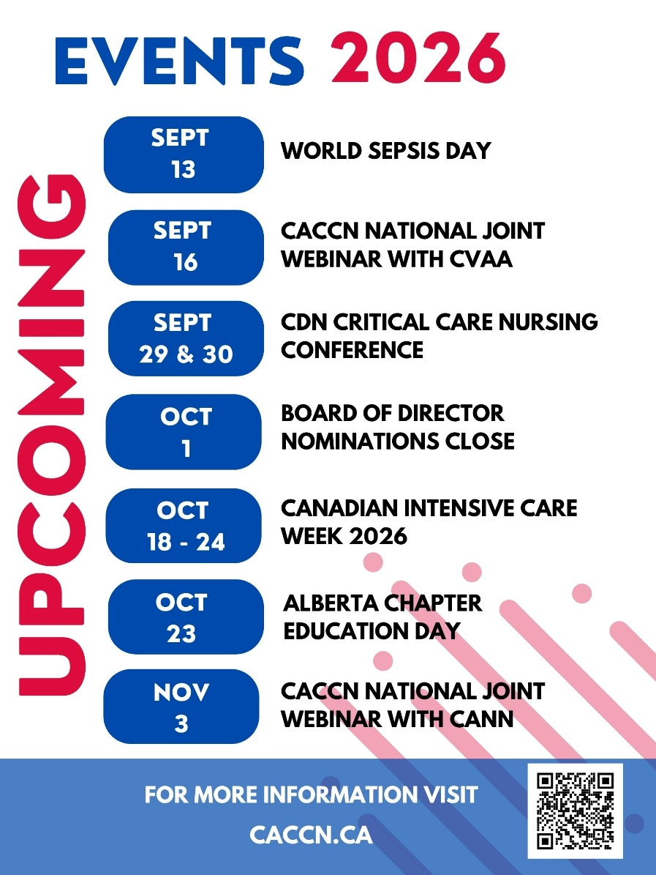

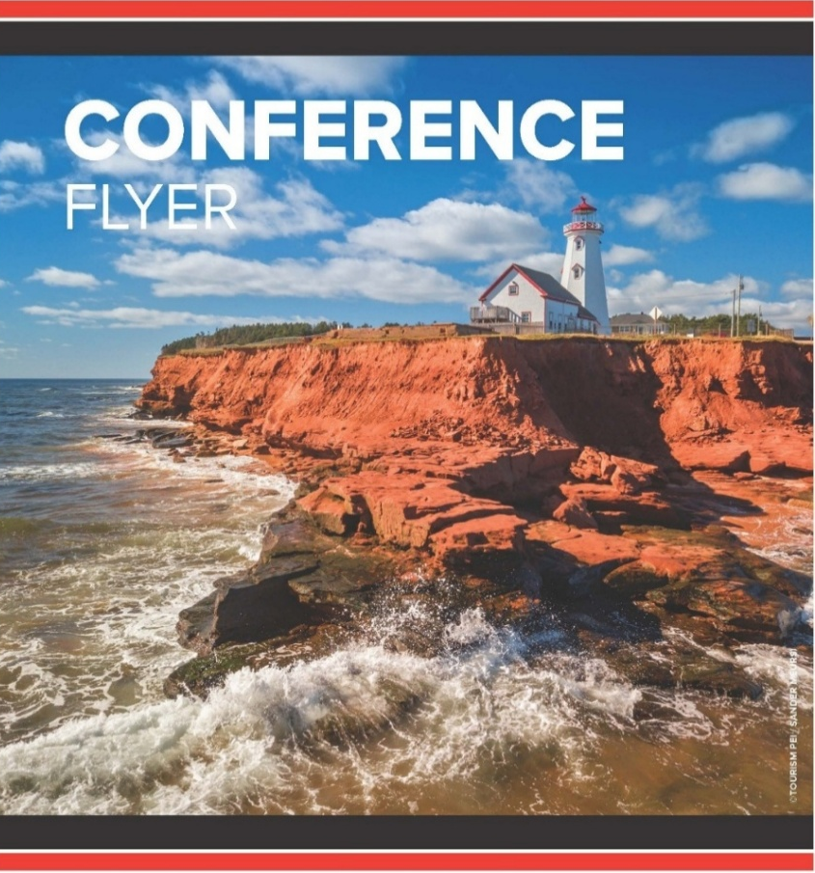
World Sepsis Day
September 13, 2026!
Theme of the 2026 World Sepsis Day: Invest in Sepsis – Save Lives - Millions of Sepsis cases and Sepsis-related deaths in children, women, and men are preventable. Yet Sepsis remains critically under-prioritized and underfunded.
The 2030 Global Agenda for Sepsis makes clear that achieving meaningful reductions in Sepsis deaths and disabilities requires investment in national policies, health systems and health workers, prevention and early detection, research and innovation, survivors and communities, and pandemic and other health emergency preparedness. Investment in Sepsis is not an additional cost to health systems.
It is an investment in stronger health systems, Universal Health Coverage, global health security, and sustainable development.
The 2026 World Sepsis Day therefore calls on governments, international financing institutions, global health organizations, development partners, philanthropies, and the private sector to Invest in Sepsis – Save Lives.
We look forward to welcoming attendees, sponsors and supporters to the Canadian Critical Care Nursing Conference 2026.

Attendees watch for your conference information email to arrive soon!

We are now accepting abstract submissions for Plenary, Concurrent, Skills Labs, and Poster Presentations!
Submissions are accepted until OCTOBER 31, 2026
Please forward to your colleagues and save the date!
Certification Bursaries

CACCN offers bursaries to support members.

Initial Certification - Two bursaries are available. Each bursary is valued at $500.

Renewal Certification - Four bursaries are available. Each bursary is valued at $250.

Criteria
https://caccn.ca/awardsandrecognition/
To qualify for the bursaries, you must meet the
Overall Award Criteria, and your exam / renewal
must be in 2026.
Continuing Learning Hours: Activities must directly relate to improving knowledge and skills in your specific nursing practice specialty. Count one CL hour for each clock hour spent on the activity; activities must be at least 30 minutes long to qualify
Beyond Survival: A Sepsis Symposium for Systems, Science, and Recovery
September 1, 10, 22 & 29 @ 1400 hrs ET
Hosted by Critical Care BC
A four-part, recorded, virtual educational series focused on advancing sepsis care across the continuum, from early recognition and treatment through recovery and future innovation. The series aims to share current evidence, practical lessons, emerging research, and lived experiences, bringing together clinicians, researchers, quality improvement leaders, and patient and family partners. These sessions will offer valuable insights and opportunities for learning, whether you work in acute care, critical care, emergency medicine, prehospital care, pediatrics, quality improvement, or healthcare leadership.

Beyond Usual Care: Does New Randomized Evidence Support a New Standard for CVAD Locking
September 16 @ 1700 hrs ET
Joint Webinar with the Canadian Vascular Access Association
Sponsored by SterileCare
This webinar will explore the scientific rationale for CVAD locking strategies and review contemporary evidence supporting catheter maintenance and complication prevention. Faculty will review the pathophysiology of catheter occlusion and intraluminal biofilm formation, explore the role of calcium in coagulation and microbial attachment, and discuss how different locking agents may influence these pathways.

Setting the Ventilator in pARDS – The First Six Hours
17 September 2026 @ 10:30 AM ET
Sponsored by WFPICCs
In this engaging session, Expert Speaker Dr. Vicent Modesto i Alapont will explore key considerations when setting the ventilator during the crucial first hours of pARDS, with a focus on supporting thoughtful, patient-specific bedside decision-making.

Med Safety Exchange – Complimentary webinar
Wednesday, September 16, 2026 @ 12 noon ET)
Join your colleagues across Canada for complimentary 50-minute webinars to share, learn and discuss incident reports, trends and emerging issues in medication safety!
In recognition of World Patient Safety Day 2026:
"Safe care for noncommunicable diseases"

Breakthroughs in blood: Advancements into action
September 29 @ 1300 hrs ET
Hosted by Canadian Blood Services
Join CBS for this webinar as Dr. Ryan Metcalf discusses the 2025 AABB and ICTMG International Clinical Practice Guidelines published in JAMA in 2025. This will be followed by a panel discussion on the implications for clinical practice.

Chronic Hand Eczema w/ Cdn Association of Neonatal Nurses
November 3 @ 1200 hrs ET
Joint Webinar with the Canadian Association of Neonatal Nurses
This session will explore the underrecognized burden of chronic hand eczema (CHE) among Canadian nurses and its implications for workforce sustainability. Beyond a skin condition, CHE is a significant occupational health issue contributing to attrition in an already strained healthcare system.

Initial Burn Care and Stabilization – Priorities in the First 24 Hours
November 25 @ 1300 hrs ET
Caring for patients with severe burn injuries presents unique challenges that extend far beyond wound management. From recognizing inhalation injury and securing a threatened airway to managing complex fluid resuscitation and identifying time-sensitive surgical emergencies, all critical care nurses can play a vital role in improving outcomes during the early phases of burn care.

Information and registration: https://caccn.ca/upcoming-events/

EDUCATIONAL OPPORTUNITIES


Volume 37, Issue 2 is now available!

https://cjccn.ca/

- A Bachelor of Science in Nursing learning pathway into critical care practice: An innovative workforce strategy focused on student support, transition, and success

- Canadian Post-graduate Education in Critical Care Nursing: An Environmental Scan of Programs

- Critical Care Nursing in the Face of Suffering: Camus’s Absurdism in Practice

- Becoming a Critical Care Nurse: Scoping Review of Newly Graduated Nurses’ Professional Transition to Practice

- Publishing as a Nurse: From Idea to Publication

- ISMP Canada Medication Safety Practice Corner: Safer packaging for neuromuscular blocking agents

Canadian Nurses Association
Certification Program

CNA certification is a nationally recognized nursing specialty credential for nurses.

Earning this credential shows your employer, peers, and clients that you are a dedicated professional committed to lifelong learning, patient advocacy, and professional practice. Certification is a great way to demonstrate your continuing competence in your nursing specialty. It can also help you fulfil some of the quality assurance program requirements of your employer and/or licensing body.

Fall examination
- Apply before September 30
- Exam writing window: November 1 – 15
- Receive your results in December

Renewal by continuous learning
- Apply before December 15, 2026

Watch the CACCN Webinar recorded September 3

Demystifying the critical care CNA certification:
Your critical care specialty roadmap

Members Only

BRITISH COLUMBIA & ONTARIO MEMBERS!
Turn frontline insight into innovation.
Have you ever thought, “This could be safer, more effective, or better with the right medical technology?”
If you are a healthcare professional from British Columbia or Ontario, there is now a way to develop your insights! Medical Device Development Centre (MDDC), a Canadian not-for-profit organization focused on need-driven healthcare innovation offers Insight to Innovation (I2I) giving healthcare professionals and connected students a supported pathway to identify unmet needs and move promising ideas forward, while retaining control over whether and how they pursue subsequent development.
For more information: https://mddc.org/innovation/.
Now accepting abstract submissions for
Plenary, Concurrent, Skills Labs,
and Poster Presentations!
Submissions are accepted until
OCTOBER 31, 2026
More Information
PUBLICATIONS AND ITEMS OF INTEREST
Latent profile analysis and influencing factors of compassion fatigue in intensive care unit nurses
Scientific Reports
https://www.nature.com/articles/s41598-026-48599-9

International Competencies of Advanced Practice Nurses in Critical Care: An Integrative Review
Journal of Advanced Nursing
https://doi.org/10.1111/jan.70179

Do-not-attempt-cardiopulmonary resuscitation decisions in critical care: The gap between theory and practice
Journal of Intensive Care Society
https://doi.org/10.1177/17511437251369306

Evidence-based sleep promotion in acute care from the perspective of nursing staff: a cross-sectional study
BMC Nursing
https://link.springer.com/article/10.1186/s12912-025-04259-3

Post-intensive Care Syndrome (PICS): an American Association for the Surgery of Trauma Critical Care Committee Consensus Guideline – Defining, Recognizing, and Managing PICS Associated Physical Impairment, Cognitive Dysfunction, and Thromboinflammatory Dysregulation
Trauma Surgery and Acute Care Open
https://tsaco.bmj.com/content/11/2/e002172

Current strategies and future directions to enhance recovery following critical illness
Thorax
https://thorax.bmj.com/content/81/6/611.abstract

Barriers and facilitators to the delivery of delirium care in intensive care units: an analysis informed by the Theoretical Domains Framework
Anaesthesia
https://doi.org/10.1111/anae.70017Digital Object Identifier (DOI)

Nurses’ experiences of end-of-life communication with children who have life-threatening conditions in paediatric intensive care units: a qualitative descriptive study
BMC Nursing
https://link.springer.com/article/10.1186/s12904-026-02007-1

Health Product InfoWatch
Government of Canada
https://www.canada.ca/en/health-canada/services/drugs-health-products/medeffect-canada/health-product-infowatch/august-2026.html

InfoVigilance sur les produits de santé
Gouvernement du Canada
https://www.canada.ca/fr/sante-canada/services/medicaments-produits-sante/medeffet-canada/infovigilance-produits-sante/aout-2026.html

WHO Prehospital Toolkit Webinar WHO Collaborating Centre on Integrated Clinical Care
https://youtu.be/6Dl_Isca8hA
https://youtu.be/plO5Dq2nzt8

A qualitative study exploring critical care survivors’ and their clinicians’ shared experiences of navigating a fragmented care system
Scientific Reports
https://www.nature.com/articles/s41598-026-42385-3

Mass intrahospital transport of the neonatal intensive care unit: a systems-based approach to safety, efficiency, and family-centered care
Journal of Perinatology
https://www.nature.com/articles/s41372-026-02721-x

Improving peripheral arterial catheter placement in critically ill children: a pre-post quality improvement study
Frontiers in Pediatrics
https://www.frontiersin.org/journals/pediatrics/articles/10.3389/fped.2026.1931589/full

Insights Into Factors Affecting Nurses’ Knowledge of and Attitudes Toward AI and Implications for Successful AI Integration in Critical Care: Cross-Sectional Study
JMIR Nursing
https://nursing.jmir.org/2026/1/e85649/

Treatment withdrawal and distress: Recognising the need for better support in critical care—A scoping review
Australian Critical Care
https://doi.org/10.1016/j.aucc.2025.101459

