
August 2026


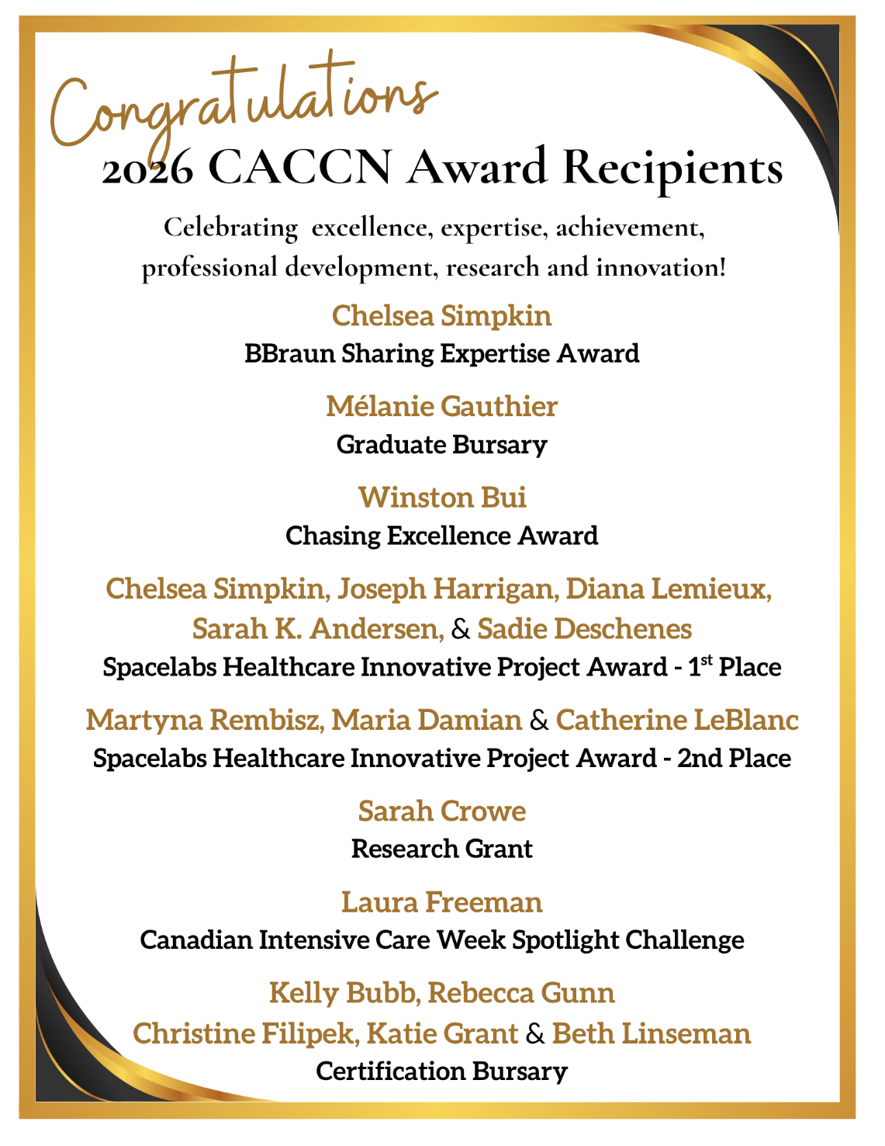
New & Returning Members!

Thank you for your
membership and support!

We look forward to your participation in your specialty nursing association!


To the CACCN Members who assisted with reviewing the
2026 Award applications.

We appreciate your expertise
and support.

Membership
Payment Processing Changes

What has changed? CACCN has successfully moved to a new payment processing system as of August 3, 2026.

What does this mean for members? Members previously on continuous renewal will be required to renew their membership updating their payment information through the website or the direct link provided in the renewal email sent 45 to 60 days before renewal.

Continuous Renewal FAQs: The FAQs remain unchanged.

MEMBER REFERRAL DRAW
Thank you and congratulations to Samantha S, from Manitoba
and Shelley S, from Nova Scotia, recipients of a one-year membership extension for their member referrals Q1 (May to July).
Thank you to all members who referred new members to the association!
We appreciate your support!

Want to know how you could win?
https://caccn.ca/wp-content/uploads/2025/03/Member-Referrals-Feb2025-Flyer.pdf

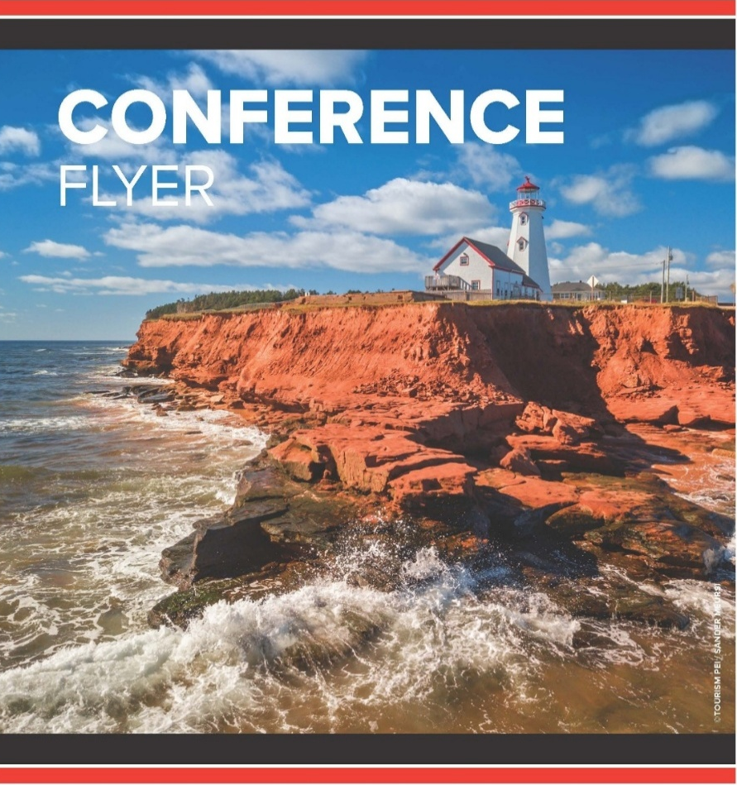
PRECONFERENCE
Enhance your conference experience! Register to attend one of two preconference events!
Innovating together: Let’s collaborate!
September 28 @ 1300 hrs AST
Sponsored by Cardinal Health

Registration: Cardinal Health – Fill out form

Join us for an interactive feedback session as we explore future innovation within intermittent pneumatic compression (IPC) devices, focused on sleeve redesign. Share your insights to help shape next-generation solutions that enhance patient care, usability, and support more sustainable product design.
Lunch will be provided.

PrisMax PowerCourse – Understanding Extracorporeal Therapies
September 28 @ 1300 hrs AST
Sponsored by Vantive

Registration: PrisMaxPowerCourse

Plan to attend this dynamic 4-hour educational experience featuring gamified stations, hands-on learning, and concise evidence-based discussions to support clinician engagement and practical application in critical care.
Requirement that attendees must be CRRT trained to participate. Limited spaces available!

THERE IS STILL TIME TO PLAN TO
JOIN US IN SEPTEMBER!
Canadian Critical Care
Nursing Conference 2026
Join critical care nurses in beautiful Charlottetown, PE - September 29–30
#CCNC2026
Why You’ll Want to Be There
- Two preconference events on September 28 to help you kick off your conference experience
- Two full days of inspiring education designed for critical care nursing professionals
- Keynote Speaker: Kathleen Vollman
- Invited Speakers: Canadian Blood Services
- Sponsored Speakers: LEOPharma, Cardinal Health, Vantive Canada, Baxter Corporation, Philips.
- Two Dinner & Learn events for even more opportunities to connect and learn
- Earn continuing learning hours while investing in your professional growth
- Connect with peers, sponsors and supporters through networking, posters, and exhibits
- Enjoy Nurses Night Out on September 29 to
make the most of your time with colleagues
Register Early and Save!
Early bird pricing ends August 24
- Early bird member rates:
- 2-day conference: $550 plus HST (15%)
- 1-day conference: $300 plus HST (15%)
Register and pay before the early bird deadline for a chance to win your conference tuition.

Visit the conference webpage!
https://caccn.ca/2026-canadian-critical-care-nursing-conference/

Canadian Nurses Association
Certification Program

CNA certification is a nationally recognized nursing specialty credential for nurses.

Earning this credential shows your employer, peers and clients that you are a dedicated professional committed to lifelong learning, patient advocacy and professional practice. Certification is a great way to demonstrate your continuing competence in your nursing specialty. It can also help you fulfil some of the quality assurance program requirements of your employer and/or licensing body.

Fall exams
- Apply before September 30
- Exam writing window: November 1 – 15
- Receive your results in December

Renewal by continuous learning
- Apply before December 15, 2026

--------------------------------------------------------------

CACCN
Certification Bursaries

CACCN offers bursaries to support members pursuing initial or renewal Critical Care Nursing Certification.

Initial Certification

If you successfully write the Critical Care Nursing Certification examination through the Canadian Nurses Association this year (2026), and are successful, you may be eligible to apply for the CACCN Initial Certification Bursary.

Two bursaries are available. Each bursary is valued at $500.

Renewal Certification

If you successfully renew your certification this year (2026), you may be eligible to apply for the CACCN Renewal Certification Bursary. Four bursaries are available.

Each bursary is valued at $250.

Criteria at
https://caccn.ca/awardsandrecognition/

CACCN is seeking an interested Association member to serve as a volunteer Board Member on the National Board of Directors for a two-year term from May 1, 2027, to April 30, 2029.

Region: Central

Region Eligibility: Members from Manitoba and Ontario

Position(s): One (1)

Eligibility Criteria: Active member of CACCN, holding a registered nursing license, and currently working in critical care.

Why Serve on the Board?
Serving on the Board is an opportunity to use your skills, experience, and voice to make a meaningful impact in your specialty nursing association.

As a Board Member, you will help provide governance and operational leadership, support strategic direction, and contribute to the Association’s long-term strength and sustainability.

Ideal Candidate Profile
- Passionate about critical care nursing
- Enthusiastic, creative,
- and positive in their approach
- Collaborative and comfortable
- working as part of a team
- Able to contribute thoughtful leadership
- and sound judgment
- Interested in supporting Association growth and sustainability

Previous experience in a not-for-profit setting is considered an asset; however, a strong commitment to CACCN’s mission is most important.

Nominations will open September 1, 2026.

Nominations will be accepted until 1600 hrs ET
on October 1, 2026.

More information
https://caccn.ca/about-caccn/annual-general-meeting/

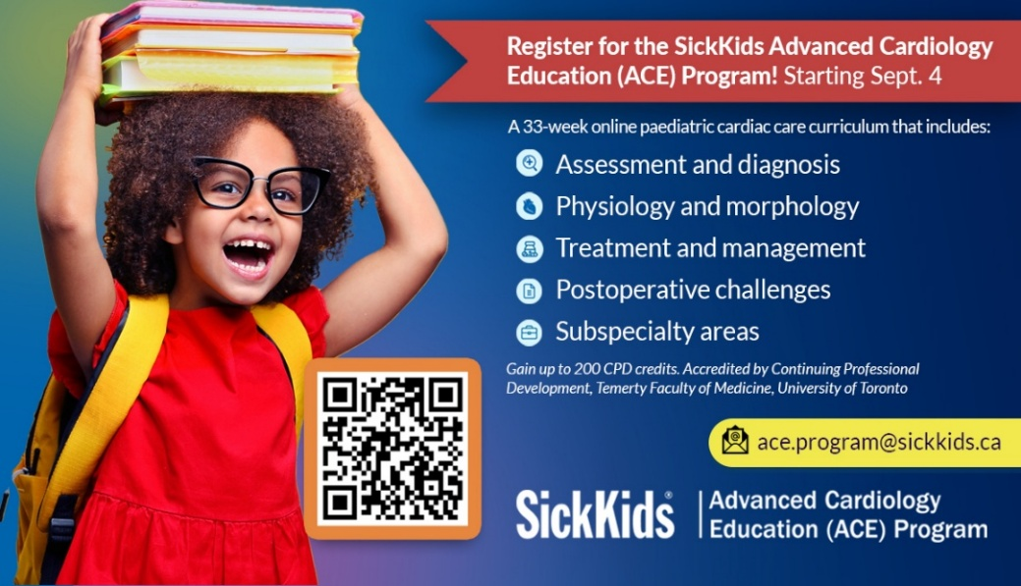
Register today to support your practice and expand your professional network. The SickKids ACE Program offers critical care nurses the opportunity to learn from renowned SickKids faculty and connect with interprofessional peers from around the world. With over 100experts contributing to the program, participants gain practical insights into assessment, diagnosis, treatment, post-operative challenges, and other essential areas of paediatric cardiac care. Live sessions are held every Friday from 9:00 a.m. to 4:30 p.m. Eastern Time and are available on demand for flexible review. Participants may also earn up to 200 learning credits and an accredited Advanced Certificate of Completion.

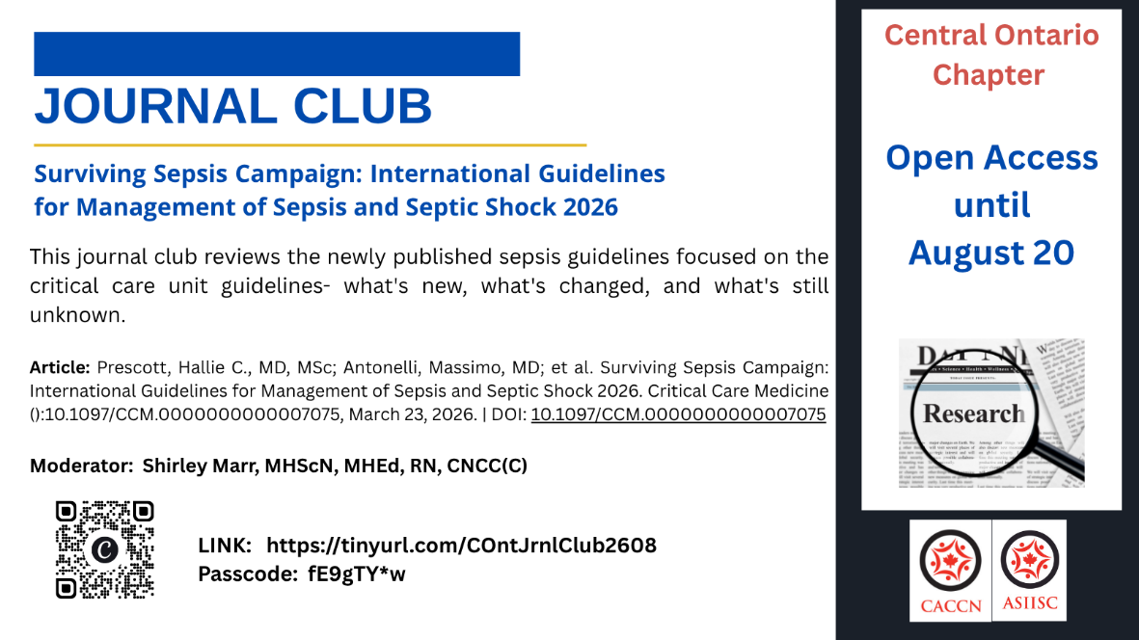

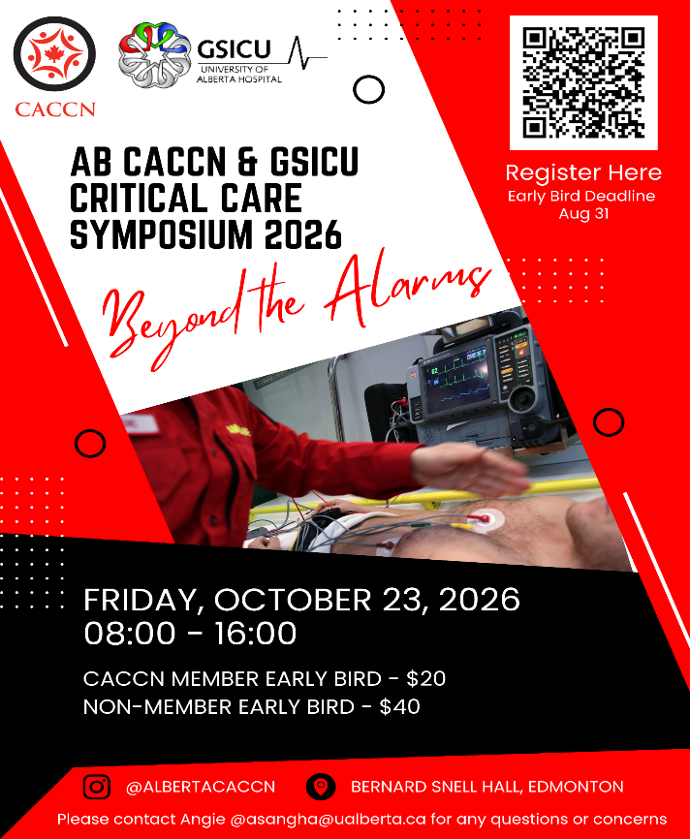
Educational Events
Beyond Tidal Volume: Driving Pressure and Lung-Protective Ventilation in PICU
20 August 2026 10:30 AM ET
The 8th session of the WFPICCS Pediatric Respiratory Critical Care Series(PRCCS) will explore “Beyond Tidal Volume: Driving Pressure and Lung-Protective Ventilation in PICU” and discuss how driving pressure can support faster, safer, more effective mechanical ventilation in critically ill children.
Registration: https://us02web.zoom.us/meeting/register/-5udVKgrQrW-KwqnX2n_MQ#/registration

“Safe care for noncommunicable diseases”
ISMP – Med Safety Exchange
Wednesday, September 16, 2026
Join your colleagues across Canada for complimentary 50-minutewebinars to share, learn and discuss incident reports, trends and emerging issues in medication safety!
Registration: https://us02web.zoom.us/webinar/register/WN_XoEXd_xJRCaWz1OMNrBXKA#/registration

