
July 2026

DO YOU HAVE STRONG CLINICAL EXPERTISE IN NEUROCRITICAL CARE?

CACCN has recently connected with two neurocritical care physicians who are eager to partner with us in bringing nurses and other clinicians together from across Canada.
Together, we aim to: Build a strong national network of neurocritical care providers and Expand access to timely, high-quality neurocritical care education across Canada.
If you are passionate about advancing neurocritical care and have the skills and experience to organize and deliver timely education, we would love to hear from you.
Please email your expression of interest to president@caccn.ca with a copy to vicepresident@caccn.ca by July 15.
We will compile a list of interested nurses and connect you with the physician partners to help move this important work forward.

Office Closure
CACCN National office
will be CLOSED
July 10
July 13 to 17
July 20 to 24
Email and telephone messages will not be monitored during this time.

IMPORTANT
INFORMATION

Payment Processor Change

What is changing
CACCN is moving to a new payment processor.
Timing
The new payment processor will launch in early August 2026.
What does this mean for members
Members on continuous renewal at this time will be required to renew their membership through the website or a direct link provided in the renewal email which will be sent 45 to 60 days before renewal.
Continuous Renewal FAQs
The FAQs will remain unchanged.
Email Notification
Email notification of the transition was sent to all members on July 3, 2026.



New & Returning Members!

Thank you for your
membership and support!

We look forward to your participation in your specialty nursing association!

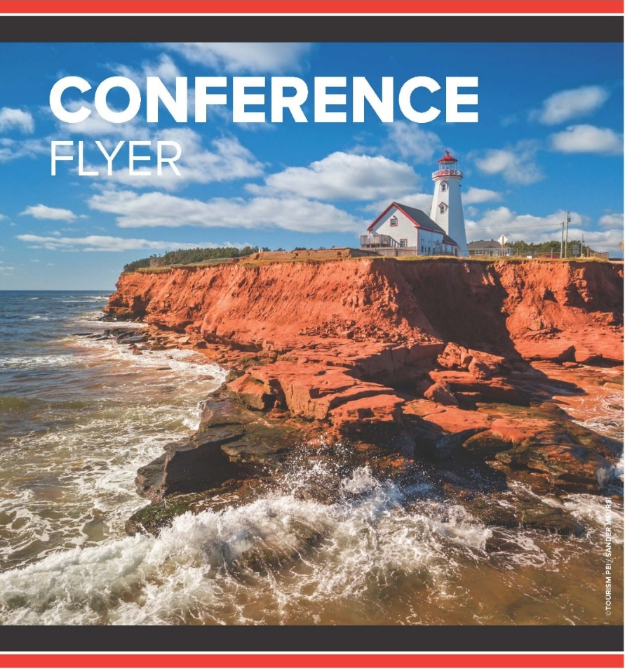
Ready to Learn More
Visit the conference webpage!
https://caccn.ca/2026-canadian-critical-care-nursing-conference/

Stay Close to the Action
Book your stay at the Delta Prince Edward for convenient access to the conference.
Travel Discounts Available
Take advantage of travel codes for Air Canada and WestJet when planning your trip.
Turn your conference into a getaway.
Discover what PEI has to offer and start planning your visit here: https://www.tourismpei.com/

JOIN US IN SEPTEMBER!
Save Your Spot Today!
Canadian Critical Care
Nursing Conference 2026
Join critical care nurses from across Canada in beautiful Charlottetown, PE - September 29–30
#CCNC2026

Why You’ll Want to Be There
- Two preconference events on September 28 to help you kick off your conference experience
- Two full days of inspiring education designed for critical care nursing professionals
- Earn 12 continuing learning hours while investing in your professional growth
- Connect with peers through networking, posters, and exhibits
- Dinner & Learn event for even more opportunities to connect and learn
- Enjoy Nurses Night Out on September 29 and make the most of your time with colleagues

Register Early and Save
- Early bird member rates:
- 2-day conference: $550 plus HST (15%)
- 1-day conference: $300 plus HST (15%)
Early bird pricing ends August 24
— don’t miss out.
Register and pay before the early bird deadline for your chance to win your tuition.
Registration closes September 10


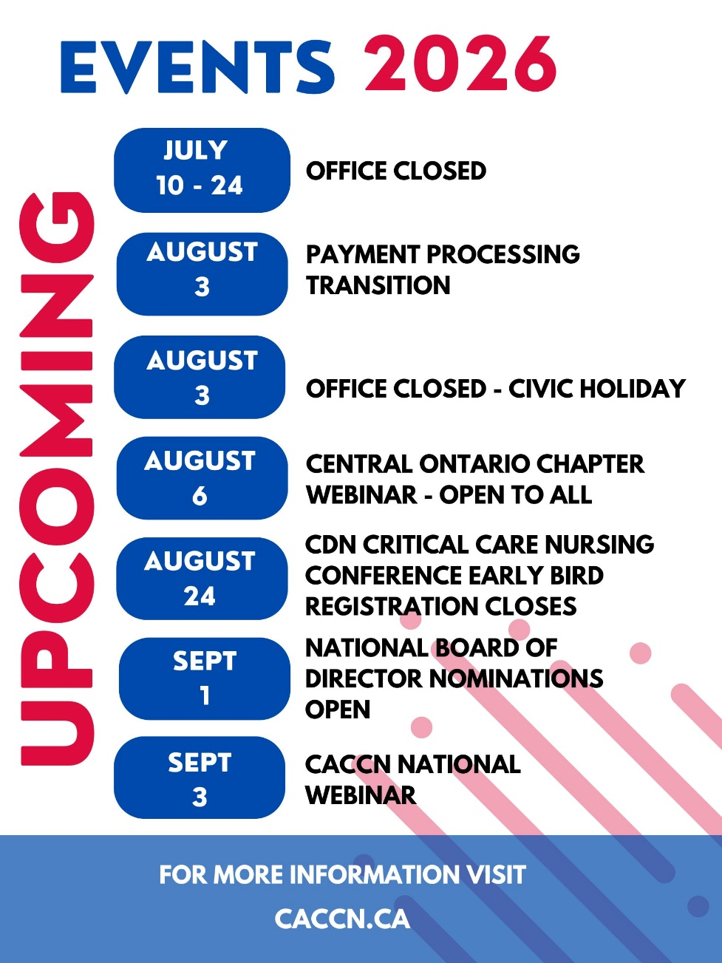

What happens when the job of caring for others begins to affect your own health? For many nurses living with Chronic Hand Eczema, the impact extends far beyond their hands. It can influence their confidence, their daily work, and even their career choices.
🎙️Watch on Amplify,
Marley Gregorio
CACCN Vice President
shares the often-overlooked realities of living and working with
Chronic Hand Eczema
—and why greater awareness and support for healthcare workers are so important.
Watch now: https://patientvoicepartners.com/more-than-skin-deep/

CACCN
Specialty Certification Bursaries

CACCN offers bursaries to support members pursuing initial or renewal Critical Care Nursing Certification.

Initial Certification
If you successfully write the Critical Care Nursing Certification examination through the Canadian Nurses Association in 2026, and were successful, you may be eligible to apply for the CACCN Initial Certification Bursary. Two bursaries are available. Each bursary is valued at $500.

Renewal Certification
If you successfully renew your certification in 2026, you may be eligible to apply for the CACCN Renewal Certification Bursary. Four bursaries are available. Each bursary is valued at $250.

Criteria at
Awards, Grants and Bursaries.


Special Standards issue
July 2026

https://cjccn.ca/

Revising the Canadian Association of Critical Care Nurses Standards for Critical Care Nursing Practice: A Modified Delphi Protocol (published Oct 2023)

Canadian Critical Care Nursing Standards Revision Part 1: A Scoping Review

Revising the Canadian Standards of Critical Care Nursing Practice 6th Edition: Part 2 - A Modified Delphi Process

Canadian Standards for Critical Care Nursing Practice 6th Ed.



Register today to support your practice and expand your professional network. The SickKids ACE Program offers critical care nurses the opportunity to learn from renowned SickKids faculty and connect with interprofessional peers from around the world. With over 100experts contributing to the program, participants gain practical insights into assessment, diagnosis, treatment, post-operative challenges, and other essential areas of paediatric cardiac care. Live sessions are held every Friday from 9:00 a.m. to 4:30 p.m. Eastern Time and are available on demand for flexible review. Participants may also earn up to 200 learning credits and an accredited Advanced Certificate of Completion.

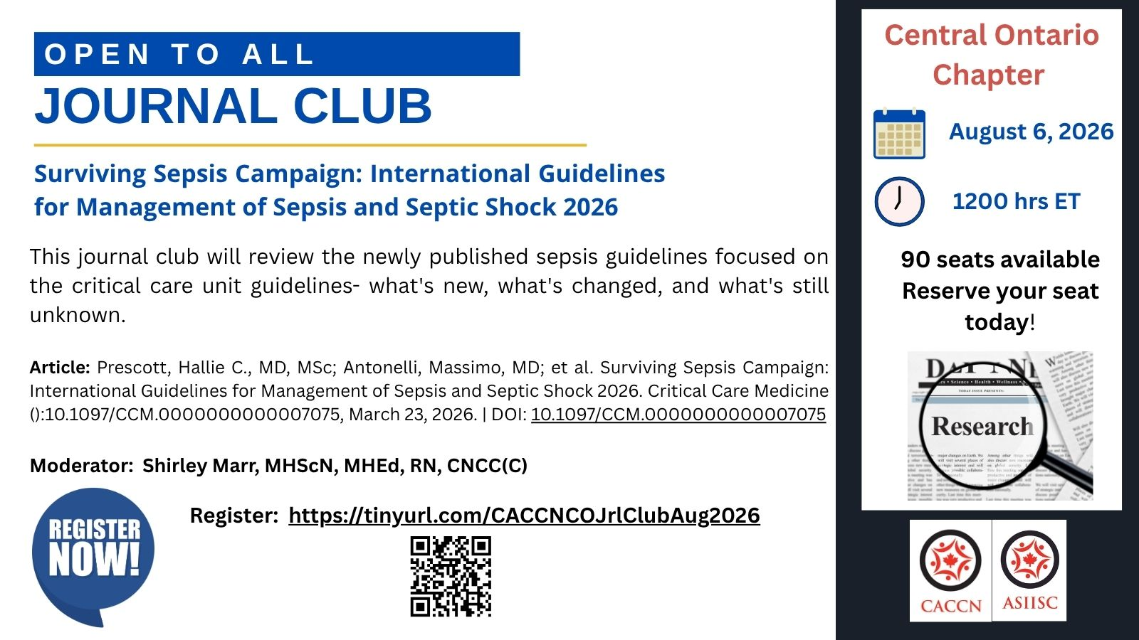

BOARD OF DIRECTOR NOMINATIONS

CACCN will be seeking an
interested Association member to serve as a volunteer Board Member on the National Board of Directors for a two-year term from May 1, 2027, to April 30, 2029.

Region Central

Region Eligibility
CACCN Members from Manitoba and Ontario

Position(s) One (1)

Eligibility Criteria
Active current member of CACCN, holding a registered nursing license, and currently working in critical care.

Why Serve on the Board?
Serving on the Board is an opportunity to use your skills, experience, and voice to make a meaningful impact in your specialty nursing association. As a Board Member, you will help provide governance and operational leadership, support strategic direction, and contribute to the Association’s long-term strength and sustainability.

Ideal Candidate Profile
- Passionate about critical care nursing
- Enthusiastic, creative,
- and positive in their approach
- Collaborative and comfortable
- working as part of a team
- Able to contribute thoughtful leadership
- and sound judgment
- Interested in supporting Association growth and sustainability

Previous experience in a not-for-profit setting is considered an asset; however, a strong commitment to CACCN’s mission is most important.

More information: CACCN AGM

PUBLICATIONS
Reported contributors to communication vulnerability for adult patients in critical care
Intensive and Critical Care Nursing
https://www.sciencedirect.com/science/article/pii/S0964339725002939

A Reflection on Current Definitions of Critical Care and Critical Illness—A Narrative Review of the Literature
BACCN Nursing
https://doi.org/10.1111/nicc.70311

Health care’s nursing shortage: how nurses can lead the change
Canadian Nurse
https://www.canadian-nurse.com/blogs/cn-content/2026/06/08/nursing-shortage-how-nurses-can-lead-the-change?_zs=71I9O1&_zl=OiNj3

“Do we still need physical restraints in ICU? No!”
Intensive and Critical Care Nursing
https://www.sciencedirect.com/science/article/pii/S0964339725003246

Methods to monitor and evaluate neuromuscular blockade use in intensive care unit patients with hypoxemic respiratory failure and acute respiratory distress syndrome: a scoping review
Canadian Journal of Anesthesia
https://link.springer.com/article/10.1007/s12630-026-03127-1

Nurses’ experiences of end-of-life communication with children who have life-threatening conditions in paediatric intensive care units: a qualitative descriptive study
BMC Palliative Care
https://link.springer.com/article/10.1186/s12904-026-02007-1

Who gets to belong in nursing? What our students are telling us
Canadian Nurse
https://www.canadian-nurse.com/blogs/cn-content/2026/06/29/who-gets-to-belong-in-nursing?_zs=71I9O1&_zl=SiNj3

The implementation of a noise reduction bundle in the intensive care unit: A qualitative process evaluation
Intensive and Critical Care Nursing
https://www.sciencedirect.com/science/article/pii/S0964339725003672

Effects of high-fidelity simulation in the management of cardiac arrest among emergency and critical care nurses: A randomized trial
International Journal of Africa Nursing Science
https://www.sciencedirect.com/science/article/pii/S2214139126000351

Choosing Wisely Recommendation
Ditch the dipstick: the important role of the nurse leader in supporting quality improvement in health care
Canadian Nurse
https://www.canadian-nurse.com/blogs/cn-content/2026/06/22/ditch-the-dipstick?_zs=71I9O1&_zl=PiNj3

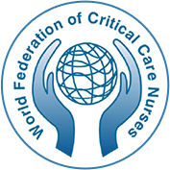

International Journal of Critical Care

Seeking Expressions of Interest for Peer Reviewers

The World Federation of Critical Care Nurses (WFCCN) is seeking expressions of interest for the role of Peer Reviewers of its journal, International Journal of Critical Care.
The peer reviewers support and respond to requests for peer review from the Editors, Associate Editors, a paid Managing Editor.

The International Journal of Critical Care endeavours to be a truly global vehicle for sharing the latest research, initiatives, policy advice, and achievements in critical care. The journal is open access and is provided online free of charge to all via the WFCCN website.

See: https://wfccn-ijcc.com/index.php/ijcc

Requirements

- Fluent in the English Language
- Must have a reliable e-mail address
- Good publication record and experience
- A passion for critical care nursing, scholarship and excellence

Expressions of interest with a cover letter and detailed CV should be emailed to Executive Officer of WFCCN at: wfccnexecutiveofficer@wfccn.org.

Closing date: 30 July 2026.

Seeking
Peer Reviewers
for the CJCCN.

Peer Reviewer criteria:

- Demonstrates expertise in critical care, content, and/or methodology.
- Holds a graduate degree: minimum master’s degree (MN, MScN, MSc.).
- Has previously published or is familiar with the publication process (preferred).
- Has experience as a peer reviewer with other journals (preferred).

Apply now:

https://cjccn.ca/call-for-peer-reviewers-external/

