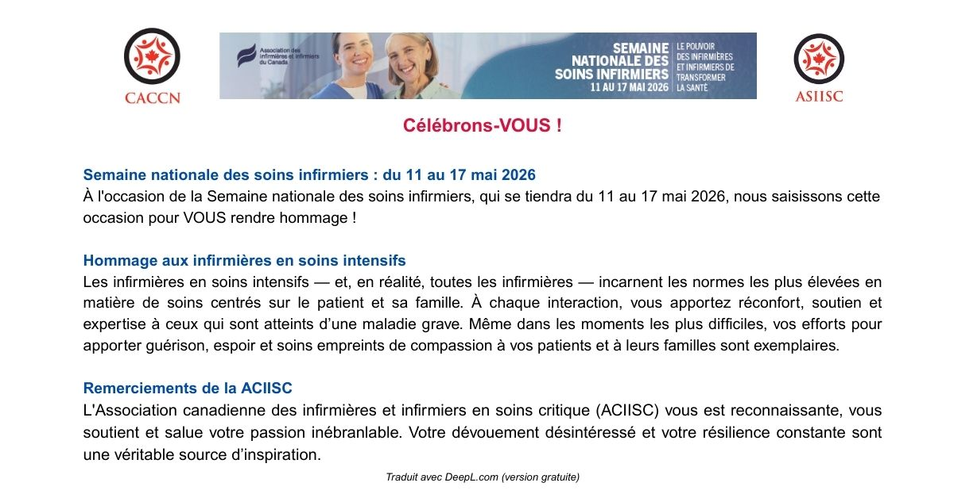
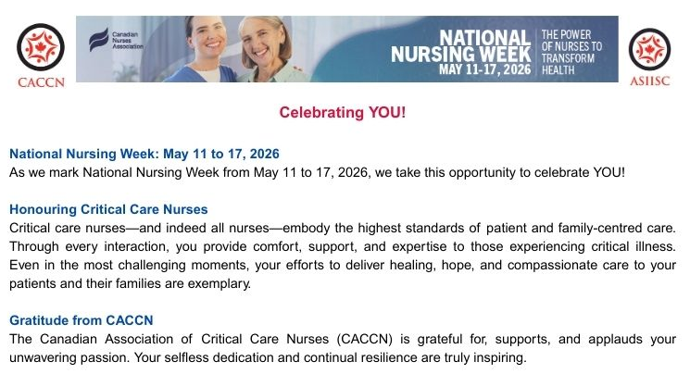
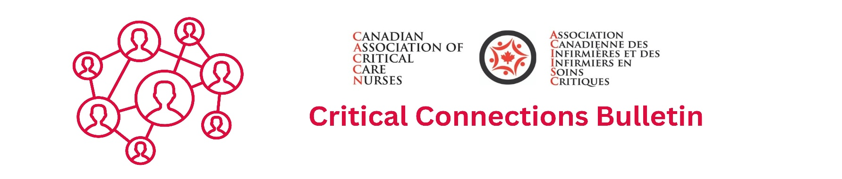
May 2026


Membership Renewals
Notification of upcoming membership renewal is sent by email approximately
45 days prior to the renewal!
May 31 renewal notifications were issued in early April via email.
Know the Continuous Renewal FAQs

Nursing Week Draw
Early Bird registration for the Canadian Critical Care Nursing Conference 2026
being held September 29 and 30, 2026 in Charlottetown, PE.

Criteria: be a current / active
member of the CACCN
at the time of submitting for the draw

Apply by May 17, 2026
https://www.zeffy.com/en-CA/ticketing/caccn-nursing-week-tuition-draw


New and Renewing members!
Thank you for your participation
and support!

SURVEY PARTICIPATION
Understanding Health Care Providers knowledge, experience, and perceived barriers to organ donation in Canada.
This survey, conducted nationally by Give Life Alberta and the University of Calgary, investigates healthcare providers’ knowledge, experiences, and perceived challenges regarding organ donation in Canada.
Link to Survey

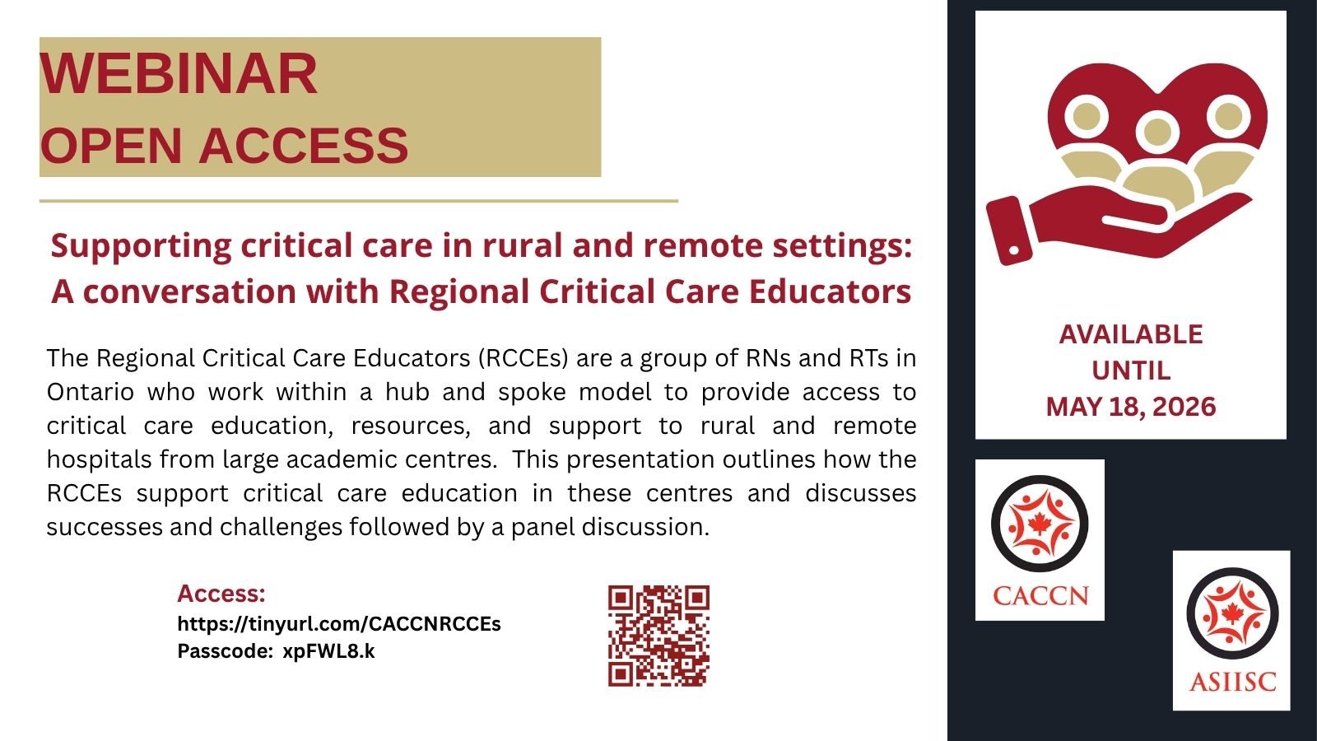
AWARDS, GRANTS, and BURSARIES

Are you conducting a research study? Apply for the CACCN Research Award provided to a critical care nurse who is the investigator of a research study that is relevant to the practice of critical care nursing.

Review the Overall
and Award specific criteria!

Submission deadline is June 1

View awards, grants, and bursaries: https://caccn.ca/awardsandrecognition/



Each year, we proudly honour nursing excellence in our specialty!

Our Awards, Grants and Bursaries celebrate individual & group excellence, expertise, outstanding achievements, professional development, and contributions to the association and our critical care specialty.

Apply or nominate for the Brenda Morgan Leadership Excellence Award, presented to a critical care nurse who, on a consistent basis demonstrates outstanding performance in leadership in CACCN and critical care.

Apply or nominate for the BBraun Sharing Expertise Award if you or a colleague exhibits stellar leadership, mentor and / or precept in critical care, advocate for your patients and families, are a champion for your nursing colleagues, support, encourage & share nursing expertise demonstrate a commitment to guiding novice to senior nursing colleagues, engage in continuous learning & professional development?

Apply for the Spacelabs Innovative Project Awards presented to a critical care nurse or group of critical care nurses who develop a project that will enhance their professional development.

Planning an event for Canadian Intensive Care Week? Apply for the Canadian Intensive Care Week “Spotlight” Challenge, presented to a group of critical care nurses who develop an activity and/or event to profile their local Critical Care Team during Canadian Intensive Care Week held annually in October.

Apply or nominate for the CACCN Chasing Excellence Award presented to Presented to a critical care nurse who consistently demonstrates excellence in critical care nursing practice.

Are you going to school? Apply for the CACCN Education Bursary, presented to assist a critical care nurse to pursue Master’s or Doctoral education with a focus on critical care nursing.

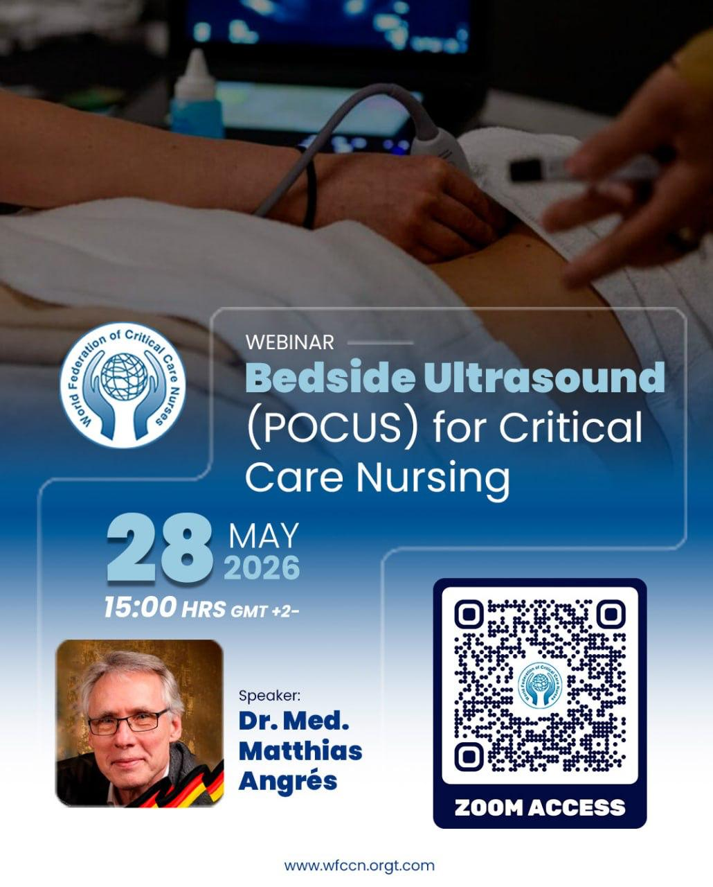

EVENTS

18 juin
Humidité optimale : un élément essentiel des soins prodigués aux patients sous ventilation non invasive et invasive
OUVERT À TOUTES LES INFIRMIÈRES
90 PLACES DISPONIBLES

Registration information
https://caccn.ca/upcoming-events/



Canadian Critical Care Society
20th Canadian Critical Care Review!
June 12-13, 2026
https://www.canadiancriticalcare.org/2026-CCCR-registration

May 19
Montreal Chapter Joint Education Day with CVAA Quebec!

May 27
Southwestern Ontario Chapter Joint Education Day with CVAA SW Ontario!

June 11
A Second Chance at Life: The Nurse’s Role in the Journey of Living Donation
Sponsored by Canadian Blood Services
OPEN to all – 90 seats available

June 17
Optimal Humidity: An Essential Component of Care for Non-invasive & Invasively Ventilated Patients
Sponsored by Fisher and Paykel Healthcare
OPEN to all – 90 seats available

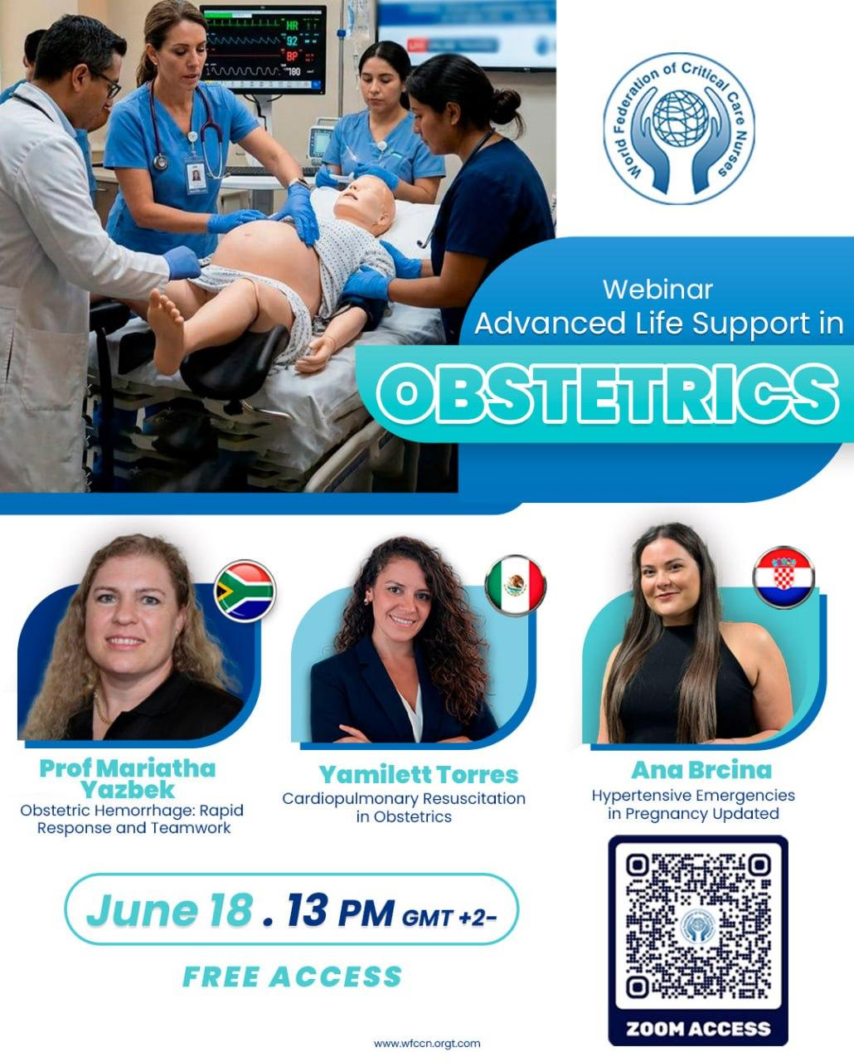

Under the hood:

How modern ventilators really work?

WFPICCS’ Pediatric Respiratory

Critical Care Series (PRCCS)

May 20 @ 1430 CEST

Registration

https://wfpiccs.org/event/under-the-hood-how-modern-ventilators-really-work/


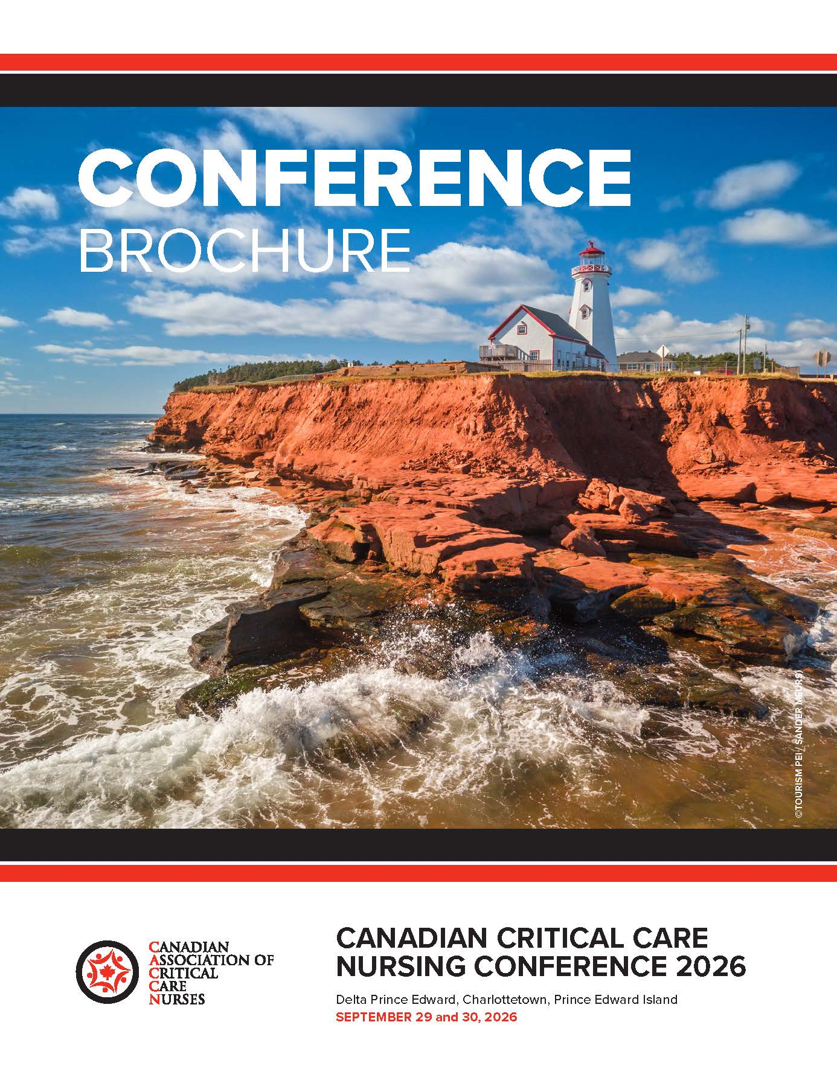
JOIN US IN CHARLOTTETOWN!

Registration
opening early June 2026!

Watch for the conference flyer to arrive in your unit and the conference brochure to go live on our website.

- Tuition Fees
- Hotel Reservation
- Travel Codes

Available on the CACCN Website
https://caccn.ca/2026-canadian-critical-care-nursing-conference/


The Canadian Association of Critical Care Nurses (CACCN) is seeking enthusiastic, engaged members to join the Member Relations Committee. This national committee plays a key role in strengthening the CACCN community, supporting chapters, and enhancing the value of membership across Canada.
The Member Relations Committee focuses on: Supporting recruitment and retention of CACCN members; Strengthening engagement with chapters across the country; Developing tools and resources to promote membership; and Highlighting member achievements and contributions. This is a collaborative, supportive committee where your ideas and energy can make a meaningful impact.
We welcome CACCN members who: Enjoy connecting with others; Want to contribute to national initiatives; Can commit a small amount of time each month; Value teamwork and communication; No previous committee experience is required, just enthusiasm and a willingness to participate.
We recognize that critical care nurses are busy professionals. This committee is designed to be manageable: 1 meeting bi-monthly (approximately 1 hour); 1–2 hours monthly for small tasks or projects; and Flexible, supportive, and realistic expectations.
What is in it for you: Experience contributing to a national professional organization; Opportunities to build leadership and communication skills; Connections with critical care nurses across Canada; A chance to influence membership initiatives and support the growth of CACCN; and Continuing Learning Hours - 25 hours annually.
If you are passionate about critical care nursing and want to help shape the future of our national association, we would love to hear from you.
If you would like to join or learn more, please email:
memberrelations@caccn.ca by June 12, 2026.

Seeking Member Participants – Member Relations Committee
Opportunity – Canadian Intensive Care Foundation (CICF) Board of Directors
The CICF Board of Directors meets four times per year, with the Annual General Meeting held in late November or December.

Criteria for Applicants

To be considered for this position, applicants must have:
- Clinical experience in a Canadian critical care setting.
- Interest in research and education grant administration.
- Demonstrated experience with fundraising initiatives.
- A current CICF membership ($25/year).
Reporting Requirements
The successful candidate will be responsible for submitting short written reports to the CACCN Board of Directors four times a year, in alignment with the CICF meeting schedule.

Application Process
CACCN Members interested in applying are asked to send the following information to caccn@caccn.ca by May 31, 2026:
- Letter of Interest
- Resume or Curriculum Vitae
Applications will be reviewed by the CACCN Vice President / Chair of the CACCN Partner Relations Committee prior to being submitted to CICF for final selection.



Overview

The Canadian Intensive Care Foundation (CICF) is seeking a representative from the Canadian Association of Critical Care Nurses (CACCN) to join its Board of Directors.
CICF was founded as a not-for-profit organization to advance critical care research and education through dedicated funding. Since its inception, CICF has allocated nearly $1.5 million in funding to support research and education led by physicians, nurses, and respiratory therapists. Through membership fees and donations, Canadians contribute directly to advancing these initiatives in critical care settings.
CICF is actively working to expand its impact, to ensure its resources and funding opportunities are available across Canada.
Website: https://www.cicf.ca/

Position Details
The CICF is seeking a CACCN member with critical care nursing experience to serve on its Board of Directors.
This is a meaningful opportunity to shape the direction of critical care research and education at the national level.
As a Director of the Foundation, you will contribute to governing the Foundation in accordance with its by-laws, acting in good faith with a view to the best interests of CICF.
Board responsibilities include, but are not limited to:
- Attending all scheduled CICF Board meetings.
- Participating in strategic planning and organizational oversight.
- Contributing to decisions on research and education funding allocations.
- Supporting fundraising and donor engagement initiatives.
- Serving on Board committees as needed (e.g., Strategic Planning, Membership, Nominations).
- Helping expand CICF’s national reach and impact.

PUBLICATIONS
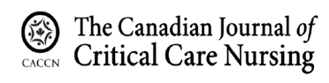
Volume 37, Issue 1, 2026

https://cjccn.ca/

Perspectives of Non-Speaking ICU Patients and their Families on Goals-of-Care and End-of-Life Discussions

Cultural adaptation in Quebec of the COMHON index: a tool for assessing the risk of pressure injury in critically ill patients

Practical Strategies for Hospital-Based Nurses to Write and Publish from the Bedside

Medication Safety Practice Corner: Anatomy of an incident analysis – Part 2

Practice Pearls: Before Calling It a Failed Sedation Vacation: Nursing Considerations
______________________________________________

Caring Amid Complexity: Intensive Care Nurses' Perceptions and Experiences of End‐Of‐Life Care—A Qualitative Study
BACCN Nursing in Critical Care
https://onlinelibrary.wiley.com/doi/10.1111/nicc.70278

MOSHI 2: An exploration of key safety concerns, mitigations and adaptive capacity arising from the use of safety huddles in ICUs across the United Kingdom − A cross-sectional national e-survey
Intensive and Critical Care
https://www.sciencedirect.com/science/article/pii/S0964339726000790

Care and support needs of families in the first 9 months after PICU discharge: A multi-center, longitudinal, qualitative study
Intensive and Critical Care
https://www.sciencedirect.com/science/article/pii/S096433972600025X

Addressing the nursing shortage in Canada: the need for PhD-prepared nurses to lead transformative change
Canadian Nurse
https://www.canadian-nurse.com/blogs/cn-content/2026/04/20/need-for-phd-prepared-nurses?_zs=71I9O1&_zl=TNGh3

Integrative therapy approaches in critical care: A survey of Canadian critical care nurses’ practices, knowledge, and views
Australian Critical Care
https://doi.org/10.1016/j.aucc.2025.101519

Addressing the nursing shortage in Canada: the need for PhD-prepared nurses to lead transformative change
Canadian Nurse
https://www.canadian-nurse.com/blogs/cn-content/2026/04/20/need-for-phd-prepared-nurses?_zs=71I9O1&_zl=TNGh3

Critical care nurses’ lived experience of compassion fatigue in the intensive care unit: A phenomenological study
Australian Critical Care
https://doi.org/10.1016/j.aucc.2025.101460

Lifelong learning tendencies, counseling self-efficacy, professional self-doubt, and perceptions of nursing excellence among emergency and critical care nurses: A cross-sectional study
Applied Nursing Research
https://doi.org/10.1016/j.apnr.2026.152062

Critical Care Nurses' Perceptions and Experiences of the Organ Donation Process: A Systematic Review
Nursing Open
https://doi.org/10.1002/nop2.70420

Caring for Dying Patients: Understanding Critical Care Nurses’ Experiences
Dimensions in Critical Care Nursing
https://journals.lww.com/dccnjournal/abstract/2026/03000/caring_for_dying_patients__understanding_critical.7.aspx

Insights Into Factors Affecting Nurses’ Knowledge of and Attitudes Toward AI and Implications for Successful AI Integration in Critical Care: Cross-Sectional Study
JMIR Publications
https://nursing.jmir.org/2026/1/e85649/

