
April 2026

New and Renewing members! Thank you for your participation and support!

CHAPTER EVENTS

Virtual ANTT® Symposium
Thursday April 30, 2026
11:00am – 2:00pm ET

2026 Virtual Symposium focused on Aseptic Non-Touch Technique (ANTT®)! This is a virtual opportunity to come together and learn from ANTT® founders, clinical experts, and industry.

Three hours
Three unique learning sessions
Free for all!

Register by April 20!

Saskatchewan
April 23 - Education Night
BRAIN WAVE, a look into EEG's
In person, virtual & recording tickets available

May 6 - Education Night
Organ Donation
In person, virtual & recording tickets available

Montreal Chapter
May 19 - Joint Education Day with
CVAA Quebec!

Southwestern Ontario Chapter
May 27 - Joint Education Day with
CVAA SW Ontario!

Registration information
https://caccn.ca/upcoming-events/

or CACCN Chapters
https://caccn.ca/chapters/

Discount Codes - Members only!
https://caccn.ca/login/
or Scan the QR Code






Notification of upcoming membership renewal is sent by email approximately 45 days prior to the renewal!
April 30 renewal notifications were issued
in early March via email.
Know the Continuous Renewal FAQs


Upcoming Webinar - April 16

Lung Recruitment and prone positioning in pediatric ventilation

Registration

Webinar Recording Available

The lung as a spring: Compliance, resistance, and work of breathing

NATIONAL EVENTS


A Second Chance at Life: The Nurse’s Role in the Journey of Living Donation
Sponsored by Canadian Blood Services

June 11 @ 1200 hrs ET
OPEN to all – 90 seats available

Registration
https://www.zeffy.com/en-CA/ticketing/caccn-national-webinar

Optimal Humidity: An Essential Component of Care for Non-invasive & Invasively Ventilated Patients
Sponsored by Fisher and Paykel Healthcare

June 17 @ 1200 hrs ET
OPEN to all – 90 seats available

Registration
https://www.zeffy.com/en-CA/ticketing/caccn-webinar-optimal-humidity-an-essential-component-of-care-for-non-invasive-and-invasively-ventilated-patients

Humidité optimale : un élément essentiel des soins prodigués aux patients sous ventilation non invasive et invasive
Parrainé par Fisher and Paykel Healthcare

18 Juin @ 12 h 00 (heure de l’Est)
90 places disponibles

Inscriptions
https://www.zeffy.com/fr-CA/ticketing/webinaire-caccn-national-une-humidite-optimale

Registration information
https://caccn.ca/upcoming-events/





SURVEY PARTICIPATION
ONTARIO NURSES!
A CACCN MEMBER NEEDS YOUR PARTICIPATION! PLEASE SHARE WITH YOUR COLLEAGUES!
Nurses’ perceptions and experiences of caring for critically ill patients in rural hospitals. The intersection of critical illness and rurality within a publicly funded healthcare system in Ontario.
The purpose of this study is to explore the perceptions and experiences of nurses who care for critically ill patients in rural healthcare settings in Ontario.
We seek to understand how the services and resources available to rural hospitals, as directed by Provincial guidelines, intersect with lived experience of nurses caring for a critically ill patient in a rural hospital.
Information:
https://caccn.ca/wp-content/uploads/2026/03/Invitation-to-Participate-Feb-2.pdf

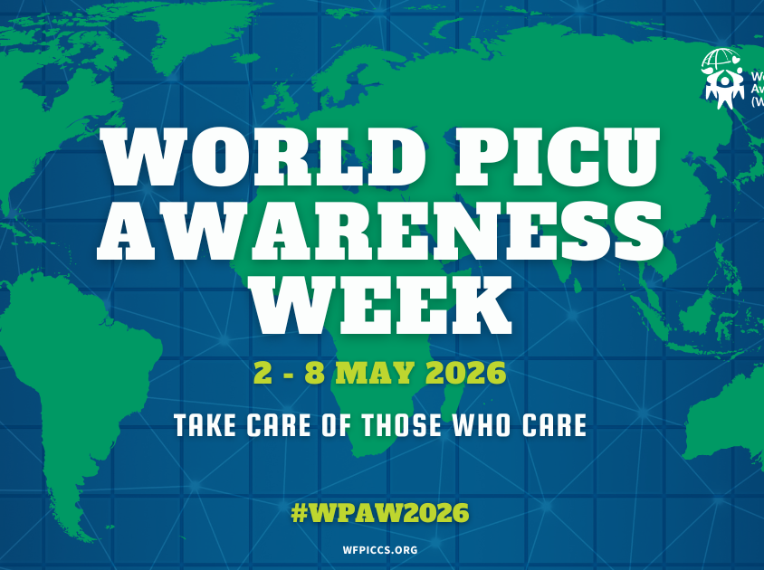



More information
https://wfpiccs.org/2026-world-picu-awareness-week-day/

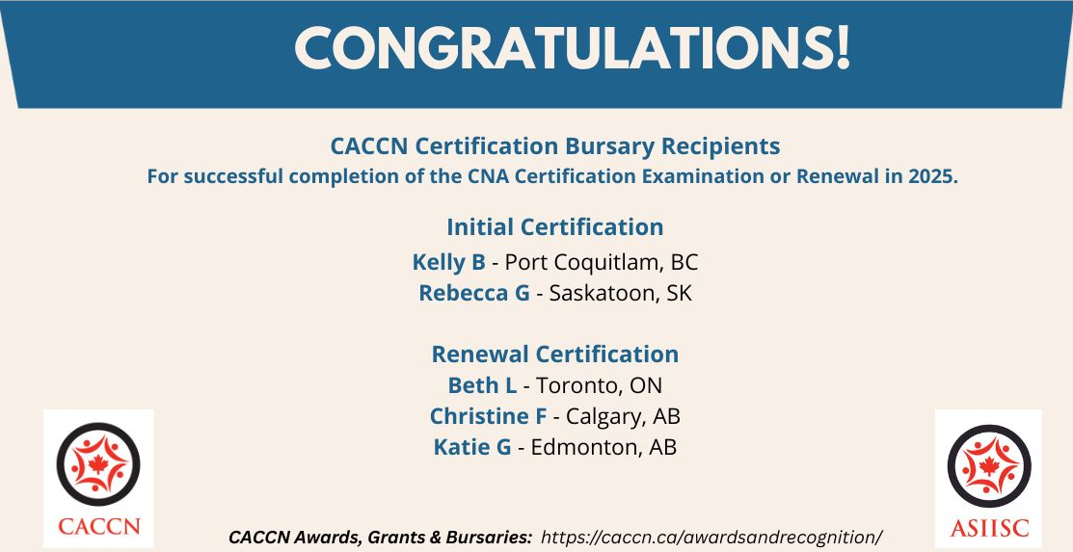

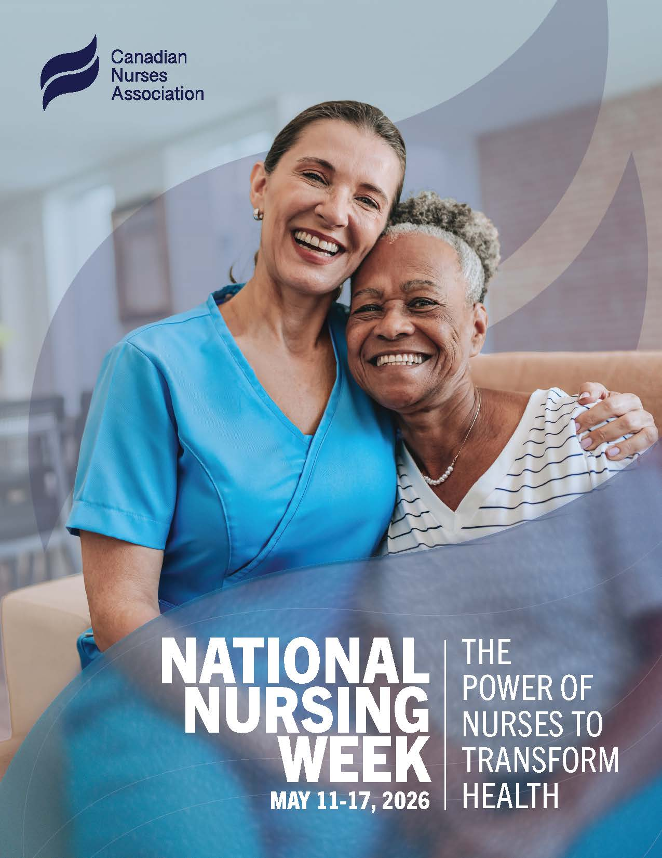
Nursing Week Draw


Early Bird registration for the Canadian Critical Care Nursing Conference 2026
being held September 29 and 30, 2026 in Charlottetown, PE.

Criteria: be a current / active member of the CACCN

Apply by May 17, 2026
Winner will be drawn by random draw.

https://www.zeffy.com/en-CA/ticketing/caccn-nursing-week-tuition-draw


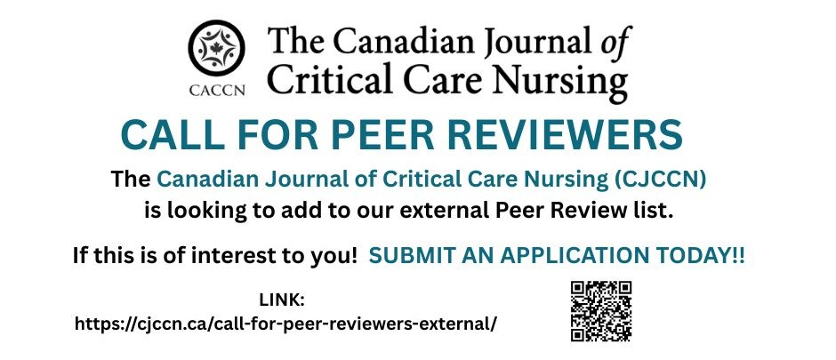

Adult and Children’s guidelines
These guidelines were developed through a joint initiative of the Society of Critical Care Medicine (SCCM) and the European Society of Intensive Care Medicine (ESICM), led by multidisciplinary international experts who are committed to reducing mortality and morbidity from sepsis and septic shock, which are leading causes of death worldwide.
Adult: https://sccm.org/survivingsepsiscampaign/guidelines-and-resources/surviving-sepsis-campaign-adult-guidelines
Children's: https://sccm.org/survivingsepsiscampaign/guidelines-and-resources/surviving-sepsis-campaign-pediatric-guidelines


Participate in the 6th World Sepsis Congress, taking place on April 22-23. Titled "Universal Sepsis Care for Newborns, Children, and Women", this free online congress will feature 15 distinctive sessions over two days (including 2 panel discussions), throughout which globally renowned clinicians, researchers, experts, and thought leaders will cover sepsis prevention, maternal and neonatal care, pediatric critical care, health system solutions, and much more. Register: https://www.worldsepsiscongress.org/

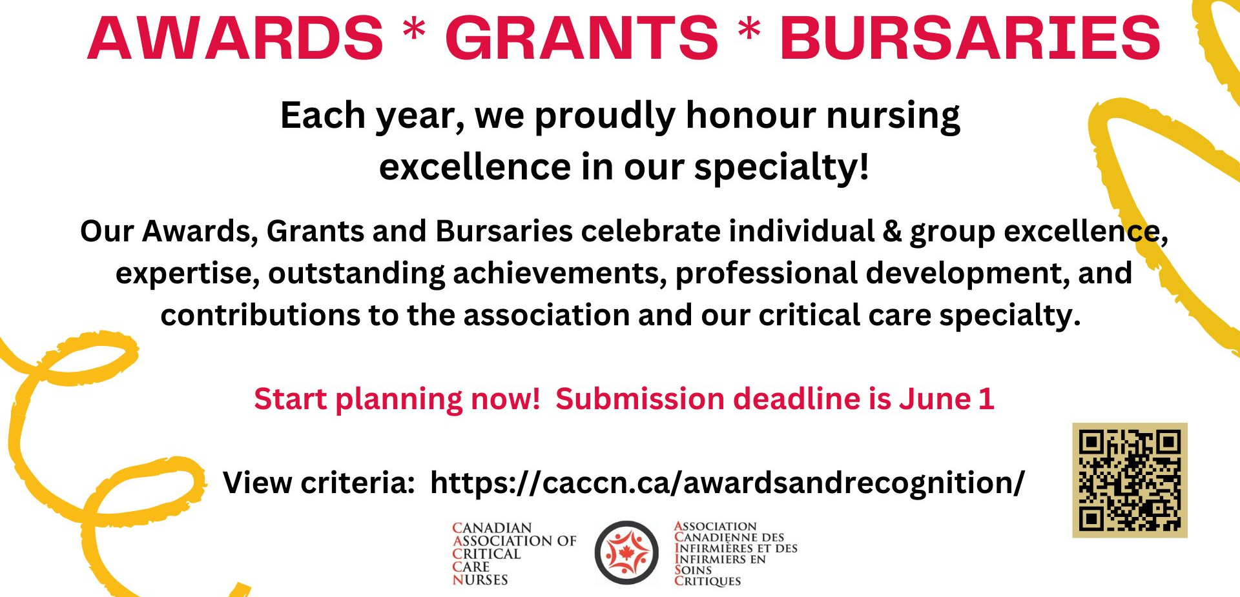

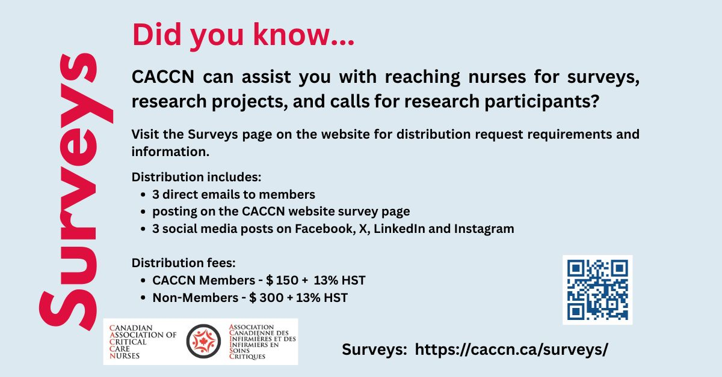
PUBLICATIONS
Justice-Oriented Critical Care in the Pediatric Intensive Care Unit: A Nursing Analysis of Barriers, Needs, and Opportunities
Nursing Inquiry
https://doi.org/10.1111/nin.70084

Leadership facilitation strategies to establish evidence-based practice in an acute care hospital
Journal of Advanced Nursing
https://doi.org/10.1111/j.1365-2648.2012.06053.x

Leadership strategies to promote frontline nursing staff engagement
Nursing Management
https://journals.lww.com/nursingmanagement/fulltext/2020/02000/leadership_strategies_to_promote_frontline_nursing.11.aspx

Leading evidence-based practice: nurse managers’ strategies for knowledge utilisation in acute care settings
BMC Nursing
https://link.springer.com/article/10.1186/s12912-025-02912-5

Newly Licensed Nurse Retention
What a 5-Year Review of Data Tells Us
Nursing Administration Quarterly
10.1097/NAQ.0000000000000735

Exploring the Ethical Dimensions of AI-Driven Patient Monitoring in Critical Care Nursing: A Systematic Review
BACCN Nursing
https://doi.org/10.1111/nicc.70384

Building an Equity-Centered Nursing Leadership Workforce: A Framework for Transformative Change
Journal of Advanced Nursing
https://onlinelibrary.wiley.com/doi/full/10.1111/jan.17097

Postoperative Coronary Artery Bypass Graft Readmissions in Rural, Remote, and Northern Communities: A Case-Control Study Focused on the Social Determinants of Health
Canadian Journal of Cardiovascular Nursing
https://cccn.ca/_uploads/695e737855af6.pdf

Health-care workers are not heroes
Canadian Nurse
https://www.canadian-nurse.com/blogs/cn-content/2026/03/23/health-care-workers-are-not-heroes?_zs=71I9O1&_zl=n6Of3

Nurses’ Experience in Providing End-of-Life Care in Intensive Care Unit: A Scoping Review
Healthcare
https://doi.org/10.3390/healthcare14030417

Feeding at the end of life: a pediatric nurse’s dilemma
Canadian Nurse
https://www.canadian-nurse.com/blogs/cn-content/2026/03/30/feeding-at-the-end-of-life?_zs=71I9O1&_zl=o6Of3

Roles and responsibilities of nurses in mechanical ventilation in pediatric intensive care units: a national survey in Austria
BMC Nursing
https://link.springer.com/article/10.1186/s12912-026-04337-0

RN prescribing: leveraging Choosing Wisely Canada for evidenced-based practice
Canadian Nurse
https://www.canadian-nurse.com/blogs/cn-content/2026/02/17/rn-prescribing-choosing-wisely-canada?_zs=71I9O1&_zl=v6Of3

Knowledge, Attitudes, and Behaviors of Critical Care Nurses Regarding Environmentally Sustainable Clinical Practice: A Longitudinal Study Protocol and Framework
Sustainability
https://doi.org/10.3390/su18031346

Development and validation of the critical care practical competency scale for clinical nurses
BMC Nursing
https://link.springer.com/article/10.1186/s12912-026-04339-y

Development and psychometric evaluation of the delirium detection and management scale for pediatric intensive care nurses
Journal of Pediatric Nursing
https://doi.org/10.1016/j.pedn.2025.10.023

What Do Pediatric Intensive Care Nurses Know About Pediatric Delirium?
Dimensions of Critical Care Nursing
https://journals.lww.com/dccnjournal/abstract/2026/03000/what_do_pediatric_intensive_care_nurses_know_about.6.aspx?context=latestarticles

The Sounds of Silence: Problematizing Voicelessness in Nursing Practice
Nursing Inquiry
https://onlinelibrary.wiley.com/doi/full/10.1111/nin.70070

