
March 2026
LAST CALL TO APPLY!

CACCN CERTIFICATION BURSARIES

Did you certify or renew in 2025?

Apply for a chance to win a bursary.
View the criteria!

Awards/Recognition – deadline March 31


New and Renewing members! Thank you for your participation and support!


- Notification of upcoming membership renewal is sent by email approximately 45 days prior to the renewal!
- Know the Continuous Renewal FAQs

Complimentary Webinar
Tomorrow


Upcoming Webinar - March 19

The lung as a spring: Compliance, resistance, and work of breathing
https://us02web.zoom.us/meeting/register/-5XLPAI0S1yHPzgaIHpalQ#/
The third session of the WFPICCS Pediatric Respiratory Critical Care Series (PRCCS) explores one of the most powerful mental models in respiratory physiology – the lung as an elastic “spring.” Building from core physiological principles, the webinar will clarify how compliance, airway resistance, and work of breathing interact, and how these concepts translate directly into bedside assessment and ventilator management in critically ill children.

Webinar Recording Available
https://wfpiccs.org/event/when-blood-meets-air-vq-matching-shunt-mysteries/
The second session focuses on ventilation–perfusion (V/Q) mismatch, shunt, and dead space ventilation as key mechanisms of hypoxemia in critically ill children, linking core respiratory physiology to everyday bedside decision-making in the PICU.

22nd Emirates
Critical Care Conference
May 8 to 10, 2026
Five (5) Complimentary Registrations - If you are attending, contact CACCN at caccn@caccn.ca to request a code. First come / first serve basis.
CACCN discount code for Members - Receive 50% off registration when you register using the discount code CACCNC50
Registration: https://eccc-dubai.com/physical-registration/
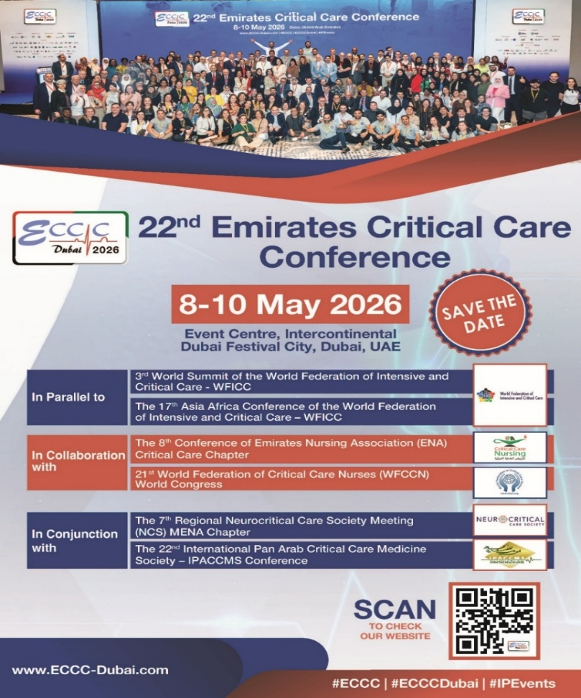

CHAPTER EVENTS
British Columbia Chapter
Winter Innovation Roundtable Recordings

Sustainability & Preparedness: Biocontainment Treatment Unit & Provincial Training Centre
https://youtu.be/loXJTGeyZug?si=rYLlbt-eay4dpe1u

BCIT's New Cerebral Oxygen
& Supply Framework
https://youtu.be/5V-jKw5Q94s?si=4gQw13ZDbxcZF2LW

ISMP

Health Care Provider Insights Drive Safer Packaging

Health Canada recently informed health care providers of an important change to the vial closure colour for cisatracurium products.

Cisatracurium is a neuromuscular blocking agent (NMBA); catastrophic harm or death has resulted when NMBAs are inadvertently selected and administered without airway control and ventilation capability.

This bulletin describes the results of end-user feedback on the labelling and packaging of cisatracurium products.
https://ismpcanada.ca/wp-content/uploads/ISMPCSB2026-i2-Cisatracurium.mp3

https://ismpcanada.ca/bulletin/safer-packaging/?utm_source=safetybulletin&utm_medium=email&utm_campaign=sbv26i2

Montreal Chapter
March 24
Pediatric Education Day

Saskatchewan
April 23
Education Night
BRAIN WAVE, a look into EEG's
In person, virtual & recording tickets available

Southwestern Ontario Chapter
May 27
Joint Education Day with CVAA!

Registration information
https://caccn.ca/upcoming-events/

or CACCN Chapters
https://caccn.ca/chapters/

Discount Codes available
in Members only!
https://caccn.ca/login/

or Scan the QR Code


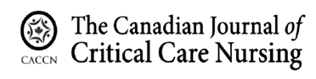The Canadian Journal of Critical Care Nursing (CJCCN) is looking to add to our external Peer Review list.
Peer Reviewer criteria:
- Demonstrates expertise in critical care, content, and/or methodology.
- Holds a graduate degree: minimum master’s degree (MN, MScN, MSc.).
- Has previously published or is familiar with the publication process (preferred).
- Has experience as a peer reviewer with other journals (preferred).
If this is of interest to you!
SUBMIT AN APPLICATION TODAY!! ​
https://www.xcdsystem.com/caccn/forms/index.cfm?ID=K7Y1NTr

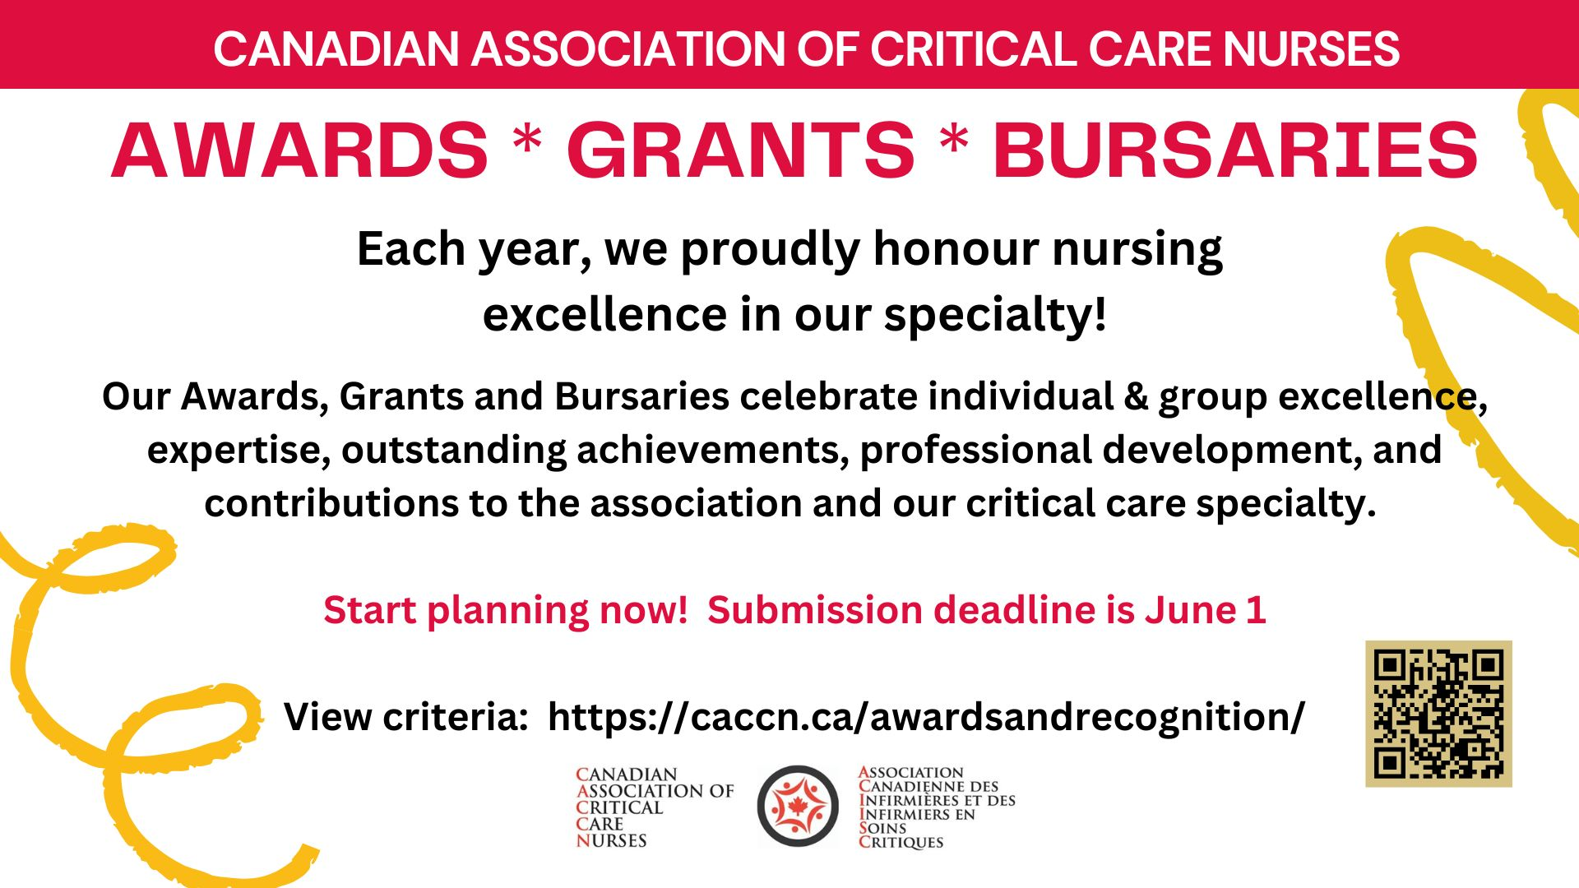
ONTARIO NURSES
Nurses’ perceptions and experiences of caring for critically ill patients in rural hospitals. The intersection of critical illness and rurality within a publicly funded healthcare system in Ontario, Canada.
The purpose of this study is to explore the perceptions and experiences of nurses who care for critically ill patients in rural healthcare settings. We seek to understand how the services and resources available to rural hospitals, as directed by Provincial guidelines, intersect with lived experience of nurses caring for a critically ill patient in a rural hospital.
Information: https://caccn.ca/wp-content/uploads/2026/03/Invitation-to-Participate-Feb-2.pdf

Navigating Transition into Canadian Critical Care Settings: Experiences, Needs, and Impact on Migrant Black Nurses
This qualitative study aims to explore the impacts of transitional experiences and specific needs on migrant Black nurses in Canadian critical care settings, and to examine effective strategies for mitigating potential negative outcomes.
RNs who have migrated and identify as Black within Canadian critical care settings, and who have undergone transitional experiences, are invited to participate.
Information: https://caccn.ca/wp-content/uploads/2026/01/Survey-SBO-Poster.pdf

SURVEY PARTICIPATION
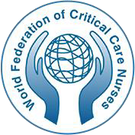

The World Federation of Critical Care Nurses (WFCCN) is seeking expressions of interest for the role of Advisory Board of its journal, International Journal of Critical Care.

The International Journal of Critical Care endeavours to be a truly global vehicle for sharing the latest research, initiatives, policy advice, and achievements in critical care. The journal is open access and is provided online free of charge to all via the WFCCN website: https://wfccn-ijcc.com/index.php/ijcc

Expressions of interest with a cover letter and detailed CV should be emailed to Executive Officer of WFCCN at: wfccnexecutiveofficer@wfccn.org

Closing date: 30 March 2026.

The Advisory Board roles are honorary positions and are unlimited in number. They are appointed by the Editors for a 4-year term. Currently IJCC provides 4 issues per year with ambitions to achieve PubMed Indexation in 2028. A summary of the requirements and role are detailed below.

Requirements
- Fluent in the English Language
- Must have a reliable e-mail address
- Good publication record and experience
- A passion for critical care nursing, scholarship, and excellence

Role
- Contribute to the editorial policies of the journal, both in terms of its coverage and the level and quality of papers and convey your views on these matters to the editorial team.
- Support the identification and development of peer reviewers.
- Provide high quality peer reviews of manuscripts and undertake at least 2 peer reviews of IJCC manuscripts per year.
- Actively encourage colleagues and peers in your field of expertise to submit appropriate high-quality papers to the journal for publication.
- Actively encourage your institution and networks to subscribe to the journal.
- Assist with promotion of the journal, for instance, by passing to the Managing Editor any lists of delegates to relevant conferences that you may have, letting the Managing Editor know about relevant events in the field etc.
- Attend and contribute to all meetings of the Advisory Board (generally, two per year).

Health Care Provider Insights Drive Safer Packaging
ISMP
https://ismpcanada.ca/bulletin/safer-packaging/?utm_source=safetybulletin&utm_medium=email&utm_campaign=sbv26i2

How best practice guidelines can support culture change in long-term care: palliative care in the last 12 months of life
Canadian Nurse
https://www.canadian-nurse.com/blogs/cn-content/2026/02/23/culture-change-in-long-term-care?_zs=71I9O1&_zl=ON0e3

Lower quadriceps muscle mass assessed by ultrasound predicts intensive care unit mortality: A cohort study with prospective data collection
Intensive and Critical Care Nursing
https://doi.org/10.1016/j.iccn.2026.104382

Enhancing Ventilator Bundle Compliance in the CVICU to Reduce Ventilator-Associated Pneumonia
The TMC Library
https://digitalcommons.library.tmc.edu/dnp_abstract/89/

A Constructivist Grounded Theory Study on the Use of Patient Diaries in pAediatric inTensive carE from parents’ and nurses’ perspectives: The UPDATE Study
BACCN Nursing in Critical Care
https://doi.org/10.1111/nicc.70419

The implementation of a noise reduction bundle in the intensive care unit: A qualitative process evaluation
Intensive and Critical Care Nursing
https://doi.org/10.1016/j.iccn.2025.104305

Increasing medication safety in the context of renal impairment
Canadian Nurse
https://www.canadian-nurse.com/blogs/cn-content/2026/02/09/medication-safety-renal-impairment?_zs=71I9O1&_zl=LN0e3

PUBLICATIONS

