

Due to a system error, two renewal notification emails were sent on February 9, 2026, to all CACCN members advising of membership renewal on March 31, 2026. We apologize for any inconvenience this may have caused.

Following notification that the emails were issued, CACCN National office immediately sent an email to all advising of the system error.

There were no automatic payments processed or set to process due to this error. The only payments that would have processed would be those for members on continuous renewal with an actual expiry date of March 31, 2026.

Members due to renew March 31, 2026, will receive an email in the next couple of days with the subject line: CACCN Membership Renewal - March 31, 2026 (to all March Member Renewals)

Members can check the status of their membership including the expiry date by logging into the database at
https://www.xcdsystem.com/caccn/store/index.cfm?ID=hhFE7PD

February 2026

New and Renewing members! Thank you for your participation and support!
CACCN 2025 CERTIFICATION
BURSARIES

Did you certify or renew in 2025?
View the criteria for the bursary
and apply by the deadline!

Awards/Recognition – deadline March 31

Thank you to the following
CACCN members for
member referrals
from October 1, 2025, to January 31, 2026.

Andrea A, Ontario Chelsea S, Alberta
Lisa GR, Nova Scotia Melissa IW, Alberta
Jessica N, Saskatchewan Becky G, Saskatchewan

Congratulations
to
Chelsea S, Alberta
Lisa GR, Nova Scotia
received complimentary 1 year membership extensions for their referral(s) **.

For information regarding the referral draws: https://caccn.ca/wp-content/uploads/2025/03/Member-Referrals-Feb2025-Flyer.pdf
** computerized blind draw

MEMBER REFERRALS
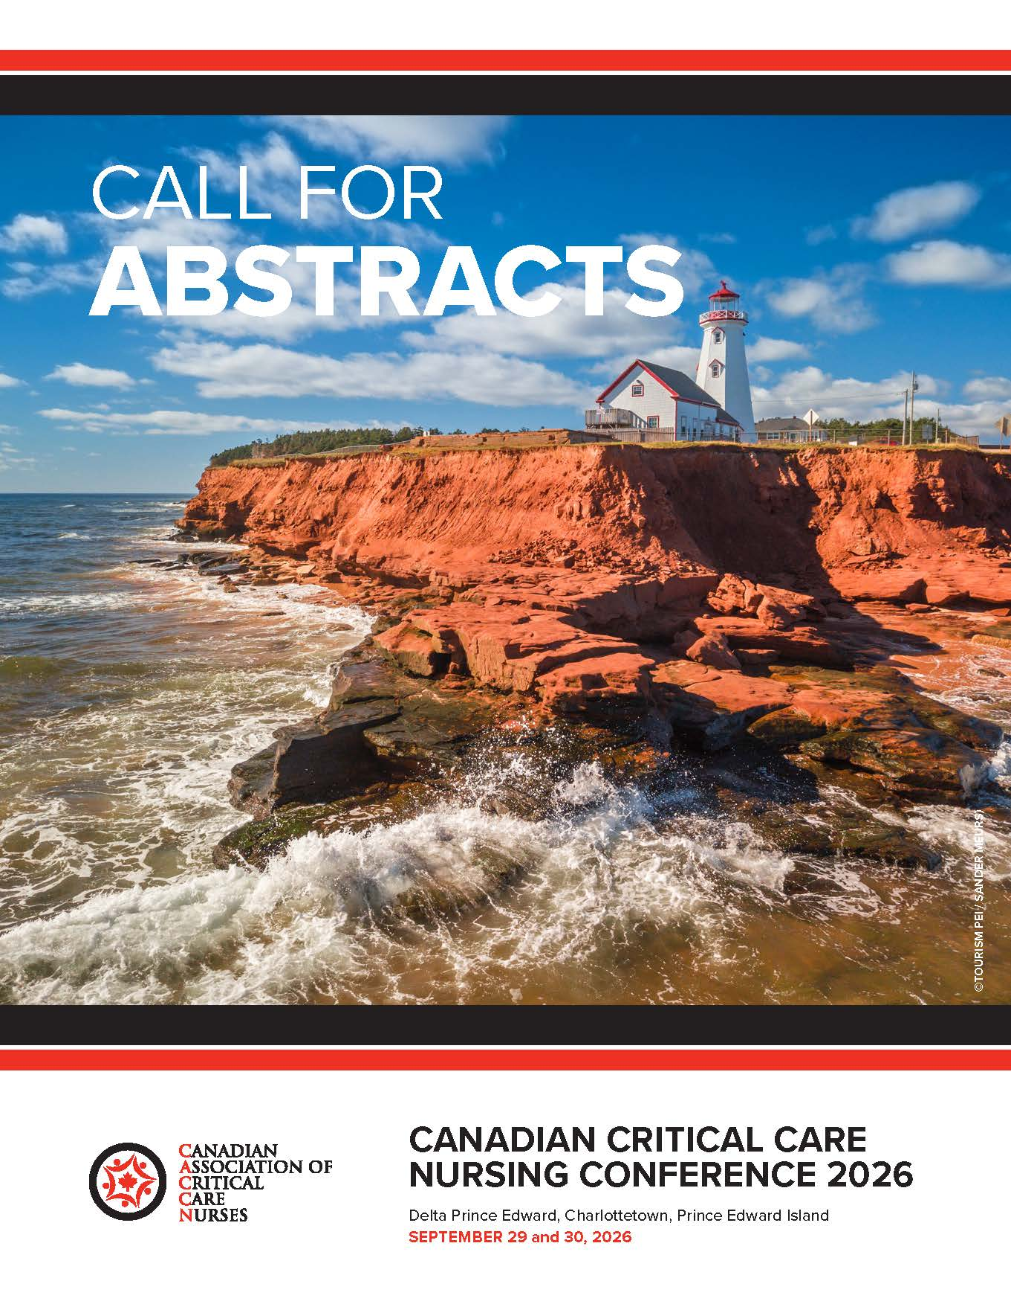
SUBMIT YOUR PROPOSALS!

Do not Delay!

Closes February 26, 2026

Two abstract categories:
- Non-research
- Research

CCNC2026 is accepting abstracts for the following presentation types:
- Concurrent
- Skills lab (hand-on learning)
- Posters (printed)
- Posters (oral)
- Other innovative educational presentations.

Content may focus on various aspects of critical care/acute care including but not limited to:
- Education
- Clinical Practice
- Leadership
- Research
- Mentorship
- Quality Improvement
- Sustainable Practices
- (environmentally friendly)
- Maximizing Resources
- Innovative Practice Changes
- Optimizing, Recognizing Clinical Expertise



NOTICE: Renewal notifications
- Renewal Notifications are now being sent by email!
- February 28 renewal notices were emailed January 6, 2026.
- March 31 renewal notices will be emailed by February 20.
- Know the Continuous Renewal FAQs

Participate in Critical Care Nursing Research:
https://caccn.ca/surveys/

- Navigating Transition into Canadian Critical Care Settings: Experiences, Needs, and Impact on Migrant Black Nurses

- Clinical practice guidelines for palliative/end-of-life care and withdrawal of life-sustaining measures (WLSM) used in ICUs in Canada
RESEARCH PARTICIPATION
Alberta Chapter
Webinar February 26
Rescue mechanical circulatory support
for cardiogenic shock

Register by emailing caccnalberta@caccn.ca

Montreal Chapter
March 24
Pediatric Education Day

Saskatchewan Chapter
Education Night
March 11
Toxicology Cases in the ICU
In person, virtual & recording tickets available

Education Night
April 23
BRAIN WAVE, a look into EEG's
In person, virtual & recording tickets available

Nova Scotia Chapter
Webinar – March 5
Back to Basics: Inotropes and Pressors

Southwestern Ontario Chapter
Education Day
May 27
Save the Date!

For registration information:

CACCN Upcoming Events
https://caccn.ca/upcoming-events/

or
CACCN Chapters
https://caccn.ca/chapters/

CHAPTER EVENTS
Complimentary Webinars

February 19 @ 1030 hrs ET
Registration
https://us02web.zoom.us/meeting/register/YEAytsMUSaW1q-R8TT-Gtw#/registration

The second session of the WFPICCS Pediatric Respiratory Critical Care Series (PRCCS) focuses on ventilation–perfusion (V/Q) mismatch, shunt, and dead space ventilation as key mechanisms of hypoxemia in critically ill children, linking core respiratory physiology to everyday bedside decision-making in the PICU.

Calling out the Leadership B.S.:
What the Evidence Actually Shows

📅 February 26 | 12 ET
🔗 Registration details**:
https://cchl-ccls.ca/event/fellowship-knowledge-translation-webinar-with-dr-jaason-geerts/

Complimentary evidence-based leadership webinar. The session examines common leadership myths that directly affect nurse leaders—who should lead, what counts as credible evidence in leadership, and diverse team performance—and contrasts them with what the peer-reviewed research shows. The intent is constructive and rigorous: to strengthen leadership practice and standards across the system, particularly for nurses navigating increasingly complex leadership expectations.

Given that we are collecting data from event registrants for a peer-reviewed academic publication, we are aiming for maximum engagement.
** CCHL account creation required for registration.

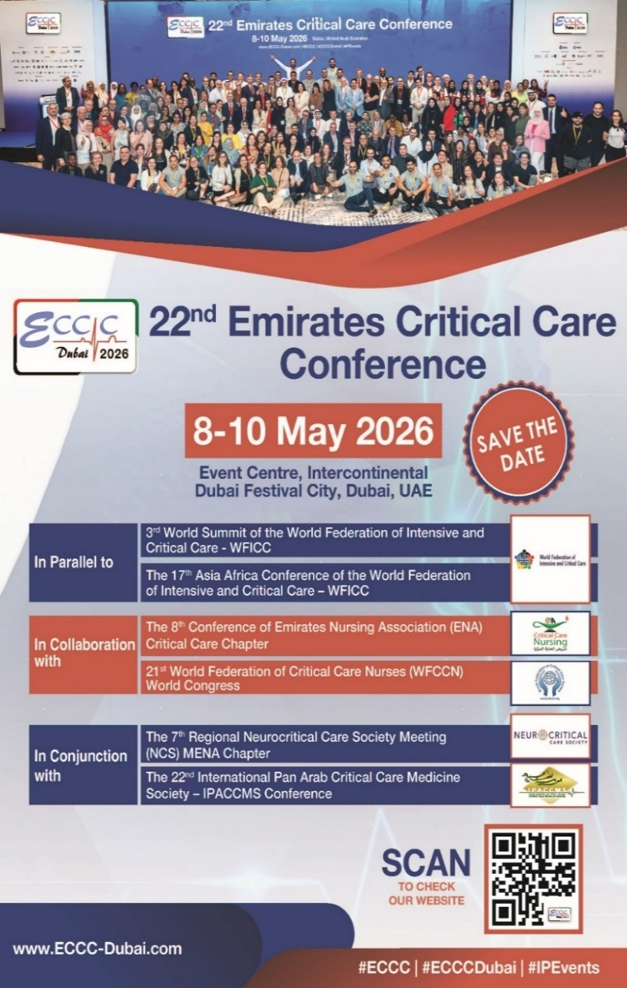
Share with your
PICU Allied Health Professional colleagues!
Join the WFPICCS AHP Network: https://app.smartsheet.com/b/form/2e324860b67e4ee584aece91e7b35c2d
WFPICCS is committed to ensuring that all professionals working in pediatric intensive care are represented, connected, and supported.
Allied Health Professionals (AHPs) play a vital role in PICU care worldwide, and their expertise, perspectives, and leadership are essential to advancing our field.
WFPICCs warmly invites AHPs working in PICU to join the WFPICCS AHP Network and become part of this expanding global community.

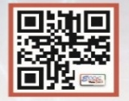

CACCN has been provided with the following for members who are interested in attending the 22nd Emirates Critical Care Conference in Dubai:
Five (5) Complimentary Registrations - If you are attending, contact CACCN at caccn@caccn.ca to request a code. First come / first serve basis.
CACCN discount code for Members
Receive 50% off registration for CACCN members when you register using the discount code CACCNC50
Registration: https://eccc-dubai.com/physical-registration/

PUBLICATIONS
Follow Her Heart: Addressing Gaps in Women’s Heart Health Patient Resources
Canadian Journal of Cardiovascular Nursing
https://cccn.ca/_uploads/695e738c1576a.pdf

Pre-hospital fibrinogen levels in major trauma patients transported by helicopter emergency medical service: determining who might benefit
Canadian Journal of Emergency Nurses
https://doi.org/10.29173/cjen534

Unit Layout and Critical Care Nurses’ Perceptions of Visibility, Teamwork, and Taking Breaks
American Journal of Critical Care Nursing
https://aacnjournals.org/ajcconline/article/35/1/54/32930

Harnessing AI to Decode the Heart
OHA Health System News
https://tinyurl.com/OHAFeb2026-2
Improving Care Where It Happens: The Value of Hospital-Based Research
OHA Health System News
https://tinyurl.com/OHAFeb2026

ICU command centres in critical care: Nursing workflows, organizational models, and implementation challenges. A narrative review
Intensive and Critical Care Nursing
https://doi.org/10.1016/j.iccn.2025.104245

AACN Practice Alert: Implementing Effective Oral Care Practices for Acutely and Critically Ill Patients
Critical Care Nurse
https://doi.org/10.4037/ccn2026463

Moral distress of intensive care unit nurses: a systematic review and meta-analysis
BMC Nursing
https://link.springer.com/article/10.1186/s12912-025-04274-4

