

January 2026
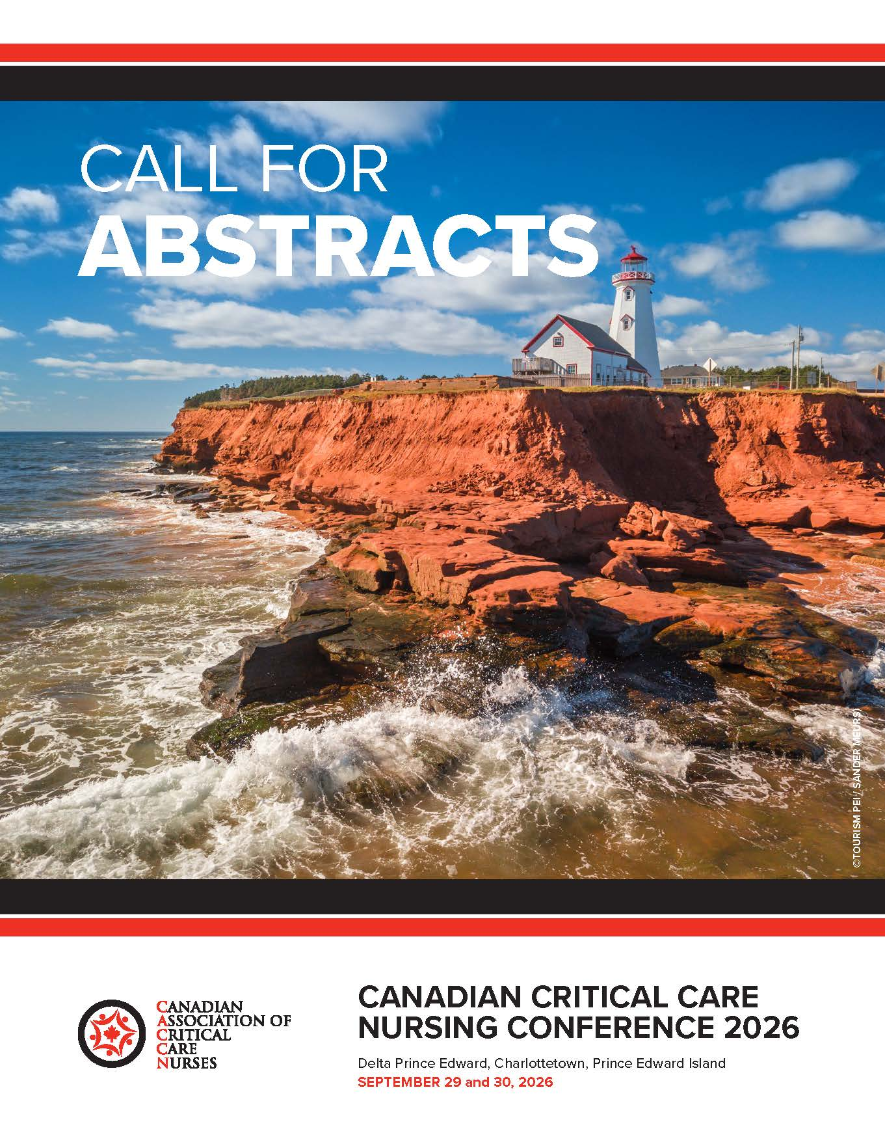
NOW OPEN!
Closes February 26, 2026

Two abstract categories:
- Non-research
- Research

Abstracts are being accepted for the following presentation types:
- Concurrent
- Skills lab (hand-on learning)
- Posters (printed)
- Posters (oral)
- Other innovative educational presentations.

Content may focus on various aspects of critical care/acute care including but not limited to:
- Education
- Clinical Practice
- Leadership
- Research
- Mentorship
- Quality Improvement
- Sustainable Practices
- (environmentally friendly)
- Maximizing Resources
- Innovative Practice Changes
- Optimizing, Recognizing Clinical Expertise


CERTIFICATION

Congratulations!
to all CACCN members on the successful completion of the 2025 Certification examinations (spring/fall) and renewals.
2025 Examination & Renewal Lists of Members

Certification Bursary!
Apply for the
2025 CACCN Certification Bursary.
Apply at Awards/Recognition by March 31

ADVOCACY / DĖFENSEUR
CACCN and CANN recognizing that Chronic Hand Eczema is a significant occupational health concern for Canadian nurses recently sent a unified letter to Dr. L Chapman, PhD, RN, CNO of Canada and to Dr. V Grdias, PhD, RN, CEO, CNA as well as provincial nursing officers and our nursing association colleagues advocating for hand eczema to be recognized as a significant occupational health issue and that Health Canada and the CNA champion initiatives that prioritize prevention, protection, early intervention and appropriate care for nurses across the country. Read the letter and view the survey!
Reconnaissant que l'eczéma chronique des mains constitue un problème important de santé au travail pour les infirmières canadiennes, l'ACCN et la CANN ont récemment envoyé une lettre commune au Dr L. Chapman, PhD, RN, directrice des soins infirmiers du Canada, et au Dr V Grdias, PhD, RN, PDG de l'AIIC, ainsi qu'aux responsables provinciaux des soins infirmiers et à nos collègues des associations d'infirmières, afin de plaider en faveur de la reconnaissance de l'eczéma des mains comme un problème important de santé au travail et pour que Santé Canada et l'AIIC soutiennent des initiatives qui accordent la priorité à la prévention, à la protection, à l'intervention précoce et aux soins appropriés pour les infirmières et infirmiers de tout le pays. Lisez la lettre et consultez le sondage ! Traduit avec DeepL.com (version gratuite)


NOTICE: Renewal notifications
- Renewal Notifications now being sent by email!
- January letters were mailed December 5, 2025.
- February letters were emailed January 6, 2026.
- Know the Continuous Renewal FAQs

CONFERENCES
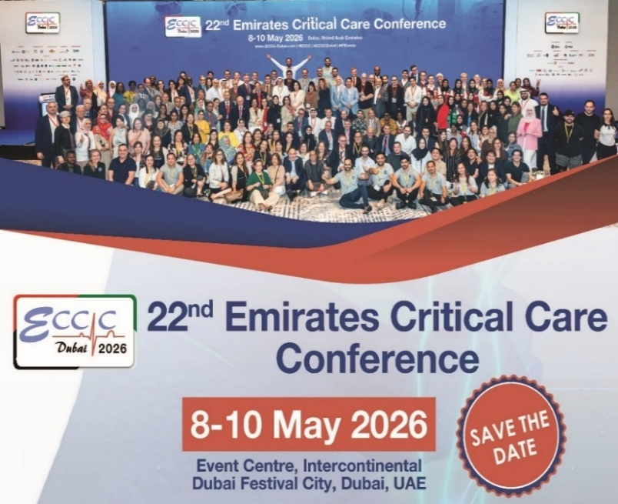

RESEARCH PARTICIPATION

Participate in Critical Care Nursing Research:
https://caccn.ca/surveys/
- Exploring and Strengthening Day-to-day Teamwork in Critical Care: A Qualitative Study
- SHINE Study
- Pediatric Critical Illness Outcomes Study (PECIOS)
- Sedation practices in the care of severe pediatric traumatic brain injury (TBI)
- Paediatric Adaptive Sepsis Platform Trial (PASSPORT)
- International Critical Care, Emergency Nurse, and Critical Care Transport Nurse Intent to Stay Study.

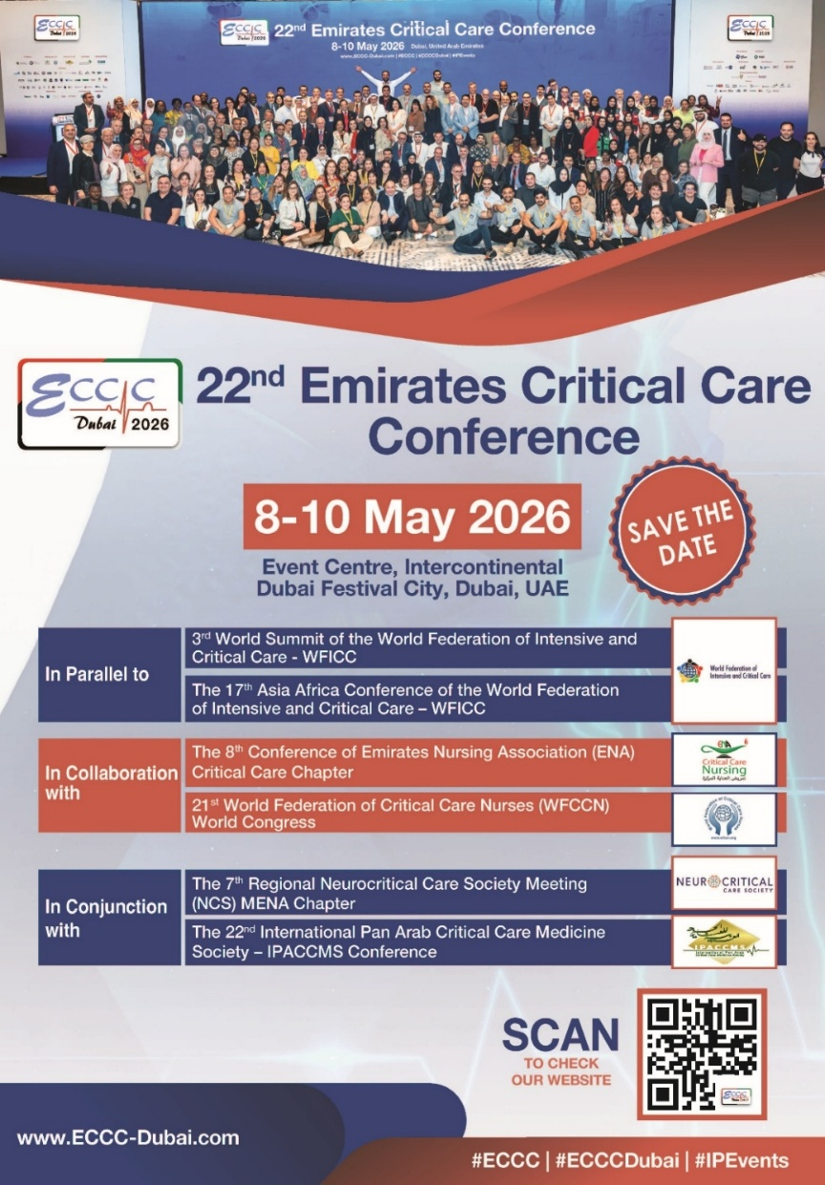

OTHER EVENTS
Driving Medication Safety in Community Pharmacies Through Continuous Quality Improvement
(Webinar)
Join this complimentary webinar to explore practical quality improvement strategies that strengthen medication safety in community pharmacy practice. Learn how continuous quality improvement can support safer systems and better patient outcomes.

Click here to register: February 9, 2026 (12:00 pm to 1:00 pm EST)



Who Decides? Power, Protection,
and Paternalism in Critical Care
The Architecture of Difficult Conversations: Civil Discourse Across Fields
Massey College, Toronto
February 2nd, 5:00-6:30pm
In the ICU, clinicians, researchers, and ethics boards frequently make judgement calls about what families can handle- which conversations to have, which options to offer, and which decisions families are ‘ready for.’ This panel explores essential questions about civil discourse in critical care. When does protecting families turn into removing choice and deciding for them, and how can we have civil discourse when the stakes are so high?
https://www.masseycollege.ca/events/the-architecture-of-difficult-conversations-civil-discourse-across-fields/

Alberta Chapter Webinars

Open to All

January 29 – 1500 hrs ET (1300 MT)
Understanding Connection:
First Nation Views on
Pharmacist Relationships

February 12 – 1500 hrs ET (1300 MT)
Exploring Families’ Experiences with
End-of-Life Care in the Pediatric
Intensive Care Unit

February 26 – 1500 hrs ET (1300 MT)
Rescue mechanical circulatory support
for cardiogenic shock

Register by emailing caccnalberta@caccn.ca

CHAPTER EVENTS
Critical Care Pronation Therapy

Island Health
shared their updated guideline and procedures for proning mechanically ventilated patients using the overhead lift or linen wrap method.

Pronation therapy videos - watch here

- Procedure Prone Positioning for vented patients - overhead lift method.pdf
- Bedside Quick Guide Proning with Ceiling Lift (OHL).docx
- Guideline Prone Positioning for vented patients.pdf
- Procedure Prone Positioning for vented patients - linen wrap method.pdf

Please reach out to Kelly Janzen (CNE Royal Jubilee Hospital ICU) for any questions about these resources – kelly.janzen@islandhealth.ca.

EDUCATIONAL RESOURCES
‘A lot of work to do, one conversation at a time’: New Year’s resolutions for 2026
The Healthy Debate
https://healthydebate.ca/2025/12/topic/new-years-resolutions-2026/

“Do we still need physical restraints in ICU? No!”
Intensive and Critical Care
https://doi.org/10.1016/j.iccn.2025.104262

Exploring Australian intensive care unit nurses’ experiences, confidence, and knowledge in supporting breastfeeding women in the early postpartum period: A descriptive cross-sectional study
Australian Critical Care
https://doi.org/10.1016/j.aucc.2025.101467

Unit Layout and Critical Care Nurses’ Perceptions of Visibility, Teamwork, and Taking Breaks
American Journal of Critical Care
https://doi.org/10.4037/ajcc2026276

Humanising paediatric care in the PICU: current strategies and emerging insights
Intensive and Critical Care Nursing
https://doi.org/10.1016/j.iccn.2025.104287

Retrospective review of a weaning and rehabilitation cohort within a tertiary critical care unit
Australian Critical Care
https://doi.org/10.1016/j.aucc.2025.101496

ICU command centres in critical care: Nursing workflows, organizational models, and implementation challenges. A narrative review
Intensive and Critical Care Nursing
https://doi.org/10.1016/j.iccn.2025.104245

A Multidisciplinary, Phased Nursing Strategy for Skin and Mucosal Management in a Pediatric Case of Toxic Epidermal Necrolysis with Respiratory Failure: A Case Report
Frontiers in Pediatrics
https://www.frontiersin.org/journals/pediatrics/articles/10.3389/fped.2026.1759262/abstract

Nurses’ Perspectives on Caring for Critically Ill Children During a Measles Outbreak: A Case Report
Critical Care Nurse
https://doi.org/10.4037/ccn2025966

Disaster Management in Critical Care Nursing
International Journal of Critical Care (IJCC)
https://wfccn-ijcc.com/index.php/ijcc

Return-to-Care After Discharge Directly Home From the PICU: A Propensity-Matched Cohort Study
Pediatric Critical Care Medicine
https://journals.lww.com/pccmjournal/fulltext/2025/12000/return_to_care_after_discharge_directly_home_from.7.aspx

Mortality effect of higher versus lower blood pressure targets in vasodilatory shock: an updated systematic review and meta-analysis
Critical Care
https://link.springer.com/article/10.1186/s13054-025-05769-x

The colonial wounds on Indigenous women’s health
The Healthy Debate
https://healthydebate.ca/2026/01/topic/colonial-wounds-indigenous-womens-health/

Noninvasive Oxygenation Strategies in Critical Care: Applications and Challenges
AACN Advanced Critical Care
https://doi.org/10.4037/aacnacc2025174

The implementation of a noise reduction bundle in the intensive care unit: A qualitative process evaluation
Intensive and Critical Care Nursing
https://doi.org/10.1016/j.iccn.2025.104305

Exploring the role of virtual reality simulation in critical care nurses' training: A randomized controlled pilot study
Clinical Simulation in Nursing
https://doi.org/10.1016/j.ecns.2025.101868

PUBLICATIONS

