


Certification!

Reminder: CNA 2025 Renewal Deadline is December 15
Did you write the examination or renew in 2025?
Apply for the CACCN Certification Bursary LINK



New & Returning Members!

We look forward to your participation in your specialty nursing association!

Thank you to all members for your
membership and support of
CACCN in 2025!

December 2025


CACCN and CANN recognizing that Chronic Hand Eczema is a significant occupational health concern for Canadian nurses recently sent a unified letter to Dr. Leigh Chapman, PhD, RN, Chief Nursing Officer of Canada and to Dr. Valerie Grdias, PhD, RN, Chief Executive Officer, Canadian Nurses Association advocating for hand eczema to be recognized as a significant occupational health issue and that Health Canada and the Canadian Nurses Association champion initiatives that prioritize prevention, protection, early intervention and appropriate care for nurses across the country. CACCN and CANN also sent the letter to all provincial nursing officers and has sought endorsement of the letter from other nursing specialty associations and groups.
Read the letter and view the survey!
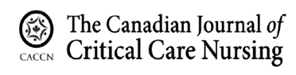

CALL FOR PEER REVIEWERS

Are you passionate about
critical care?

Interested in sharing
your knowledge & expertise?

If so…the CJCCN is looking to add to our external Peer Review list.
If this is of interest to you!

SUBMIT AN APPLICATION TODAY!!

LINK:
https://cjccn.ca/call-for-peer-reviewers-external/



Saskatchewan Chapter
Education Night
January 13, 2026

Evidence-Based Physical Therapy Treatment in Critical Care
This is an in-person event however the chapter is offering an Event Recording Ticket option for those who are unable to attend in person. Register and receive a link to the zoom recording post-education night to view whenever works best for you.
Register HERE

Alberta Chapter Webinar
January 29, 2026

Understanding Connection:
First Nation Views on Pharmacist Relationships
This webinar will highlight perspectives from a master’s research project with a First Nation community in Edmonton, exploring how trust, relationships, and culturally safe care can shape pharmacist–patient interactions.

Register by emailing caccnalberta@caccn.ca

CHAPTER EVENTS
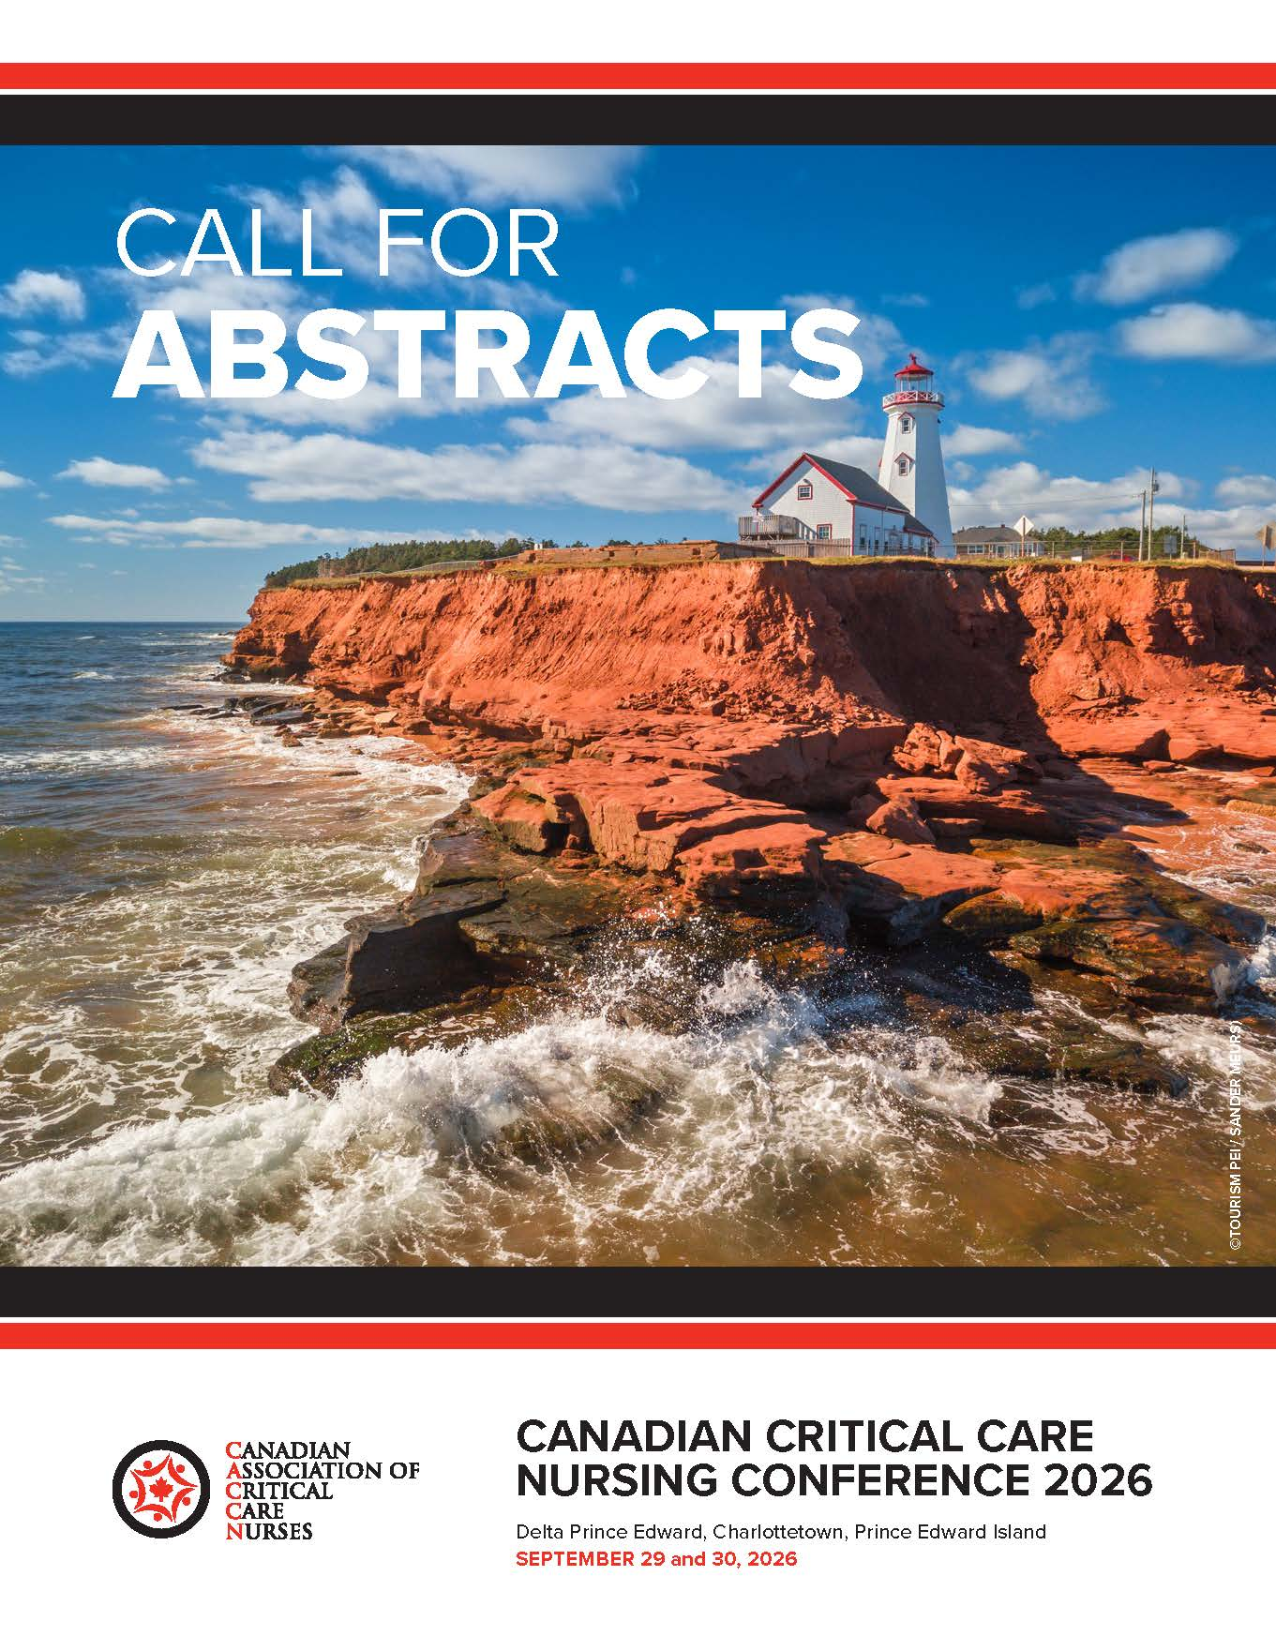
Canadian Nurses Association

Critical Care Certification 2026

Spring Applications
January 15 to March 30
Examination in May

Fall Applications
June 15 to September 30
Examination in November

Renewal Applications
January 15 to December 15

Information

Starting with the February 2026 renewal notification
will be issued by email!
December 2025 renewals process on or about January 1, 2026. Renewal letters were mailed November 5, 2025.

January 2026 renewals will process on or about February 1, 2026. Renewal letters were mailed December 5, 2025.

Know the Continuous Renewal FAQs

Opening January 5, 2026

Closes February 26, 2026

Two abstract categories:

- Non-research
- Research

Abstracts are being accepted for the following presentation types:

- Concurrent
- Skills lab (hand-on learning)
- Posters (printed)
- Posters (oral)
- Other innovative educational presentations.

Content may focus on various aspects of critical care/acute care including but not limited to:

- Education
- Clinical Practice
- Leadership
- Research
- Mentorship
- Quality Improvement
- Sustainable Practices
- (environmentally friendly)
- Maximizing Resources
- Innovative Practice Changes
- Optimizing/Recognizing
Clinical Expertise

More information:
https://caccn.ca/2026-canadian-critical-care-nursing-conference/

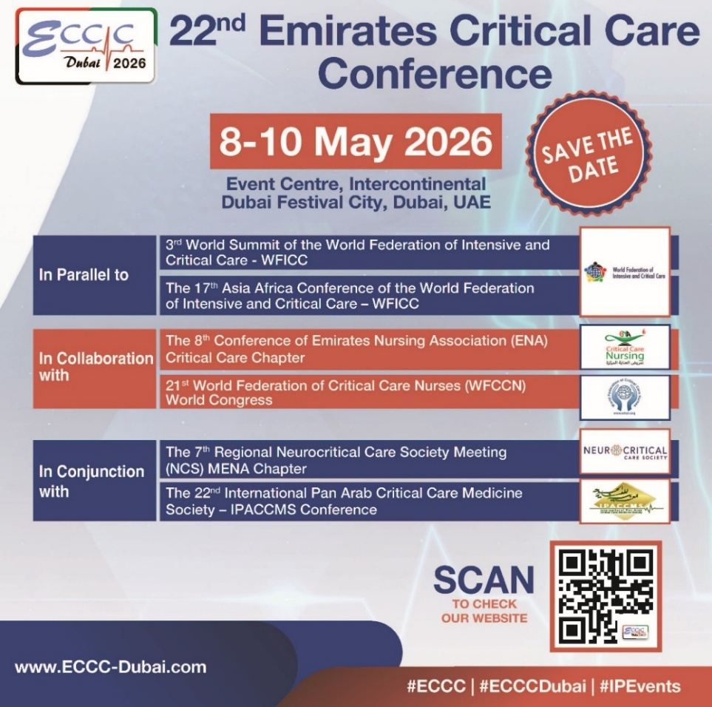
Canadian Journal of Critical Care Nursing

Consider Publishing
with the CJCCN!

Publishing Resources
Publishing Webinar

Information for Authors
Reporting Guidelines
Manuscript Requirements

Volume 36, Issue 3, 2025 Coming Soon – watch for the email!

Open Access https://cjccn.ca/

Addressing Barriers and Facilitators to Post-PICU Shared Care: Insights from British Columbia.

17th World Congress of Intensive
and Critical Care Nursing Abstracts

ISMP Medication Safety Practice Corner
Anatomy of an incident analysis – Part 1
Ready for Practice! Virtual Simulation in
Critical Care and Emergency Nursing Education
Practice Pearls:
Post Intensive Care Syndrome in Pediatrics PICS-P)

PUBLICATIONS
Health System Context Series
CIHI Website

Implementation of a partnership involving parents in the care of critically ill children: an integrative review
Acute and Critical Care
https://doi.org/10.4266/acc.001896

Exploring resilience in critical care nursing: a qualitative inquiry into continuous adaptation, collaborative unity, and emotional balance
BMC Nursing
https://link.springer.com/article/10.1186/s12912-025-02844-0

Beginning to Think About Ethical Issues in Critical Care
American Journal of Critical Care
https://doi.org/10.4037/ajcc2025435

Frequent Mental health and Addiction related Emergency Department Visits: Perspectives from Healthcare Providers
Canadian Journal of
Emergency Nurses
https://doi.org/10.29173/cjen233

Arterial Changes After Vascular Reconstruction Following Decannulation From Extracorporeal Life Support: Single-Center, Retrospective Cohort 2002–2022
Pediatric Critical Care Medicine
10.1097/PCC.0000000000003849

Toleration of a Speaking Valve Placed In-Line With the Ventilator Circuit in Critically Ill Tracheostomized Patients
American Journal of Critical Care
https://doi.org/10.4037/ajcc2025258

