
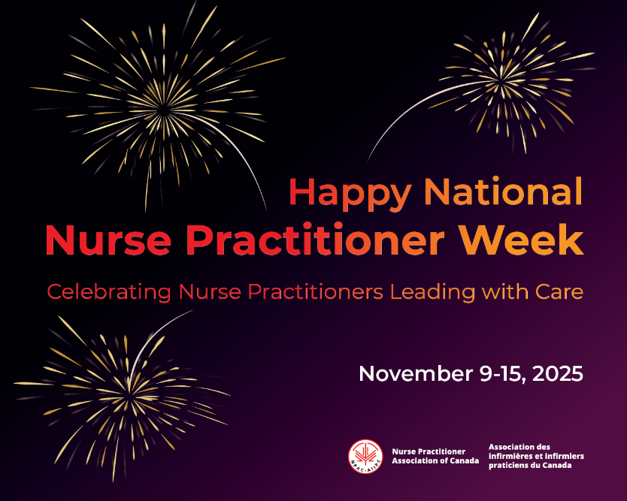



November 24 to 28: Office Closure
December 4: Webinar : ICU Diaries
December 22 to January 2: Office Closure


New &
Returning Members!
Thank you for your membership!
We look forward to your participation in your specialty nursing association!

November 2025


Annual General Meeting of Members
The annual general meeting was held October 30, 2025.
Access to the meeting information:
- annual report
- financial audit
- draft minutes
- PowerPoint,
- Zoom recording
is available by logging into the Members Only area: About Us: Association Reports (scroll down the Members Only page): HERE.

JOIN US AT OUR LAST EVENT FOR 2025
Register https://caccn.ca/upcoming-events/

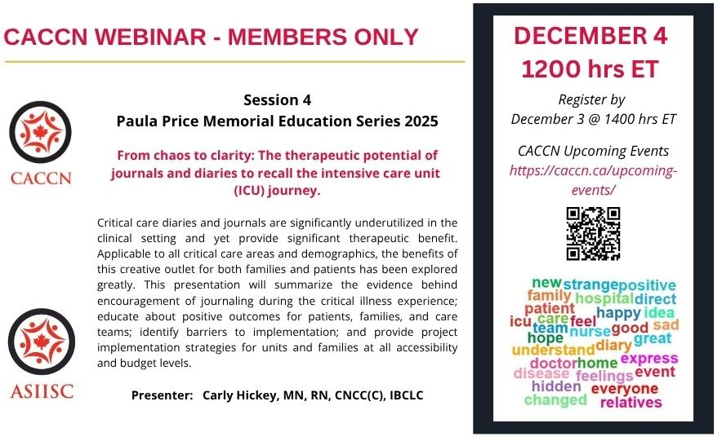

CHAPTER EVENTS
Register today!

Alberta Chapter Webinar
January 29, 2026 - Webinar
Register by
emailing caccnalberta@caccn.ca

Understanding Connection: First Nation Views on Pharmacist Relationships
This webinar will highlight perspectives from a master’s research project with a First Nation community in Edmonton, exploring how trust, relationships, and culturally safe care can shape pharmacist–patient interactions.

Nova Scotia Chapter
November 26, 2025 - Webinar
Registration
Positive Pressure Partners: A Refresher on Intubation, Ventilation, and Collaboration
This webinar offers a practical refresher on the care of intubated and mechanically ventilated patients.

Saskatchewan Chapter
November 27, 2025 - Education Night
Registration
Evidence-Based Physical Therapy Treatment in Critical Care
Whether you're a healthcare provider, student, or someone with an interest in the complexities of critical care, this is an event you won't want to miss. We look forward to seeing you for an engaging and informative evening!

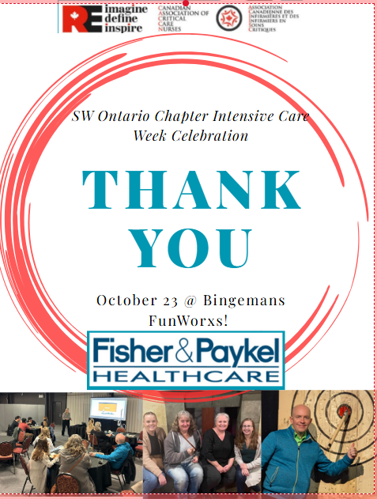
Announcement
Chapter Name Change

The Board of Directors is pleased to announce the
renaming
of the London Regional Chapter to the
Southwestern Ontario Chapter.

New email address SWOntario@caccn.ca.



Membership!
Know the Continuous Renewal FAQs
November 30 renewals were emailed
on October 5th due to the postal strike.

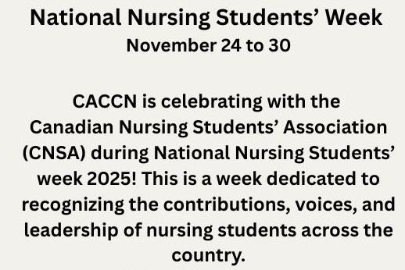
Good Luck
to all critical care nurses writing the
Canadian Nurses Association Critical Care Certification Exam this month!
You’ve got this!

Reminder: CNA Renewal Deadline
Deadline: December 15

When you receive your successful exam or renewal results be sure to apply for the CACCN Certification Bursary LINK





RESEARCH / SURVEYS

New Graduate Nurses in Pediatric Critical Care Float Pools: Qualitative research to explore mentorship’s role in facilitating the transition of new graduate nurses into pediatric critical care float roles. Seeking interested participants! Participate: scan the QR Code on the flyer or email K Yee kyee041@uottawa.ca.

Critical Care, Emergency Nurse and Critical Care Transport Nurse Intent to Stay Study: To examine factors which influence the intent to stay of nurses working in critical or intensive care, emergency or critical care transport: Survey Flyer and Survey Link.

SHINE Study:
Take part in the SHINE Study: Shaping ICU nurses’ future – How an ICU Nurse Envisions the professional role in 2030 and beyond! Share your vision for the future of ICU nursing! Complete the expression of interest - LINK

Exploring and strengthening day-to-day teamwork in critical care: A qualitative study:
Research study aimed at characterizing the nature of teamwork in critical care settings to generate a nuanced understanding of how teamwork functions to influence care delivery. Invitation to Participate! Flyer with QR Code or LINK

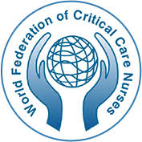
WFCCN Research Committee
Expressions of Interest

The WFCCN is an international federation comprised of national critical care nursing associations from over 50 countries and regions. The key aims of the WFCCN are to represent critical care nursing at an international level and to help improve critical care nursing practice worldwide.

WFCCN supports effective international cooperation between health professionals, institutions, agencies, healthcare industry and charities that have an interest in the care of critically ill patients. The Canadian Association of Critical Care Nurses is a member of the WFCCN.

WFCCN is requesting expressions of interest in joining the WFCCN Research Committee.
Interested candidates submit an email, along with a CV, to adriano@hdmsarist.hr, with a copy to wfccnexecutiveofficer@wfccn.org and caccn@caccn.ca so we are aware of your interest.
The call will remain open until 24 November.
For more information: Surveys

COST Action Project SAFE ICU (CA24017) approved by the European Commission. The project was officially launched on 23 October 2025 in Brussels and will run for four years. This international network aims to advance patient safety through the standardised measurement of three key patient safety outcomes: pressure ulcers, healthcare-associated infections (HCAIs), and delirium. In addition, the project will investigate the processes contributing to the development of these conditions.
There is currently an open call for participation on several working groups focusing on pressure ulcer prevention, healthcare-associated infections delirium, education of intensive care nurses and policy impact and dissemination. Apply to be part of these international research groups.
To apply: Action CA24107 - COST
OPPORTUNITIES: INTERNATIONAL RESEARCH PARTICIPATION!

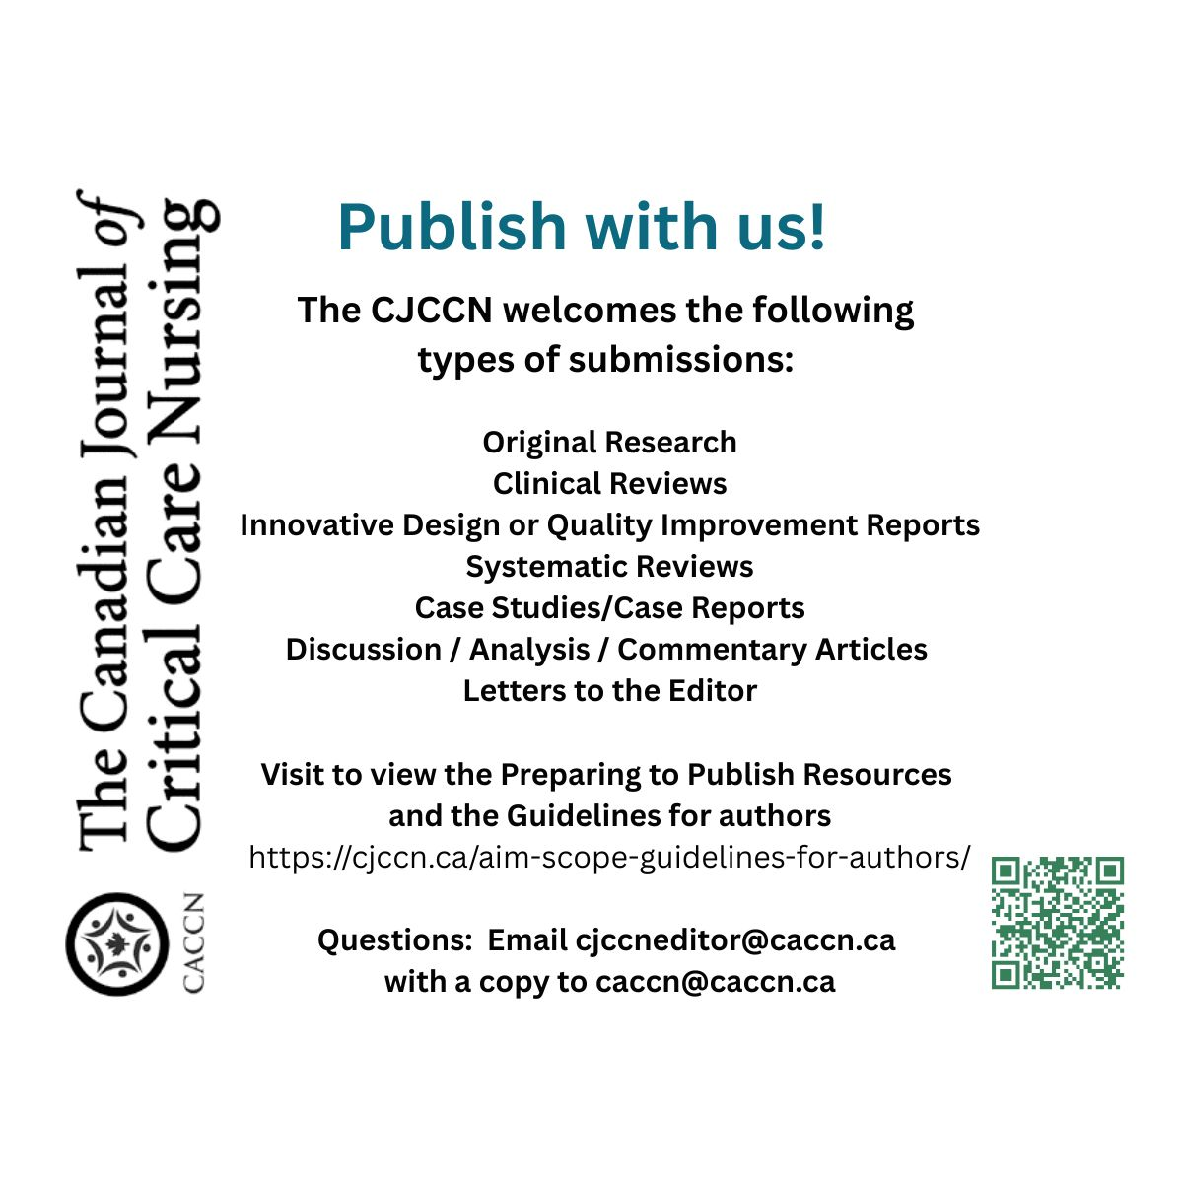
Care amongst the chaos: the voices of nurses working in conflict
Royal College of Nursing (United Kingdom)
https://www.rcn.org.uk/Professional-Development/publications/rcn-care-amongst-the-chaos-uk-pub-012-203

Exploring Applications of Artificial Intelligence in Critical Care Nursing: A Systematic Review
Nursing Reports
https://doi.org/10.3390/nursrep15020055

Influence of clinical practice stressors on critical care nursing student’s burnout:
Resilience as a mediating factor
Teaching and Learning in Nursing
https://doi.org/10.1016/j.teln.2025.05.031

Critical care nurses’ experiences of ethical challenges in end-of-life care
Nursing Ethics
https://doi.org/10.1177/09697330241252975

Challenges and best practices for moving forward in interprofessional collaboration in critical care units: nurses’ perspectives
BMC Nursing
https://link.springer.com/article/10.1186/s12912-025-02860-0

Integrating Artificial Intelligence Into Critical Care Nursing: Next Steps
Critical Care Nurse
https://doi.org/10.4037/ccn2025194

The impact of a clinical academic nurse researcher in critical care: A 1-year service review
JAN
https://doi.org/10.1111/jan.16367

Risk factors for colonisation by Multidrug-Resistant bacteria in critical care units
Intensive and Critical Care Nursing
https://doi.org/10.1016/j.iccn.2024.103760

Longitudinal trajectories of health-related quality of life among critical care survivors: A latent class growth approach
Intensive and Critical Care Nursing
https://doi.org/10.1016/j.iccn.2024.103892

Prevalence of Post-intensive care syndrome among intensive care unit-survivors and its association with intensive care unit length of stay: Systematic review and meta-analysis
PLOSone
https://doi.org/10.1371/journal.pone.0323311

Reliability, validity and practicability of the Chelsea Critical Care Physical Assessment tool (CPAx) following an e-learning programme: A clinimetric study
Intensive and Critical Care Nursing
https://doi.org/10.1016/j.iccn.2025.103959

PUBLICATIONS OF INTEREST
The impact of AI-based decision support systems on nursing workflows in critical care units
International Nursing Review
https://doi.org/10.1111/inr.13011

Barriers and Facilitators in Implementing Clinical Practice Guidelines Among Nurses in Emergency Departments and Critical Care Units: A Systematic Review
Journal of Clinical Nursing
https://doi.org/10.1111/jocn.70086

What motivates critical care nurses to stay in their job? – Structural aspects for empowering intrinsic motivation in permissive professional contexts: A scoping review
Intensive and Critical Care Nursing
https://doi.org/10.1016/j.iccn.2024.103929

Simulation-based learning in postgraduate critical care and anaesthesia nursing: an interview study from postgraduate nurses’ perspectives
BMC Nursing
https://link.springer.com/article/10.1186/s12912-025-03336-x

Practice recommendations for culturally sensitive communication at the end of life in intensive care: A modified eDelphi study
Intensive and Critical Care Nursing
https://doi.org/10.1016/j.iccn.2024.103814

The role of critical care nurses in organ and tissue donation: A position statement of the Australian College of Critical Care Nurses
Australian Critical Care
https://doi.org/10.1016/j.aucc.2024.05.010

Integrating Artificial Intelligence Into Critical Care Nursing: Next Steps
Critical Care Nurse
https://doi.org/10.4037/ccn2025194

