**Out of Office Alerts**

**September 15–19  
 World Congress**

**October 17-24  
BOD Meetings and   
CICU Week Event**

**November 24–28**

**September 2025**



**New** & **Returning Members!**

**Thank you for your membership!**

We look forward to your participation in your specialty nursing association!

**Volume 36, Number 2, Summer 2025**

**Available Now!**

**Open Access** [**https://cjccn.ca/**](https://cjccn.ca/)

Nurses’ perceived feasibility and the clinical utility of the Nociception Level (NOL™) Index for pain assessment in critically ill adults

Exploring long-term impacts on ICU survivors:

A concept analysis of post-intensive care syndrome

Caregiver needs in and after the ICU:

A call to action for critical care nurses

ISMP Medication Safety Practice Corner:

No drug selected: Nurses report safety risks when programming smart pumps



**Know the** [**Continuous Renewal**](https://caccn.ca/wp-content/uploads/2024/10/CACCN-Continuous-Renewal-FAQs-FINAL-Sept-2024.pdf) **FAQs**

**September Renewal letters were  
mailed August 5!**

**Check your expiry date in your member database profile**

**https://www.xcdsystem.com/caccn/store/index.cfm?ID=hhFE7PD**



**CNA Certification**

* [Fall Examination register by September 30!](https://www.cna-aiic.ca/en/certification/initial-certification)
* [Renewal by CL Hours complete by December 15!](https://www.cna-aiic.ca/en/certification/renewing-your-certification)
* **CACCN** [Certification Resources](https://caccn.ca/education-certification-resources/certification/)
* **CACCN** [Certification Bursaries](https://caccn.ca/awardsandrecognition/)

**OPEN TO ALL**

**JOIN US IN BEAUTIFUL  
ST JOHN’S, NEWFOUNDLAND    
FOR THIS   
TWO DAY EDUCATIONAL EVENT!   
  
PLAN TO ATTEND 1 DAY   
OR BOTH DAYS!**

**Information / Registration**

[**https://caccn.ca/cicu-week-educational-event-2025/**](https://caccn.ca/cicu-week-educational-event-2025/)

Member Discount code is available in   
[Members Only](https://caccn.ca/login/)!

**Nomination submission deadline**

**October 1 @ 1600 hrs ET**

**For more information**

[**https://caccn.ca/about-caccn/annual-general-meeting/**](https://caccn.ca/about-caccn/annual-general-meeting/)

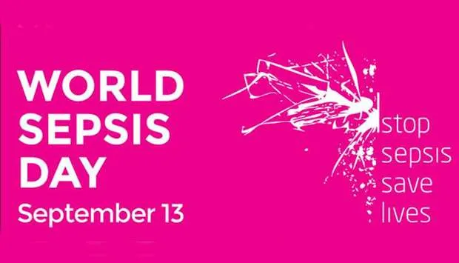

**Register!**

[**https://caccn.ca/about-caccn/annual-general-meeting/**](https://caccn.ca/about-caccn/annual-general-meeting/)

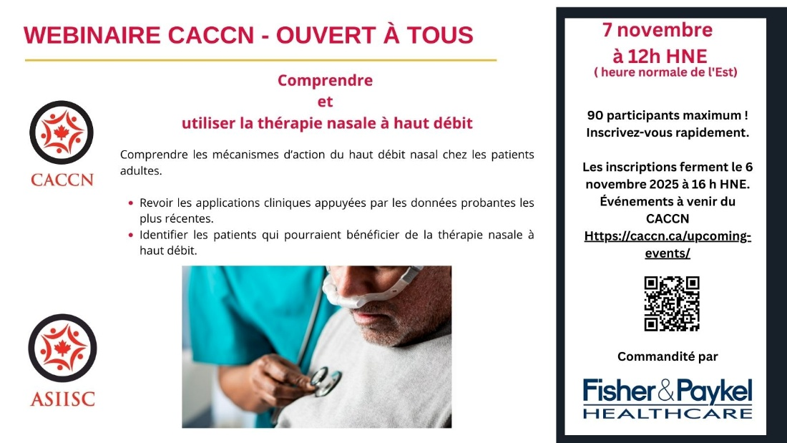

**JOIN US FOR UPCOMING EVENTS**

**EMAIL** [**caccnalberta@caccn.ca**](mailto:caccnalberta@caccn.ca)

**to register**

**17TH WORLD CONGRESS OF INTENSIVE AND CRITICAL CARE**

SEPTEMBER 15 TO 19 ● VANCOUVER, BC

Surveys

**International Critical Care, Emergency Nurse, and Critical Care Transport Nurse   
Intent to Stay Study**

**National Survey of Humanizing Initiatives in intensive Care Units**

**Acute Dialysis/CRRT: Nursing and Providers Survey**

[**https://caccn.ca/wp-admin/post.php?post=2311&action=edit**](https://caccn.ca/wp-admin/post.php?post=2311&action=edit)

**LONDON REGIONAL CHAPTER SOCIAL & EDUCATIONAL EVENT**

**SCAN THE QR CODE BELOW**

**LONDON REGIONAL CHAPTER   
SOCIAL AND EDUCATIONAL EVENT**

**PUBLICATIONS**

**Diagnostic accuracy of nurse‑performed lung ultrasound for pulmonary congestion in acute kidney injury: An exploratory study**

*International Journal of Nursing Knowledge*

<https://doi.org/10.1111/2047-3095.70018>

**CLABSI prevention in hospitalized patients receiving hemodialysis**

*American Nurse*

<https://www.myamericannurse.com/clabsi-prevention-in-hospitalized-patients-receiving-hemodialysis/>

**Optimal Head-of-Bed Positioning Before Thrombectomy in Large Vessel Occlusion Stroke:**

**A Randomized Clinical Trial**

*JAMA Neurology*

<https://jamanetwork.com/journals/jamaneurology/fullarticle/2835054>

**Delirium in the Acute Care Setting From the Families Perspective: A Scoping Review**

*JAN*

<https://doi.org/10.1111/jan.16891>

**Pulmonary Manifestations of Sepsis**

*Critical Care Nursing Quarterly*

<https://journals.lww.com/ccnq/fulltext/2025/07000/pulmonary_manifestations_of_sepsis.2.aspx>

**The key role of intensive care nurses in critical illness dysphagia assessment, prevention, and management**

*Intensive and Critical Care Nursing*

<https://doi.org/10.1016/j.iccn.2024.103935>

**Insights from the top-cited papers in the critical care nursing literature: A bibliometric and visualized analysis**

*BACCN Nursing in Critical Care*

<https://doi.org/10.1111/nicc.13236>

**Educating the nurses of 2025: Technology trends of the next decade**

*Nurse Education in Practice*

<https://www2.ufjf.br/pgenfermagem/files/2018/04/Educating-the-nurses-of-2025-Technology-trends-of-the-next-decade.pdf>

**Oral medications for sleep in nonintubated ICU patients and their impact on delirium**

*CHEST Physician*

<https://www.chestphysician.org/oral-medications-for-sleep-in-nonintubated-icu-patients-and-their-impact-on-delirium/>

**Introduction to RN prescribing in Ontario: lessons learned from Georgian College**

*Canadian Nurse*

<https://www.canadian-nurse.com/blogs/cn-content/2025/09/02/introduction-to-rn-prescribing-in-ontario?_zs=71I9O1&_zl=5LVQ3>

**Model establishment based on clinical data from patient monitors: Optimising night-time alarms in intensive care units**

*Intensive and Critical Care Nursing*

<https://doi.org/10.1016/j.iccn.2025.104192>

**CAMEO Acuity Tool to Assess Workload**

*AACN Nurse Story*

<https://www.aacn.org/nursing-excellence/nurse-stories/cameo-acuity-tool-to-assess-workload?sc_camp=05BE1BF9D3FE42299D56E0128D5F476C&_zs=K0dSX&_zl=NqNe4>

**Nurse-Led Family Support Intervention for Families of Critically Ill Patients  
The FICUS Cluster Randomized Clinical Trial**

*JAMA Internal Médicine*

<https://jamanetwork.com/journals/jamainternalmedicine/fullarticle/2836585>

**Open Intensive Care Units**

**A Global Challenge for Patients, Relatives, and Critical Care Teams**

*Dimensions of Critical Care Nursing*

<https://journals.lww.com/dccnjournal/fulltext/2014/07000/Open_Intensive_Care_Units__A_Global_Challenge_for.2.aspx>

**AI Interventions to Alleviate Healthcare Shortages and Enhance Work Conditions in Critical Care: Qualitative Analysis**

*Journal of Medical Internet Research*

<https://www.jmir.org/2025/1/e50852/>

**Emotional analysis of operating room nurses in acute care hospitals in Japan: insights using ChatGPT**

*BMC Nursing*

<https://link.springer.com/article/10.1186/s12912-024-02655-9>

**Environmental sustainability, medical waste management, energy and medicine consumption of the surgical intensive care nurses: A qualitative study**

*BACCN Nursing in Critical Care*

[**https://doi.org/10.1111/nicc.13150**](https://doi.org/10.1111/nicc.13150)