**June 2025**



**June, July & August**

**Open - Monday to Thursday   
0800 – 1600 hrs ET**

**Closed – July 14 - 18** & **21 – 25  
Closed - August 25 – 29**

*We will not be responding to emails, or telephone calls the weeks of   
July 14-18, 21-25 & August 25-29.*



**Celebrating our Indigenous nursing colleagues and all Indigenous peoples during National Indigenous History Month. NIHM honours the histories, achievements and resilience of First Nations, Inuit and Métis peoples, who have cared for this land since time immemorial.**

**New** & **Returning Members!**

Thank you for your membership and look forward to your participation in your specialty nursing association!

**Celebrating our 2SLGBTQIA+ colleagues and all others with diverse genders and sexualities. Happy Pride Month!**

**JOIN US! FINAL WEBINAR BEFORE SUMMER**

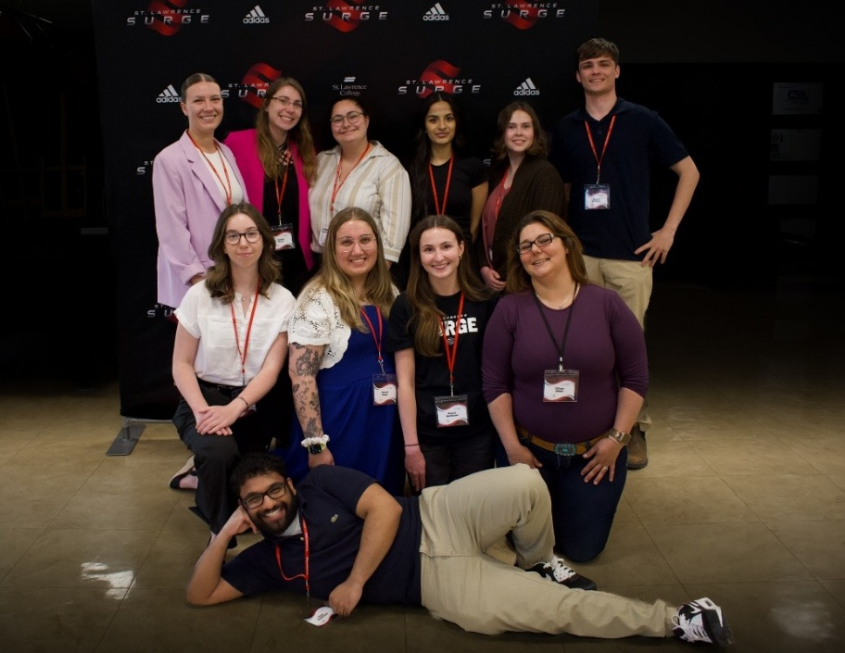

On behalf of

**St. Lawrence College**

and the entire

**Synapse 2025 Planning Committee**,

I want to extend our gratitude for your support and contribution. Your sponsorship and contributions played a significant role in making this year's conference incredible.

Thanks to your commitment, we assembled a vibrant community of students, professors, innovators, and thought-provoking leaders who strive to advance research within the St. Lawrence College community.

Sincerely

*Natalie Garvey (Student)*

*Synapse Nursing Symposium*

CACCN provided literature and door prizes to giveaway.

**“Caring Intensively”**

**Critical Care Nurse Registration = 4 – Days = $ 700 plus taxes**

*NOTE: You will be asked if you are a CACCN Member. This is for tracking purposes only.   
A CACCN member discount is not available as a reduction in the registration fees was negotiated.*

**Registration** [**https://www.wcicc2025.com/registration-fees**](https://www.wcicc2025.com/registration-fees)

**WORLD CONGRESS 2025**

**Registration**

<https://www.eventbrite.ca/e/practical-strategies-to-communicate-with-your-critically-ill-patient-tickets-1311966690689?aff=ebdssbdestsearch>



**Facebook:** [**https://www.facebook.com/CACCN.National**](https://www.facebook.com/CACCN.National)

**LinkedIn:** [**https://www.linkedin.com/company/caccn**](https://www.linkedin.com/company/caccn)

**X: @CACCN1** [**https://x.com/caccn1?lang=en**](https://x.com/caccn1?lang=en)

**Instagram** [**https://www.instagram.com/caccn_national/**](https://www.instagram.com/caccn_national/)

**SURVEY**

**World Federation of Critical Care Nurses (WFCCN)**

**Acute Dialysis/CRRT: Nursing & Providers Survey**

Focusing on the utilization and practice variations of Continuous Renal Replacement Therapy (CRRT). Despite the widespread utilization of CRRT techniques there is significant variation in how the technique is prescribed, delivered, and monitored for quality. We believe there is a great need to assess the knowledge and practice gaps that exist in this field.

[**https://www.surveymonkey.com/r/YSP23BX**](https://www.surveymonkey.com/r/YSP23BX)

***Do Not Use: Dangerous Abbreviations, Symbols, and Dose Designations - 2025 Update***

This bulletin describes the development of an updated list through a multi-input process that included an environmental scan, incident analyses, and stakeholder consultations from health care sectors and regions across Canada.

[**Do Not Use List**](https://ismpcanada.ca/resource/do-not-use-list/) **– *Printable Bulletin***

[**https://ismpcanada.ca/resource/do-not-use-list/**](https://ismpcanada.ca/resource/do-not-use-list/)



**Consultation sur l’ébauche révisée des Lignes directrices : Exigences en matière d’information et de présentation pour les médicaments biologiques biosimilaires**

Le 10 juin 2025, la Direction des médicaments biologiques et radiopharmaceutiques (DMBR) de Santé Canada a publié une version révisée de ses [***Lignes directrices : Exigences en matière d’information et de présentation pour les médicaments biologiques biosimilaires***](https://www.canada.ca/fr/sante-canada/programmes/consultation-exigences-matiere-information-presentation-medicaments-biologiques-biosimilaires.html) (Lignes directrices sur les biosimilaires) aux fins de consultation auprès des intervenants.

Ces lignes directrices fournissent des renseignements aux promoteurs afin de leur permettre de satisfaire aux exigences du Règlement sur les aliments et drogues pour l’autorisation des biosimilaires. La DMBR a entrepris un examen détaillé des Lignes directrices sur les biosimilaires compte tenu de son expérience accumulée en matière d’examen des biosimilaires depuis la dernière mise à jour en 2016 et a révisée ces lignes directrices afin de mieux refléter l’état actuel de la science réglementaire et les développements réglementaires internationaux.

Les intervenants intéressés sont invités à examiner les lignes directrices révisées et à faire part de leurs commentaires à la DMBR avant la clôture de la période de consultation le 8 septembre, 2025.



**Consultation on draft revised Guidance Document: Information and Submission Requirements for Biosimilar Biologic Drugs**

On June 10, 2025, Health Canada’s Biologic and Radiopharmaceutical Drugs Directorate (BRDD) posted a revised version of its [***Guidance Document: Information and Submission Requirements for Biosimilar Biologic Drugs***](https://www.canada.ca/en/health-canada/programs/consultation-information-submission-requirements-biosimilar-biologic-drugs.html) (Biosimilars Guidance) for stakeholder consultation.

This guidance provides information to sponsors to enable them to satisfy requirements under the *Food and Drug Regulations* for the authorization of biosimilars. BRDD undertook a detailed review of the Biosimilars Guidance considering its cumulated experience in reviewing biosimilars since the guidance was last updated in 2016 and revised it to better reflect the current state of regulatory science and international regulatory developments.

**Interested stakeholders are invited to review the revised guidance and provide their comments to BRDD before the closing of the stakeholder consultation period on September 8, 2025.**

**The effectiveness of a three-dimensional printed model for training novice healthcare professionals in central venous catheter insertion: A cross-sectional study in a critical care setting**

*Australian Critical Care*

<https://www.australiancriticalcare.com/article/S1036-7314(25)00027-X/fulltext>

**Nursing for Planetary Health and Well-being**

*ICN Topic Brief*

<https://www.icn.ch/sites/default/files/2025-05/Planetary%20Health%20Topic%20Brief%20-%20EN_0.pdf>

**Wake-up call: paediatric cardiac intensive care nurse and advanced practice provider well-being and intent to vacate**

*Cambridge Care*

<https://tinyurl.com/ArticleCCare1>

**100: CREATIVE STAFFING SOLUTIONS FOR NURSING SHORTAGES IN PICU WHILE IMPROVING   
QUALITY OF CARE**

*Critical Care Medicine*

<https://journals.lww.com/ccmjournal/citation/2025/01001/100__creative_staffing_solutions_for_nursing.53.aspx>

**Facilitating Family Presence During Resuscitation and Invasive Procedures Throughout the Life Span**

*AACN Practice Alert*

<https://doi.org/10.4037/ccn2023733>

**Family-centered care in neonatal and pediatric critical care units: a scoping review of interventions, barriers, and facilitators**

*BMC Pediatrics*

<https://link.springer.com/article/10.1186/s12887-025-05620-w>

**Beyond Patient Safety: Exploring the Mechanism of How Organizational Support Influences Nurses’ Safety Behavior in Pediatric Intensive Care Units**

*Risk Management and Healthcare Policy*

<https://www.tandfonline.com/doi/full/10.2147/RMHP.S517964>

**How simple non-verbal cues can help Indigenous patients trust the health-care system**

*Canadian Nurse*

[**https://www.canadian-nurse.com/blogs/cn-content/2025/05/05/non-verbal-cues-can-help-indigenous-patients?_zs=71I9O1&_zl=gTHL3**](https://www.canadian-nurse.com/blogs/cn-content/2025/05/05/non-verbal-cues-can-help-indigenous-patients?_zs=71I9O1&_zl=gTHL3)

**Sepsis in the hospital setting: A case study**

*American Nurse*

<https://www.myamericannurse.com/sepsis-in-the-hospital-setting/>

**Organizational Mental Health**

**& Wellness Supports**

Three nursing organizations, Canadian Federation of Nurses Unions (CFNU), Canadian Federation of Mental Health Nurses (CFMHN) and Canadian Nurses Association (CNA) have come together with Dr. Leigh Chapman, Chief Nursing Officer of Canada to address a major theme within the *Nursing Retention Toolkit: Improving the working lives of nurses in Canada*: **Organizational Mental Health & Wellness Supports.**

**Session 1: June 18 @ 1300 hrs ET** - ***Proven Solutions to Enhance Nurse Wellness*.**

**Session 2:** June 25, 2025 (1500 to 1600 hours EDT)

**Session 3**: September 2025 (date/timing TBD)

**Register:** [**https://cna-aiic-ca.zoom.us/webinar/register/WN_WkPSAlP1RDyjsSI1pvMz5Q**](https://cna-aiic-ca.zoom.us/webinar/register/WN_WkPSAlP1RDyjsSI1pvMz5Q)

For Nursing Retention Toolkit, go to link: [nursing-retention-toolkit-improving-working-lives-nurses.pdf](https://www.canada.ca/content/dam/hc-sc/documents/services/health-care-system/health-human-resources/nursing-retention-toolkit-improving-working-lives-nurses/nursing-retention-toolkit-improving-working-lives-nurses.pdf)

For Psychological Health & Safety Tools, go to link: [Home - Team Health and Safety](https://teamhealthandsafety.ca/)

**PUBLICATIONS**

**Practice recommendations for culturally sensitive communication at the end of life in intensive care: A modified eDelphi study**

*Intensive and Critical Care Nursing*

<https://www.sciencedirect.com/science/article/pii/S096433972400199X>

**Exploring the impact and challenges of tele-ICU: A qualitative study on nursing perspectives**

*Applied Nursing Research*

<https://doi.org/10.1016/j.apnr.2025.151914>

**Podcast**

**Navigating Professional Life:   
Supporting New Nurse Graduates**

<https://outcomesrocket.health/mass-general-hospital-2/2023/03/>

**How do patients feel about research ethics review?**

*The Healthy Debate*

<https://healthydebate.ca/2025/05/topic/how-do-patients-feel-about-research-ethics-review/>