May 2024

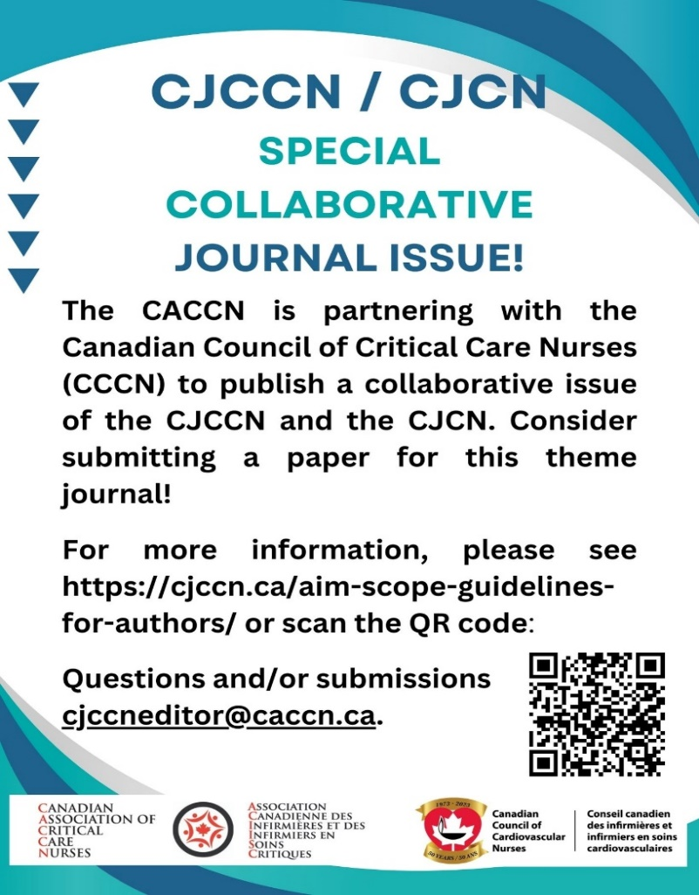

May 6-12 Nursing Week – Changing Lives, Shaping Tomorrow
- Media Kit

May 12 International Nurses Day

May 23 Webinar: Communities of Practice: Nurse Managers

Webinar Alberta Chapter: Neuroprognostication after cardiac arrest

May 30 Webinar: OB Emergencies

June 1 Awards, Grants, Bursaries deadline

CJCCN/CJCN Joint Issue – Manuscripts due

June 4 CACCN London Chapter Education Day

June 6 Webinar: Children are not little adults

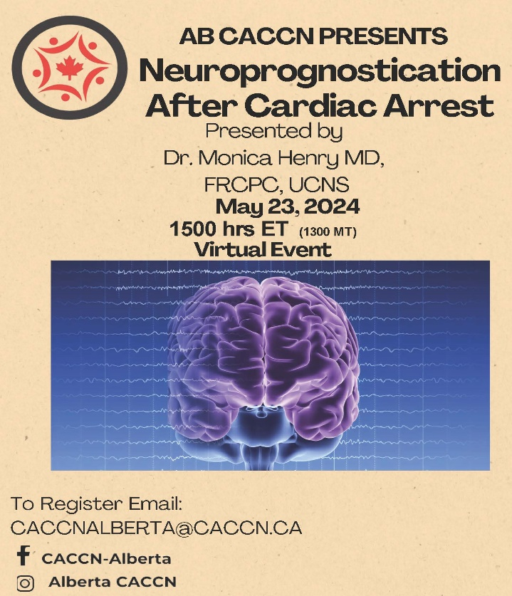
CACCN Awards, Grants and Bursaries
Deadline: June 1
Review the OVERALL Criteria and Online Submission: https://caccn.ca/awardsandrecognition/

BBraun Sharing Expertise Award  Criteria | Presented to an individual who exhibits stellar leadership and mentoring abilities in critical care. Award: Conference Tuition, Travel Bursary, Hotel Bursary to a maximum of $1750
Spacelabs Innovative Project Awards  Criteria | Presented to a critical care nurse or group of critical care nurses who develop a project that will enhance their professional development. Awards: 1st Place $1000 and 2nd Place $ 500 OR Two Awards: $750
Brenda Morgan Leadership Excellence Award  Criteria | Presented to a critical care nurse who, on a consistent basis demonstrates outstanding performance in leadership in CACCN and critical care. Award: Trophy and $1000
Canadian Intensive Care Week “Spotlight” Challenge Award  Criteria | Presented to a group of critical care nurses who develop an activity and/or event to profile their local Critical Care Team during Canadian Intensive Care Week held annually in October.  Bursary: $500
Chasing Excellence Award  Criteria | Presented to a critical care nurse who consistently demonstrates excellence in critical care nursing practice. Award: $ 1000
Graduate Education Bursary  Criteria | Presented to assist critical care nurses to pursue Master’s or Doctoral education with a focus on critical care nursing​. Bursary: $1000
Research Grant  Grant Criteria | Awarded to a critical care nurse who is the investigator of a research study that is relevant to the practice of critical care nursing. Grant: $2500

FOLLOW CACCN on Social Media

Facebook: https://tinyurl.com/FBCACCN /

Linkedin: https://ca.linkedin.com/company/caccn

X (formerly Twitter): www.twitter.com @CACCN1

Instagram https://www.instagram.com/caccn_national/ @caccn_national

CACCN Events
