May 2024

May 20 Office will be closed.

May 22 Office will be closed.

May 23 Webinar: Communities of Practice: Nurse Managers

Webinar Alberta Chapter: Neuroprognostication after cardiac arrest

May 30 Webinar: OB Emergencies

June 1 Awards, Grants, Bursaries deadline

CJCCN/CJCN Joint Issue – Manuscripts due

June 4 CACCN London Chapter Education Day

June 6 Webinar: Paula Price Memorial Educational Series - Critical Care Conundrums Session 2 - Children are not little adults

June 11 Webinar: ICU Survivorship - Alberta Chapter

June 20 Journal Club

NEW and RENEWING members!
We thank you for your support of your specialty nursing association!

Critical Care Certification!

Best of Luck!
Wishing the best of luck to everyone who is writing the Canadian Nurses Association critical care specialty certification examination this month!

When you receive your results – complete the bursary application: Bursary.

Renewing? Complete the renewal bursary application: Bursary.

Photos!
Show off your accomplishment of initial or renewal certification by sharing a photo of you & your certification letter with CACCN. Send an email to caccn@caccn.ca with your full name and the photo.

By sending the information – you are consenting to your name and likeness being posted on Facebook, Instagram, LinkedIn, and X.

CACCN Awards, Grants and Bursaries
Deadline: June 1
Review the OVERALL Criteria and Online Submission: https://caccn.ca/awardsandrecognition/

BBraun Sharing Expertise Award  Criteria | Presented to an individual who exhibits stellar leadership and mentoring abilities in critical care.  Award: Conference Tuition, Travel Bursary, Hotel Bursary to a maximum of $1750
Spacelabs Innovative Project Awards  Criteria | Presented to a critical care nurse or group of critical care nurses who develop a project that will enhance their professional development. Awards: 1st Place $1000 and 2nd Place $ 500 OR Two Awards: $750
Brenda Morgan Leadership Excellence Award  Criteria | Presented to a critical care nurse who, on a consistent basis demonstrates outstanding performance in leadership in CACCN and critical care. Award: Trophy and $1000
Canadian Intensive Care Week “Spotlight” Challenge Award  Criteria | Presented to a group of critical care nurses who develop an activity and/or event to profile their local Critical Care Team during Canadian Intensive Care Week held annually in October.  Bursary: $500
Chasing Excellence Award  Criteria | Presented to a critical care nurse who consistently demonstrates excellence in critical care nursing practice. Award: $ 1000
Graduate Education Bursary  Criteria | Presented to assist critical care nurses to pursue Master’s or Doctoral education with a focus on critical care nursing​. Bursary: $1000
Research Grant  Grant Criteria | Awarded to a critical care nurse who is the investigator of a research study that is relevant to the practice of critical care nursing. Grant: $2500

CACCN Social Media
Click the icons for access! Follow/Join Us!

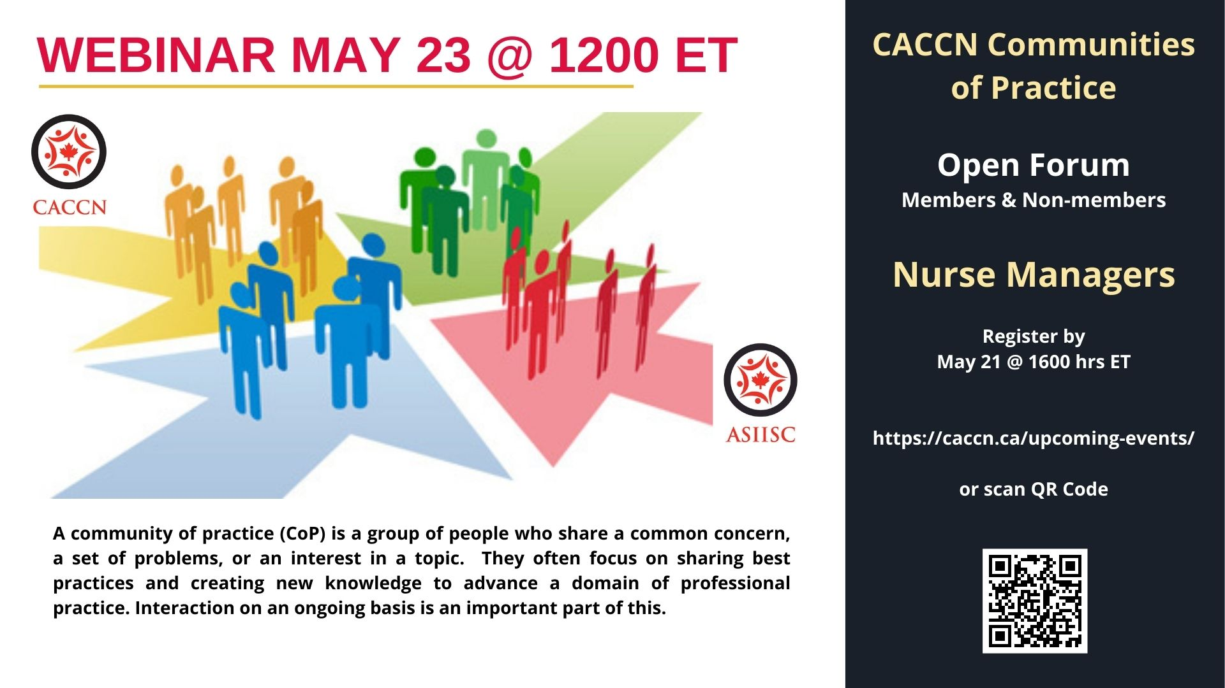
MAY EVENTS – Still time to register!
https://caccn.ca/upcoming-events/
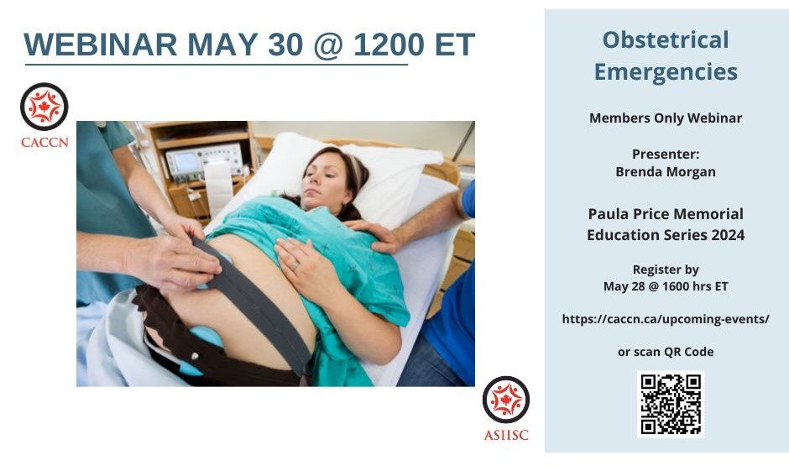
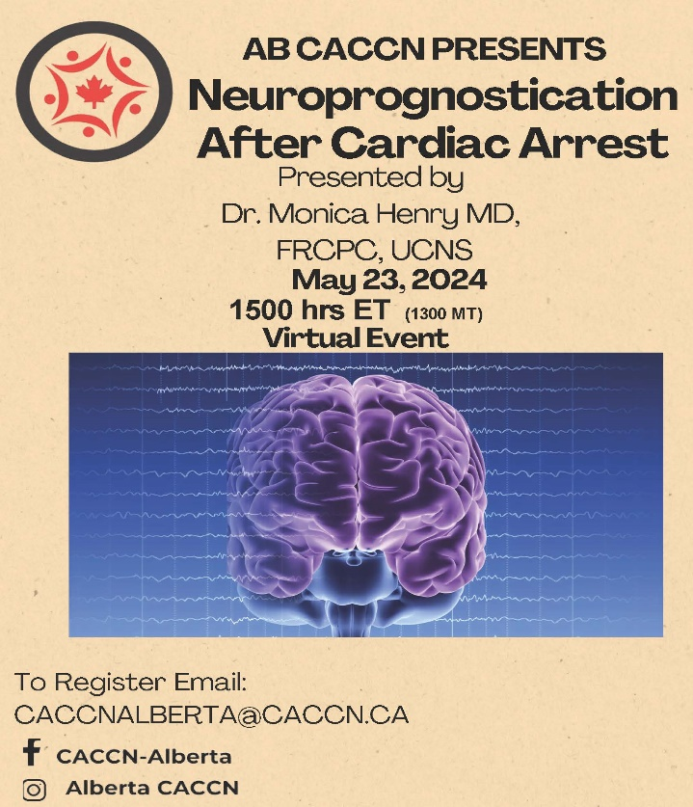

To the
Editorial Management Team

Thank you!

Dr. Asha Pereira, PhD, RN

Dr. Michelle House-Kokan
EdD, MSN, RN, CNCC(C), CCNE

Ms. Catherine Liao, MSc, RN

Dr. Ramesh Venkatesa-Perumal
PhD, RN, CCNE, CNCC(C), CCSNE

Watch for the announcement
for the CJCCN Editorial Management Team 2024-2026.

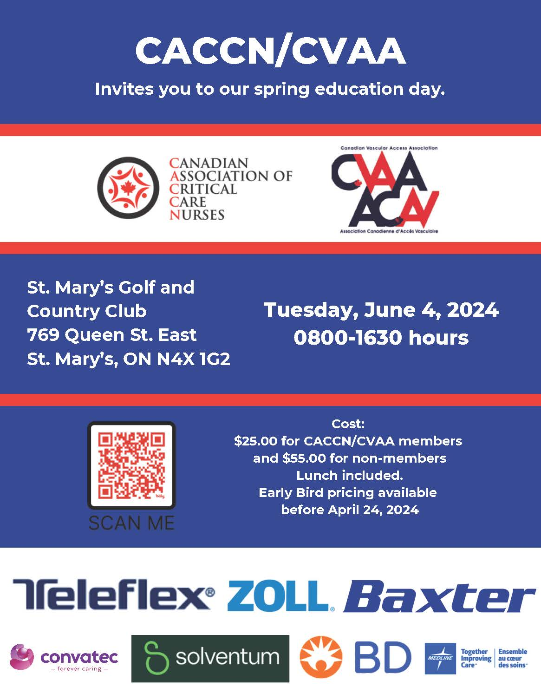
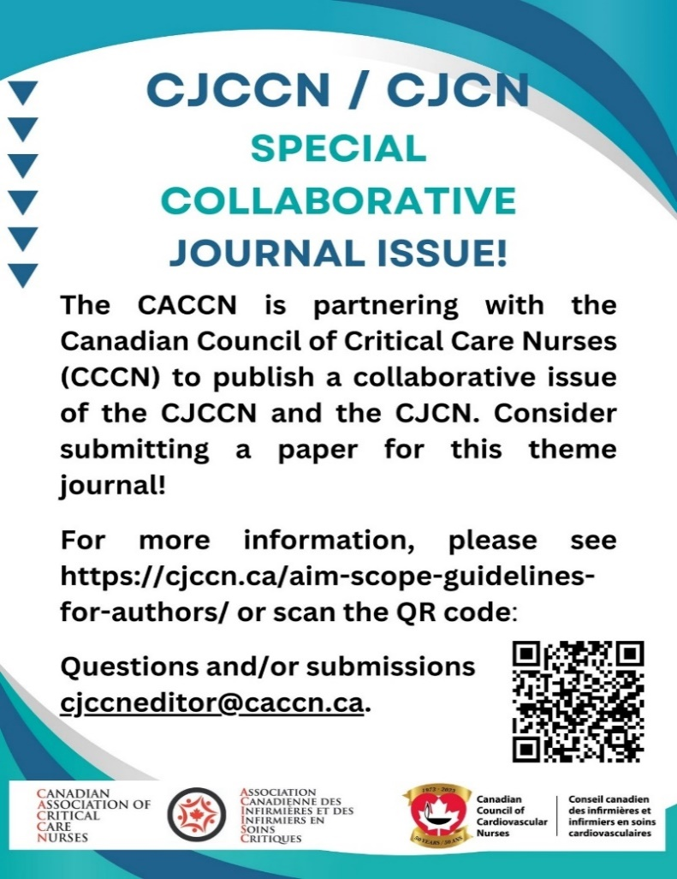

National Nursing Week
- A Message from the Minister of Health and the Minister of Mental Health and Addictions and Associate Minister of Health on National Nursing Week

Vaccines
- Guidance on the use of COVID-19 vaccines during the fall of 2024
- Summary of NACI statement of May 3, 2024: Guidance on the use of COVID-19 vaccines during the fall of 2024
- HPV vaccine
- Measles vaccine

Health Equity
- Enhancing equity, diversity, and inclusion to better serve those using Canada's crisis and distress lines
- Government of Canada Supports Lakehead University’s project to assist underserved populations in receiving palliative care services

Vaccins
- Directives sur l’utilisation des vaccins contre la COVID-19 à l’automne 2024
- Résumé de la déclaration du CCNI du 3 mai 2024 : Directives sur l’utilisation des vaccins contre la COVID-19 à l’automne 2024
- Vaccin contre le VPH
- Vaccin contre la rougeole

Semaine nationale des soins infirmiers
- Message du ministre de la Santé et de la ministre de la Santé mentale et des Dépendances et ministre associée de la Santé à l'occasion de la Semaine nationale des soins infirmiers

L’équité en santé
- Améliorer l'équité, la diversité et l'inclusion pour mieux servir les personnes qui utilisent les lignes de crise et de détresse du Canada
Le gouvernement du Canada appuie un projet de l’Université Lakehead pour aider les populations mal desservies à recevoir des services de soins palliatifs

Canadian
Critical Care Nursing
Conference 2024
September 23 to 29, 2024
Delta Regina, Regina, SK

Watch for the
Conference Flyer, Online Brochure and Registration coming in early June!

CACCN has been actively providing
critical care education for over 40 years!

This year we come together to
REimagine, REdefine, and REinspire
ourselves, our careers,
our colleagues, and nursing in Canada.

The conference allows you to share and learn the latest on a multitude of topics,
and to hone your skills both clinical and professional through Fast & Focused, Concurrent, Plenary, Oral Poster,
and Poster presentations.

This national event also provides an excellent opportunity to network with nurses, interprofessional colleagues
and industry providers from
across the country.

Join us!

REimagine REdefine REinspire

National Rapid Genome Sequencing in Neonatal Intensive Care
JAMA Network Open
https://jamanetwork.com/journals/jamanetworkopen/article-abstract/2815388

The diverse invitations to participate in early rehabilitation – A qualitative study of nurse-patient interactions in the intensive care unit
Intensive and Critical Care Nursing
https://doi.org/10.1016/j.iccn.2023.103556

Photographs in burn patient diaries: A qualitative study of patients’ and nurses’ experiences
Intensive and Critical Care Nursing
https://doi.org/10.1016/j.iccn.2023.103619

Intention to use physical restraint in paediatric intensive care units and correlated variables: A multicentre and cross-sectional study
Intensive and Critical Care Nursing
https://doi.org/10.1016/j.iccn.2024.103690

Pain management interventions of the non-communicating patient in intensive care: What works for whom and why? A rapid realist review.
Journal of Clinical Nursing
https://doi.org/10.1111/jocn.17065

Looking for a CJCCN article?
View the article list.

Assessing the impact of creating virtual windows on the incidence of delirium in a surgical intensive care unit: a before and after study
Canadian Journal of Critical Care Nursing
https://cjccn.ca/featured-article/assessing-the-impact-of-creating-virtual-windows-on-the-incidence-of-delirium-in-a-surgical-intensive-care-unit-a-before-and-after-study/

Revising the Canadian Association of Critical Care Nurses Standards for Critical Care Nursing Practice: A Modified Delphi Protocol
Canadian Journal of Critical Care Nursing
https://cjccn.ca/journals/cjccn-volume-34-number-3-fall-2023/

Precepting in critical care: Building the future of critical care nursing (Page 6)
Canadian Journal of Critical Care Nursing
https://cjccn.ca/wp-content/uploads/2024/01/CJCCN-V34-N4-Winter-2023.pdf

Can the Reboot coaching programme support critical care nurses in coping with stressful clinical events? A mixed-methods evaluation assessing resilience, burnout, depression, and turnover intentions
BCM Health Services Research
https://link.springer.com/article/10.1186/s12913-023-10468-w

Reality shock in newly graduated critical care nurses and its association with missed nursing care: The mediating role of caring ability
Intensive and Critical Care Nursing
https://doi.org/10.1016/j.iccn.2023.103554

CACCN
PO Box 25322, London, ON, N6C 6B1

Toll Free 866-477-9077
Direct 519-207-7007

Email caccn@caccn.ca

Monday to Friday 0800 – 1600 hrs ET
Closed Saturday and Sunday

